|  |  |
| --- | --- |
|  | **MINISTRY OF EDUCATION AND TRAINING** |

|  |
| --- |
| **FPT UNIVERSITY** |
| Capstone Project Document |
| SKETTER – Smart Travel Planner |

|  |  |
| --- | --- |
| **SP22SE12** | |
| **Group Members** | Dương Thanh Huy – SE140223  Quách Khổng Triết – SE140868  Trần Trung Hậu – SE130205  Dư Xuân Lộc – SE140213 |
| **Supervisor** | Nguyễn Trọng Tài |
| **Ext Supervisor** | N/A |
| **Capstone Project code** | FA22SE20 |

- Ho Chi Minh, 12/2022 -

**List of Contents**

I. Project Introduction 7

**1.** **Overview** 7

**1.1** **Project information** 7

**1.2** **Project team** 7

**2.** **Product Background** 7

**3.** **Existing Systems** 7

**3.1** **Trip hunter** 7

**3.2** **Trip** 8

**4.** **Business Opportunity** 8

**5.** **Software Product Vision** 9

**6.** **Project Scope & Limitations** 9

**6.1** **Major features** 9

II. Project Management Plan 10

**1.** **Overview** 11

**1.1** **Scope & Estimation** 11

**1.2** **Project Objectives** 12

**1.3** **Project Risks** 12

**2.** **Management Approach** 12

**2.1** **Project Process** 13

**2.2** **Quality Management** 13

**2.3** **Training Plan** 13

**3.** **Project Deliverables** 14

**4.** **Responsibility Assignments** 14

**5.** **Project Communications** 14

**6.** **Configuration Management** 15

**6.1** **Document Management** 15

**6.2** **Source Code Management** 15

**6.3** **Tools & Infrastructures** 15

III. Software Requirement Specification 15

**1.** **Product Overview** 15

**2.** **User Requirements** 16

**2.1** **Actors** 16

**2.2** **Use cases** 16

**2.2.1** **Diagram(s)** 16

**2.2.2** **Use Cases List** 19

**2.2.3** **Use case specification** 21

**2.2.3.1** **UC01 – Register traveler account** 21

**2.2.3.2** **UC02 – Register supplier account** 22

**2.2.3.3** **UC03-Login** 23

**2.2.3.4** **UC04 – Update profile** 25

**2.2.3.5** **UC05 – View profile** 26

**2.2.3.6** **UC06 – Change password** 27

**2.2.3.7** **UC07 – Forgot password** 28

**2.2.3.8** **UC08 - Logout** 29

**2.2.3.9** **UC09 – Create account** 30

**2.2.3.10** **UC10 – View account list** 32

**2.2.3.11** **UC11 – View account details** 33

**2.2.3.12** **UC12 – Update account** 34

**2.2.3.13** **UC13 – Delete account** 35

**2.2.3.14** **UC14 – Search account** 36

**2.2.3.15** **UC15 – Create catalog** 37

**2.2.3.16** **UC16 – View catalog list** 38

**2.2.3.17** **UC17 – Enable catalog** 39

**2.2.3.18** **UC18 – Disable catalog** 40

**2.2.3.19** **UC19 – Create destination** 41

**2.2.3.20** **UC20 – View destination list** 43

**2.2.3.21** **UC21 – View destination details** 44

**2.2.3.22** **UC22 – Update destination** 45

**2.2.3.23** **UC23 – Delete destination** 47

**2.2.3.24** **UC24 – View destination reviews** 48

**2.2.3.25** **UC25 – Create draft voucher** 49

**2.2.3.26** **UC26 - Active voucher** 50

**2.2.3.27** **UC27 – Stop voucher** 52

**2.2.3.28** **UC28 – Search voucher** 53

**2.2.3.29** **UC29 – View voucher list** 54

**2.2.3.30** **UC30 – View voucher information** 55

**2.2.3.31** **UC31 – View voucher code list** 57

**2.2.3.32** **UC32 – Update voucher** 58

**2.2.3.33** **UC33 – Duplicate voucher** 59

**2.2.3.34** **UC34 – Delete voucher** 60

**2.2.3.35** **UC35 – View bookmarked list** 61

**2.2.3.36** **UC36 – Add bookmark** 62

**2.2.3.37** **UC37 – Delete bookmark** 63

**2.2.3.38** **UC38 – Review destination** 64

**2.2.3.39** **UC39 – Delete destination review** 65

**2.2.3.40** **UC40 – View most viewed destinations** 66

**2.2.3.41** **UC41 – View newest destinations** 67

**2.2.3.42** **UC42 – View trending destinations** 68

**2.2.3.43** **UC43 – View recently created plans** 70

**2.2.3.44** **UC44 – View most viewed plans** 71

**2.2.3.45** **UC45 – Duplicate plan** 72

**2.2.3.46** **UC46 – Create manual plan** 72

**2.2.3.47** **UC47 – Create smart plan** 76

**2.2.3.48** **UC48 – Update plan** 79

**2.2.3.49** **UC49 – Delete plan** 81

**2.2.3.50** **UC50 – View suggested smart plans** 82

**2.2.3.51** **UC51 – View plan details** 83

**2.2.3.52** **UC52 – Save smart plan** 84

**2.2.3.53** **UC53 – View personal plans** 86

**2.2.3.54** **UC54 – Recommend destinations** 86

**2.2.3.55** **UC55 – Complete draft plan** 87

**2.2.3.56** **UC56 – Check in** 88

**2.2.3.57** **UC57 – Buy voucher** 90

**2.2.3.58** **UC58 – Use voucher** 91

**2.2.3.59** **UC59 – Complete plan** 92

**2.2.3.60** **UC60 – View own voucher** 93

**2.2.3.61** **UC61 – View payment history** 94

**2.2.3.62** **UC62 – Verify email** 95

**2.2.3.63** **UC63 – View destination vouchers** 96

**3.** **Functional Requirements** 97

**3.1** **System Functional Overview** 97

**3.1.1** **Screen Flow** 97

**3.1.2** **Screen Descriptions** 99

**3.1.3** **Screen Authorization** 103

**3.1.4** **Non-Screen Functions** 104

**3.1.5** **Entity Relationship Diagram** 104

**3.2** **Manage destination** 109

**3.2.1** **View destination list** 109

**3.2.2** **Create destination** 110

**3.2.3** **View destination list** 112

**3.2.4** **Update destination** 112

**3.2.5** **Delete destination** 114

**3.2.6** **View destination review** 115

**3.3** **Planning** 116

**3.3.1** **Create manual plan** 116

**3.3.2** **Update plan** 117

**3.3.3** **Delete plan** 122

**3.3.4** **Recommend destinations** 124

**3.3.5** **View plan details** 124

**3.3.6** **Create smart plan** 126

**3.3.7** **View suggested smart plans** 127

**3.3.8** **Save plan** 128

**3.3.9** **View personal plans** 129

**3.3.10** **Complete draft plan** 130

**3.3.11** **Check in** 130

**3.3.12** **Complete plan** 131

**3.4** **Voucher management** 132

**3.4.1** **Create draft voucher** 132

**3.4.2** **Active voucher** 133

**3.4.3** **Stop voucher** 134

**3.4.4** **View voucher list** 135

**3.4.5** **View voucher information** 136

**3.4.6** **Update voucher** 136

**3.4.7** **Duplicate voucher** 137

**3.4.8** **Delete voucher** 138

**3.4.9** **Search voucher** 138

**3.4.10** **View voucher code list** 139

**4.** **Non-Functional Requirements** 139

**4.1** **External Interfaces** 139

**4.2** **Quality Attributes** 140

**4.2.1** **Usability** 140

**4.2.2** **Reliability** 140

**4.2.3** **Performance** 140

**4.2.4** **Dependability** 140

**4.2.5** **Supportability** 140

**4.2.6** **Design Constraints** 140

**4.2.7** **Support Documents** 140

**5.** **Requirement Appendix** 140

**5.1** **Business Rules** 140

**5.2** **Application Messages List** 144

IV. Software Design Description 146

**1.** **System Design** 146

**2.** **Database Design** 149

**3.** **Detailed Design** 152

**3.1** **Manage Destination** 152

**3.2** **Planning** 165

**3.3** **Manage Voucher** 188

V. Software Testing Documentation 202

**1.** **Scope of Testing** 202

**2.** **Test Plan** 202

VI. Release Package & User Guides 203

**1.** **Deliverable Package** 203

**2.** **Installation Guides** 204

**2.1** **System Requirements** 204

**2.2** **Installation Instruction** 205

**3.** **User Manual** 227

**3.1** **Overview** 227

**Definition and Acronyms**

| **Acronym** | **Definition** |
| --- | --- |
| BR | Business Rule |
| ERD | Entity Relationship Diagram |
| GUI | Graphical User Interface |
| UC | Use Case |
| API | Application Programming Interface |
| FE | Feature |
| LI | Limitation |
| EX | Exclusion |
| QR | Quick Response |
| IIS | Internet Information Services |

1. **Project Introduction**
2. **Overview**
3. **Project information**
   * + - Project name: Smart travel planner.
       - Project code: FA22SE20
       - Group name: Sketter
       - Software type: Web Application, Mobile Application.
4. **Project team**
5. **Supervisors**

|  |  |  |  |
| --- | --- | --- | --- |
| **Full Name** | **Email** | **Phone** | **Title** |
| Nguyễn Trọng Tài | [Taint5@fe.edu.vn](mailto:Taint5@fe.edu.vn) | 0903346184 | Lecturer |

1. **Team member**

|  |  |  |  |
| --- | --- | --- | --- |
| **Full Name** | **Email** | **Phone** | **Title** |
| Dương Thanh Huy | [Huydtse140223@fpt.edu.vn](mailto:Huydtse140223@fpt.edu.vn) | 0948103306 | Leader |
| Quách Khổng Triết | [Trietqkse140868@fpt.edu.vn](mailto:Trietqkse140868@fpt.edu.vn) | 0903846603 | Member |
| Trần Trung Hậu | [Hauttse130205@fpt.edu.vn](mailto:Hauttse130205@fpt.edu.vn) | 0387698743 | Member |
| Dư Xuân Lộc | [Locdxse140213@fpt.edu.vn](mailto:Locdxse140213@fpt.edu.vn) | 0932082951 | Member |

1. **Product Background**

Currently, the needs of life are sufficient, so tourism is a necessary demand for everyone. Moreover, the number of domestic travelers has increased strongly in various local destinations, especially Dalat city. Using Google maps and a travel application to be considered as a necessary condition for a self-planned traveler. But now there are many applications that help you do that, which is the best way to help you have a perfect plan for your trip. Sketter seems like a good choice, all you have to do is sign up for your email confirmation and our app will instantly create a schedule for you based on personal preference, budget or distance. It even suggests the most favorite places for your reference.

1. **Existing Systems**
2. **Trip hunter**

* Link: <https://triphunter.vn/>
* Description:

Trip Hunter is an application that helps self-sufficient travelers make smart and convenient travel schedules. Users can find destination information, find flight tickets, hotels, attractions/activities and book tickets online.

With the automatic schedule creation function, you can automatically create a travel itinerary to all the places of Vietnam in just a few seconds. TripHunter helps compare prices and book hotels, sightseeing tickets, bus tickets, airline tickets, tour bookings, and book tours on demand. All travel facilities and services are available in one app.

* System actor:

+ Admin: Manage system, accounts

+ Supplier: Provide products

+ User: Create tour, search destination, hotel plan, and price for tour, view suggested trip, edit tour.

* Features:

+ Create a trip  
+ Hotel booking

+ Flight Booking

+ Search tour

+ Sharing trip

+ Find destination

* Advantages and Disadvantages

+ Advantage: Friendly interface, variety of destination, using big data on application.

+ Disadvantages: Cannot create a trip.

1. **Trip**

* Link: <https://vn.trip.com/>
* Description:

Trip.com hotel and flight booking app is used by more than 400 million members worldwide, in 25 languages, present in 38 countries and territories, offers air tickets to more than 5,000 cities ​​with 900 airlines, 1.4 million hotels in more than 200 countries and territories, train tickets in China, Korea, UK, Germany. Trip.com is one of the world's leading online travel agencies, ready to help you plan the perfect trip - whether traveling, vacation or business, Trip.com will be the bridge to take you around the world with cheap flights, deals on airfares, deals on hotels and cruises.

* System actor:

+ Admin: Manage system and accounts

+ Supplier: Provide products.

+ User: Search destination, hotel, flight, train tickets, and price for tour.

* Features:

+ Hotel booking

+ Flight Booking

+ Train tickets

+ Search tour

+ Find destination

* Advantages and Disadvantages

+ Advantage: Friendly interface, variety of destination, simple application easy to operate, safety payment.

+ Disadvantages: Don’t have manual trip.

1. **Business Opportunity**

The strong increase of the traveler’s proportion has a tourism-changing effect, not least on the backing packing tourism. The smart travel planner system is created based on the needs of market demand in general, as well as domestic tourists and service suppliers in specific. It is expected to receive specific proposals, priority policies to support the tourism industry to recover and develop in the new situation. Solutions focus on opening tourism safely, applying digital transformation, creating tourism products suitable for new trends, new normal situation.

1. **Software Product Vision**

For suppliers, they can advertise their services on different platform to make more revenue and benefits through our website and mobile application.

For travelers, smart travel plan system will create new experiments. They can make an itinerary for their own with Dalat’s travel destination sightseeing, restaurants, foods and café. They can create a tour base on budget, age, tour days or even personality favorited. Moreover, our systems will generate automated plan for the customers.

1. **Project Scope & Limitations**
2. **Major features**
3. **Unauthenticated User**

FE-01: Register traveler account

FE-02: Register supplier account

1. **Authenticated User**

FE-03: Login

FE-04: Update profile

FE-05: View profile

FE-06: Change password

FE-07: Forgot password

FE-08: Logout

1. **Admin**

FE-09: Create account

FE-10: View account list

FE-11: View account details

FE-12: Update account

FE-13: Delete account

FE-14: Search account

FE-15: Create catalog

FE-16: View catalog list

FE-17: Enable catalog

FE-18: Disable catalog

1. **Manager**

FE-19: Create destination

FE-20: Search destination

FE-21: View destinations list

FE-22: View destination details

FE-23: Update destination

FE-24: Delete destination

FE-25: View destination review

1. **Supplie**r

FE-26: Create draft voucher

FE-27: Active voucher

FE-28: Stop voucher

FE-29: Search voucher

FE-30: View voucher list

FE-31: View voucher information

FE-32: View voucher code list

FE-33: Update voucher

FE-34: Duplicate voucher

FE-35: Delete voucher

1. **Traveler**

FE-36: View bookmarked list

FE-37: Add bookmark

FE-38: Delete bookmark

FE-39: Review destination

FE-40: Delete destination review

FE-41: View most viewed destinations

FE-42: View newest destinations

FE-43: View trending destinations

FE-44: View recently created plans

FE-45: View most viewed plans

FE-46: Duplicate plan

FE-47: Create manual plan

FE-48: Create smart plan

FE-49: Update plan

FE-50: Delete plan

FE-51: View suggested smart plans

FE-52: View plan details

FE-53: Save smart plan

FE-54: View personal plans

FE-55: Recommend destinations

FE-56: Complete draft plan

FE-57: Check in

FE-58: Buy voucher

FE-59: Use voucher

FE-60: Complete plan

FE-61: View own voucher

FE-62: View payment history

FE-63: Verify email

## Limitations

LI-01: The Sketter system can only assist traveler making a simple plan for their trip, does not support to connect variety of supplier such as flight, train or car tickets, booking hotels and restaurants.

LI-02: With a small data which added by members that make suggested smart plan is quite simple.

1. **Project Management Plan**
2. **Overview**
3. **Scope & Estimation**

|  |  |  |  |
| --- | --- | --- | --- |
| **#** | **WBS Item** | **Complexity** | **Est. Effort**  **(man-days)** |
| ***1*** | ***Requirement analysis*** |  | ***12*** |
| 1.1 | Define background and context of product | Complex | 7 |
| 1.2 | Find problems of travelers and suppliers | Medium | 2 |
| 1.3 | Existing system analysis | Simple | 1 |
| 1.4 | Business opportunity analysis | Medium | 2 |
| ***2*** | ***Technology training*** |  | ***30*** |
| 2.1 | Learn React framework | Complex | 6 |
| 2.2 | Learn JavaScript | Complex | 6 |
| 2.3 | Learn NodeJS framework | Complex | 6 |
| 2.4 | Learn TypeScript | Complex | 6 |
| 2.5 | Learn Flutter UI framework | Complex | 6 |
| 2.6 | Learn DevOps tool and third-party | Complex | 6 |
| ***3*** | ***Workspace setup*** |  | 10 |
| 3.1 | Setup resources storage workplace | Medium | 5 |
| 3.2 | Setup resources and version control | Medium | 5 |
| ***4*** | ***Document writing*** |  | **40** |
| 4.1 | Write project introduction | Medium | 2 |
| 4.2 | Write project management plan | Medium | 6 |
| 4.3 | Write software requirement specification | Complex | 8 |
| 4.4 | Write software design document | Complex | 8 |
| 4.5 | Write test document | Medium | 5 |
| 4.6 | Write user guide document | Medium | 5 |
| 4.7 | Write final document | Medium | 6 |
| **5** | ***Interface design*** |  | **50** |
| 5.1 | Design web application interface | Complex | 15 |
| 5.2 | Design mobile  application interface | Complex | 35 |
| **6** | ***Implementation*** |  | **130** |
| 6.1 | Implement authentication/authorization features | Medium | 10 |
| 6.2 | Implement supplier features | Complex | 20 |
| 6.3 | Implement manager features | Complex | 20 |
| 6.4 | Implement admin features | Complex | 15 |
| 6.5 | Implement traveler features(mobile application) | Complex | 65 |
| **7** | ***Testing*** |  | **24** |
| 7.1 | Unit Test | Complex | 8 |
| 7.2 | Integration Test | Complex | 8 |
| 7.3 | System Test | Complex | 8 |
| **8** | ***Closing*** |  | **8** |
| 6.5 | Maintenance | Medium | 4 |
| 8.2 | Prepare slides for thesis defense | Medium | 4 |
| ***Total Estimated Effort (man-days)*** | | | **294** |

1. **Project Objectives**

* Timeliness: 70%
* Allocated Effort: 4 (members) * 4 (months) * 20 (days/month) = 320 man-days
* Estimated total cost: 0 VNĐ

1. **Project Risks**

|  |  |  |  |  |
| --- | --- | --- | --- | --- |
| **#** | **Risk Description** | **Impact** | **Possibility** | **Response Plans** |
| 1 | High weight points are skewed to Fronted. | Critical | Medium | Assign more members and spend more time doing frontend tasks. |
| 2 | Host servers dies | Critical | Low | Change host servers |
| 3 | Google Map services error | Critical | Low | Change to text field input. |

1. **Management Approach**
2. 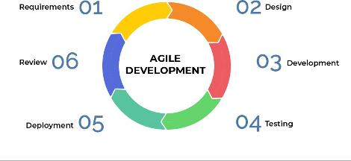**Project Process**

The Sketter system developed using the Agile model is a good framework for using short and flexible time frames to easily respond to changes in development.

Some reasons why we choose Agile:

* + - Easy to learn and use.
    - Reduce waste of time.
    - Optimize team performance and efficiency.

Agile Life-cycle:

* + - Requirement
    - Design
    - Development
    - Testing
    - Deployment
    - Review

1. **Quality Management**

* Make rules about clean coding conventions to easily manage and support each other.
* Carefully cross-review code.
* Do user testing.

1. **Training Plan**

|  |  |  |  |
| --- | --- | --- | --- |
| **Training Area** | **Participants** | **When, Duration** | **Waiver Criteria** |
| React frontend framework | HuyDT | Week 1 - 6 days | Mandatory |
| Node.JS framework | HauTT | Week 1 - 6 days | Mandatory |
| Flutter | TrietQK, LocDX | Week 1 - 6 days | Mandatory |
| DevOps tools(Github, PostgreSQL, Sequelize..) | HauTT, LocDX | Week 1 - 3 days | Mandatory |
| Research Third-party | TrietQK | Week 1 - 3 days | Mandatory |

1. **Project Deliverables**

|  |  |  |  |
| --- | --- | --- | --- |
| **#** | **Deliverable** | **Due Date** | **Notes** |
| 1 | Project Plan Document | 15/09/2022 | Almost completing the project plan |
| 2 | Use case specification | 25/9/2022 | Function Requirement |
| 3 | Design documents | 1/10/2022 | UI design, Architecture design |
| 4 | Web admin & mobile modules | 30/11/2022 | Mobile features, Web admin for system |
| 5 | Web supplier and manager modules | 30/11/2022 | Modules for other actors |

1. **Responsibility Assignments**

|  |  |  |  |  |
| --- | --- | --- | --- | --- |
| **Responsibility** | **Hau** | **Huy** | **Triet** | **Loc** |
| Backend for System | D | R | R | R |
| Front end web for admin, manager, supplier | R | D | R | R |
| Mobile app | R | R | D | D |
| DevOps | D | S | S | D |
| Others | D | D | D | D |

1. **Project Communications**

|  |  |  |  |  |
| --- | --- | --- | --- | --- |
| **Communication Item** | **Who/ Target** | **Purpose** | **When, Frequency** | **Type, Tool, Method(s)** |
| Working with advisor | Supervisor (Nguyen Trong Tai) | * Demonstrate Features * Evaluate progress and result * Review documentation | 2 times per week | Online meeting and face to face |
| Working with team | Team members | * Raise problems * Review source code * Evaluate process and result | always | Messenger, Google meet and face to face. |

1. **Configuration Management**
2. **Document Management**

We use Google and Jira for storing document:

* Using Google to save images, diagrams, etc.
* Use Jira to create tasks, bugs, reports, etc. , and then we apply Agile with dynamic time for the sprints.

**Image**

1. **Source Code Management**

Creating a github that covered 3 source projects for FE, BE, and Mobile. We can define many rules in the github that will apply to all projects.   
 In each source project, we created a dev branch that will be cloned from other branches for building features. After that, we made a pull request from the dev to the master branch that is deployed into the server.

**Image**

1. **Tools & Infrastructures**

|  |  |
| --- | --- |
| **Category** | **Tools / Infrastructure** |
| **Technology** | ReactJS (FrontEnd), Flutter (App), NodeJS (BackEnd) |
| **Database** | PostgreSQL, FireBase |
| **IDEs/Editors** | Visual Studio Code, Android studio 2019 |
| **Diagramming** | DrawIO |
| **Documentation** | Ms Office, Google Docs/Sheets/Slides |
| **Version Control** | GitHub (Source Codes), Google Drive (Documents) |
| **Deployment server** | Heroku, App Center(mobile ) |
| **Project management** | Jira (Task management), Google Drive (Media files management), GitHub(Code management) |

1. **Software Requirement Specification**
2. **Product Overview**

The Smart Travel Planning System is a new software system that replaces the manual plan papers and website’s tournament for supporting and suggesting a smart plan with various criteria. The context diagram below shows the external entities and system interface for release 1.0. The system is expected to evolve over  several releases, ultimately linked to different services of local destinations and connected to payment banking services.

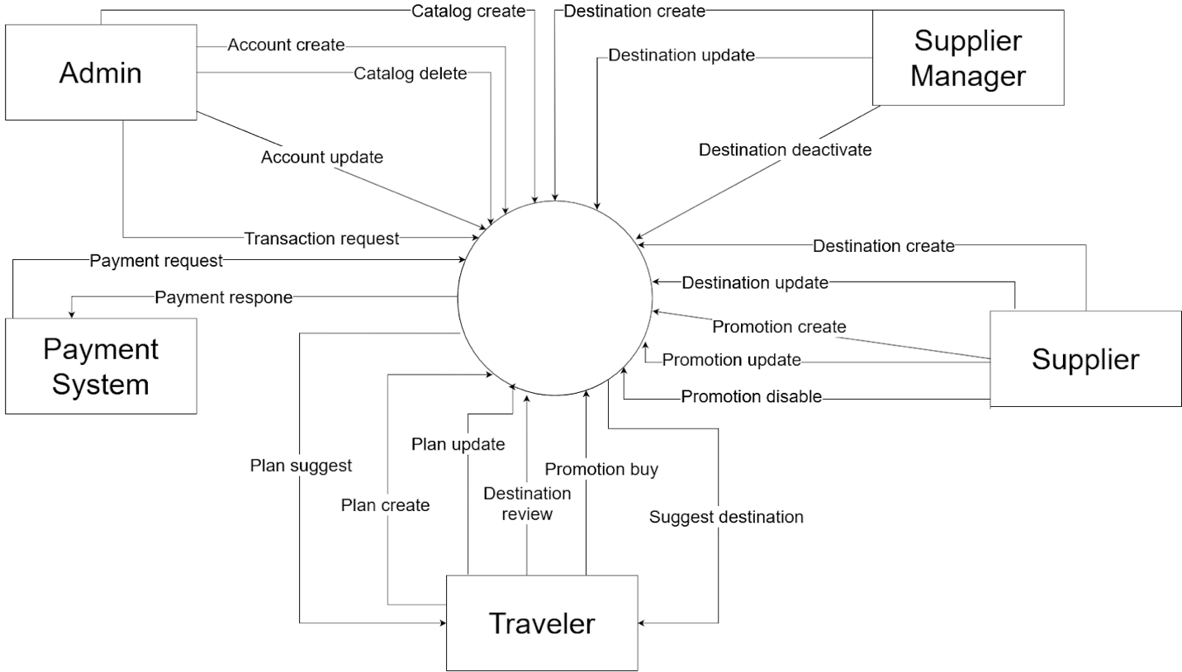

1. **User Requirements**
2. **Actors**

|  |  |  |
| --- | --- | --- |
| **#** | **Actor** | **Description** |
| 1 | Administrator | Admin is the person who accesses the system in an admin role and is responsible for managing the system. Concretely, admin can create accounts, update accounts, delete accounts and add catalog. |
| 2 | Manager | Manager is the person who accesses the system in the Manager role and is responsible for managing all destinations of the system. Moreover, the manager can view a list of destination reviews. |
| 3 | Supplier | Supplier is the person who accesses the system in a supplier role. Suppliers not only manage their own destination, but also can create vouchers, update vouchers and view lists of vouchers. |
| 4 | Traveler | Traveler is the person who accesses the system in a traveler role. They can create manual and smart plans, view lists of destinations, plans, and besides that, they can update plans and check in. |

1. **Use cases**
2. **Diagram(s)**
3. **Web Application**

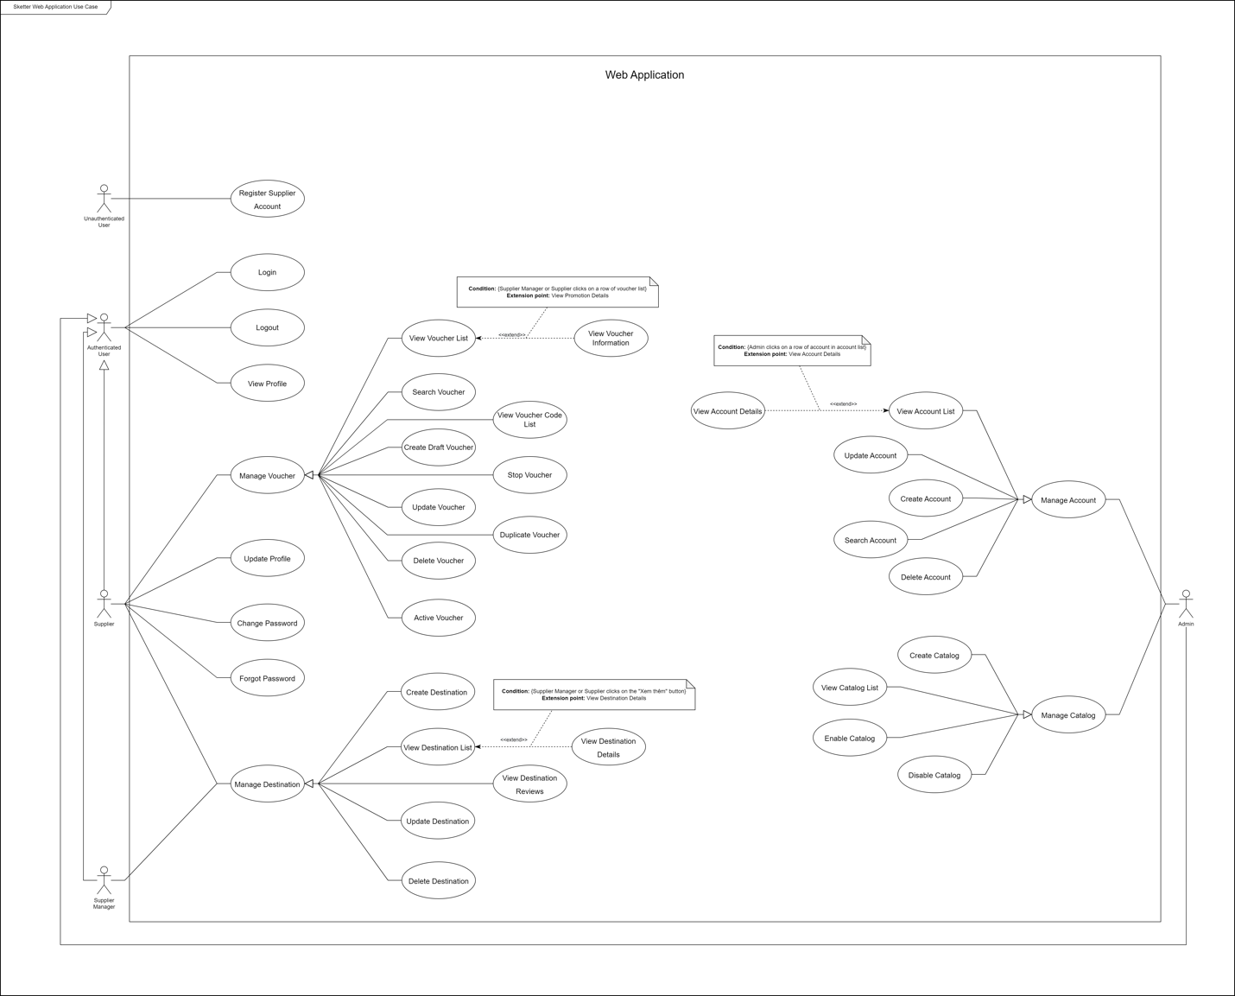

1. **Mobi Application**

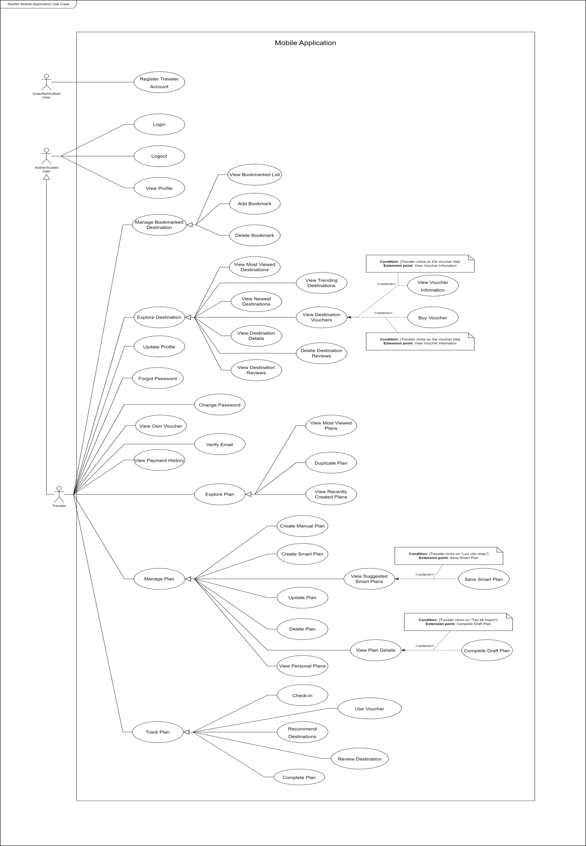

1. **Use Cases List**

|  |  |  |  |
| --- | --- | --- | --- |
| **ID** | **Use Case** | **Primary Actors** | **Secondary Actors** |
| UC01 | Register traveler account | Unauthenticated user | N/A |
| UC02 | Register supplier account | Unauthenticated user | N/A |
| UC03 | Login | Authenticated user | N/A |
| UC04 | Update profile | Authenticated user | N/A |
| UC05 | View profile | Authenticated user | N/A |
| UC06 | Change password | Authenticated user | N/A |
| UC07 | Forgot password | Authenticated user | N/A |
| UC08 | Logout | Authenticated user | N/A |
| UC09 | Create account | Admin | N/A |
| UC10 | View account list | Admin | N/A |
| UC11 | View account details | Admin | N/A |
| UC12 | Update account | Admin | N/A |
| UC13 | Delete account | Admin | N/A |
| UC14 | Search account | Admin | N/A |
| UC15 | Create catalog | Admin | N/A |
| UC16 | View catalog list | Admin | N/A |
| UC17 | Enable catalog | Admin | N/A |
| UC18 | Disable catalog | Admin | N/A |
| UC19 | Create destination | Manager | Supplier |
| UC20 | View destination list | Manager | Supplier, Traveler |
| UC21 | View destination details | Manager | Supplier, Traveler |
| UC22 | Update destination | Manager | Supplier |
| UC23 | Delete destination | Manager | Supplier |
| UC24 | View destination reviews | Manager | Supplier, Traveler |
| UC25 | Create draft voucher | Supplier | N/A |
| UC26 | Active voucher | Supplier | N/A |
| UC27 | Stop voucher | Supplier | N/A |
| UC28 | Search voucher | Supplier | N/A |
| UC29 | View voucher list | Supplier | N/A |
| UC30 | View voucher information | Supplier | N/A |
| UC31 | View voucher code list | Supplier | N/A |
| UC32 | Update voucher | Supplier | N/A |
| UC33 | Duplicate voucher | Supplier | N/A |
| UC34 | Delete voucher | Supplier | N/A |
| UC35 | View bookmarked list | Traveler | N/A |
| UC36 | Add bookmark | Traveler | N/A |
| UC37 | Delete bookmark | Traveler | N/A |
| UC38 | Review destination | Traveler | N/A |
| UC39 | Delete destination review | Traveler | N/A |
| UC40 | View most viewed destinations | Traveler | N/A |
| UC41 | View newest destinations | Traveler | N/A |
| UC42 | View trending destinations | Traveler | N/A |
| UC43 | View recently created plans | Traveler | N/A |
| UC44 | View most viewed plans | Traveler | N/A |
| UC45 | Duplicate plan | Traveler | N/A |
| UC46 | Create manual plan | Traveler | N/A |
| UC47 | Create smart plan | Traveler | N/A |
| UC48 | Update plan | Traveler | N/A |
| UC49 | Delete plan | Traveler | N/A |
| UC50 | View suggested smart plans | Traveler | N/A |
| UC51 | View plan details | Traveler | N/A |
| UC52 | Save smart plan | Traveler | N/A |
| UC53 | View personal plans | Traveler | N/A |
| UC54 | Recommend destinations | Traveler | N/A |
| UC55 | Complete draft plan | Traveler | N/A |
| UC56 | Check in | Traveler | N/A |
| UC57 | Buy voucher | Traveler | N/A |
| UC58 | Use voucher | Traveler | N/A |
| UC59 | Complete plan | Traveler | N/A |
| UC60 | View own vouchers | Traveler | N/A |
| UC61 | View payment history | Traveler | N/A |
| UC62 | Verify email | Traveler | N/A |
| UC63 | View destination vouchers | Traveler | N/A |

1. **Use case specification**
2. **UC01 – Register traveler account**

|  |  |  |  |
| --- | --- | --- | --- |
| ID and Name: | **UC01 - Register traveler account** | | |
| Created By: | TrietQK | Date Created: | 2/12/2022 |
| Primary Actor: | Unauthenticated user | Secondary Actors: | N/A |
| Description: | An unauthenticated user requests to register with the role of traveler. | | |
| Trigger: | An unauthenticated user indicated that he/she wants to register. | | |
| Preconditions: | PRE-1. Unauthenticated user has not logged in to Sketter.  PRE-2. The current screen is “Đăng ký” screen. | | |
| Post-conditions: | POST-1:   * Success: Sketter creates a new account with the role traveler and shows success messages. * Fail: Sketter shows error messages. | | |
| Normal Flow: | **1.0 Register (Exception 1.1.E3)**   1. Unauthenticated user inputs information    * Email: Text input.    * Mật khẩu: Hidden input.    * Xác nhận mật khẩu: Hidden input.    * Đăng ký: Button. 2. Unauthenticated user clicks on the “Đăng ký” button. 3. Sketter creates a new account and navigates to the login screen. (Exception 1.0.E1) (Exception 1.0.E2) (Exception 1.0.E3). | | |
| Alternative Flows: | N/A | | |
| Exceptions: | **1.0.E1 Missing required fields.**   1. Sketter shows messages MSG02, MSG03, MSG04, MSG05, MSG06, MSG07, MSG08, MSG09.   **1.0.E2 Invalid inputs.**   1. Sketter shows messages MSG06, MSG08   **1.0.E3 Internet connection lost.**   1. Sketter forwards to the lost Internet page. | | |
| Priority: | Medium | | |
| Frequency of Use: | Low | | |
| Business Rules: | BR-20, BR-6, BR-4 | | |
| Other information: | N/A | | |
| Assumption: | N/A | | |

1. **UC02 – Register supplier account**

|  |  |  |  |
| --- | --- | --- | --- |
| ID and Name: | **UC02 – Register supplier account** | | |
| Created By: | TrietQK | Date Created: | 2/12/2022 |
| Primary Actor: | Unauthenticated user | Secondary Actors: | N/A |
| Description: | An unauthenticated user requests to register a new account with the role of supplier. | | |
| Trigger: | An unauthenticated user indicated that he/she wants to register. | | |
| Preconditions: | PRE-1. Unauthenticated user has not logged in to Sketter.  PRE-2. The current screen is “Đăng ký” screen. | | |
| Post-conditions: | POST-1:   * Success: Sketter creates a new account with the role supplier and shows success messages. * Fail: Sketter shows error messages. | | |
| Normal Flow: | **2.0 Register (Exception 1.1.E3)**   1. Unauthenticated user inputs information    * Email: Text input.    * Mật khẩu: Hidden input.    * Xác nhận mật khẩu: Hidden input.    * Tên hiển thị: Text input.    * Chủ sở hửu: Text input.    * Số điện thoại: Number input    * Địa chỉ: Text input    * Đăng ký: Button. 2. Unauthenticated user clicks on the “Đăng ký” button.   Sketter creates a new account and navigates to the login screen. (Exception 2.0.E1) (Exception 2.0.E2) (Exception 2.0.E3). | | |
| Alternative Flows: | N/A | | |
| Exceptions: | **2.0.E1 Missing required fields.**   1. Sketter shows messages MSG02, MSG03, MSG04, MSG05, MSG06, MSG07, MSG08, MSG09.   **2.0.E2 Invalid inputs.**   1. Sketter shows messages MSG06, MSG08   **2.0.E3 Internet connection lost.**   1. Sketter forwards to the lost Internet page. | | |
| Priority: | Medium | | |
| Frequency of Use: | Low | | |
| Business Rules: | BR-6, BR-4,BR-7, BR-17, BR-19 | | |
| Other information: | N/A | | |
| Assumption: | N/A | | |

1. **UC03-Login**

|  |  |  |  |
| --- | --- | --- | --- |
| ID and Name: | **UC03-Login** | | |
| Created By: | TrietQK | Date Created: | 2/12/2022 |
| Primary Actor: | Unauthenticated user | Secondary Actors: | N/A |
| Description: | An unauthenticated user log into Sketter | | |
| Trigger: | The unauthenticated user indicates that he/she wants to login. | | |
| Preconditions: | PRE-1. An unauthenticated user has an account.  PRE-2. An unauthenticated user has not logged in to Sketter.  PRE-3. The current screen is the “Đăng nhập” screen. | | |
| Post-conditions: | POST-1:   * Success: User logins to Sketter with his/her role successfully and gets directly to the corresponding screen as their role. * Fail: Sketter shows an error message. | | |
| Normal Flow: | **3.0 Login (Exception 3.0.E4)**   1. The user goes to the login view. It includes:  * Email: text input. * Mật khẩu: hidden input.  1. The user inputs Email and Mật khẩu. 2. The user clicks on the “Đăng nhập” button. 3. Sketter checks Email, and Mật khẩu. (Exception 3.0.E1) (Exception 3.0.E2) (Exception 3.0.E3). 4. Sketter generates token information and returns it to the client-side. 5. Client-side saves token information to local storage. 6. Sketter allows a user to access this account with their specific role and shows the message “Đăng nhập thành công”. | | |
| Alternative Flows: | N/A | | |
| Exceptions: | **3.0.E1 User enters wrong identity information.**   1. User inputs invalid Email and Mật khẩu. 2. Sketter shows the message MSG01.   **3.0.E2 Missing required fields.**   1. Sketter shows messages MSG01, and MSG02.   **3.0.E3 Input’s length is larger than specified.**   1. Sketter shows message MSG01.   **3.0.E4 Internet connection lost.**   1. Sketter forwards to the lost Internet page. | | |
| Priority: | High | | |
| Frequency of Use: | Medium | | |
| Business Rules: | BR-1, BR-2, BR-6, BR-18 | | |
| Other information: | N/A | | |
| Assumption: | N/A | | |

1. **UC04 – Update profile**

|  |  |  |  |
| --- | --- | --- | --- |
| ID and Name: | **UC04 – Update profile** | | |
| Created By: | TrietQK | Date Created: | 2/12/2022 |
| Primary Actor: | Authenticated user | Secondary Actors: | N/A |
| Description: | An authenticated user updates the user’s information. | | |
| Trigger: | The authenticated user indicates that he/she wants to update the information account. | | |
| Preconditions: | PRE-1. Authenticated user has already logged in to Sketter.  PRE-2. The current screen is “Thông tin tài khoản” screen. | | |
| Post-conditions: | POST-1:   * Success: Sketter updates users’ information and shows success messages. * Fail: Sketter shows error messages. | | |
| Normal Flow: | **3.0 Update profile** (Exception 3.0.E1).   1. An authenticated user fills in all inputs:    * Tên: Text input.    * Giới tính: Dropdown button.    * Năm sinh: Datetime pickup.    * Số điện thoại: Number input.    * Địa chỉ: Text input.    * Tính cách: Option button. 2. An authenticated user clicks on the “Xác nhận” button. 3. Sketter updates the user’s information and shows the message MSG10. (Exception 3.0.E1) (Exception 3.0.E2) (Exception 3.0.E3). | | |
| Alternative Flows: | N/A | | |
| Exceptions: | **3.0.E1 Missing required fields.**   1. Sketter shows messages MSG02, MSG03, MSG04, MSG05, MSG06, MSG07, MSG08, MSG09.   **3.0.E2 Invalid inputs.**   1. Sketter shows messages MSG06, and MSG08.   **3.0.E3 Internet connection lost.**   1. Sketter forwards to the lost Internet page. | | |
| Priority: | Medium | | |
| Frequency of Use: | Low | | |
| Business Rules: | BR-12, BR-13, BR-14, BR-15 | | |
| Other information: | N/A | | |
| Assumption: | N/A | | |

1. **UC05 – View profile**

|  |  |  |  |
| --- | --- | --- | --- |
| ID and Name: | **UC05 – View profile** | | |
| Created By: | TrietQK | Date Created: | 2/12/2022 |
| Primary Actor: | Authenticated user | Secondary Actors: | N/A |
| Description: | An authenticated user requests to view their account information. | | |
| Trigger: | The authenticated user indicates that he/she wants to view an information account. | | |
| Preconditions: | PRE-1. An authenticated user has already logged in to Sketter. | | |
| Post-conditions: | POST-1:   * Success: Sketter shows this user’s profile. * Fail: Sketter shows error messages. | | |
| Normal Flow: | **5.0 View account information**. (Exception 5.0.E1)   1. An authenticated user clicks on the “Thông tin tài khoản” button in account page. 2. Sketter shows this user’s profile. | | |
| Alternative Flows: | N/A | | |
| Exceptions: | **5.0.E1 Internet connection lost.**   1. Sketter forwards to the lost Internet page. | | |
| Priority: | Low | | |
| Frequency of Use: | Low | | |
| Business Rules: | BR-12, BR-13 | | |
| Other information: | N/A | | |
| Assumption: | N/A | | |

1. **UC06 – Change password**

|  |  |  |  |
| --- | --- | --- | --- |
| ID and Name: | **UC06 – Change password** | | |
| Created By: | TrietQK | Date Created: | 2/12/2022 |
| Primary Actor: | Authenticated user | Secondary Actors: | N/A |
| Description: | An authenticated user requests to change their password. | | |
| Trigger: | The authenticated user indicates that he/she wants to change their password. | | |
| Preconditions: | PRE-1. An authenticated user has already logged in to Sketter.  PRE-2. Current screen is “Thay đổi mật khẩu” screen. | | |
| Post-conditions: | POST-1:   * Success: Sketter shows success message reloads page * Fail: Sketter shows error messages. | | |
| Normal Flow: | **6.0 Change password**. (Exception 6.0.E1)   1. User inputs field to change password:  * Mật khẩu: Hidden text. * Mật khẩu mới: Hidden text. * Xác nhận mật khẩu: Hidden text.  1. User clicks “Xác nhận” button. 2. Sketter changes the password and shows the message MSG10. (Exception 6.0.E2) (Exception 6.0.E3) | | |
| Alternative Flows: | N/A | | |
| Exceptions: | **6.0.E1 Internet connection lost.**   1. Sketter forwards to the lost Internet page.   **6.0.E2 Missing required fields.**   1. Sketter shows messages MSG03, and MSG07.   **6.0.E3 Invalid inputs.**   1. Sketter shows message MSG07. | | |
| Priority: | Low | | |
| Frequency of Use: | Low | | |
| Business Rules: | BR-14 | | |
| Other information: | N/A | | |
| Assumption: | N/A | | |

1. **UC07 – Forgot password**

|  |  |  |  |
| --- | --- | --- | --- |
| ID and Name: | **UC07 – Forgot password** | | |
| Created By: | TrietQK | Date Created: | 2/12/2022 |
| Primary Actor: | Authenticated user | Secondary Actors: | N/A |
| Description: | An authenticated user requests to forgot password. | | |
| Trigger: | The authenticated user indicates that he/she wants to retake their password. | | |
| Preconditions: | PRE-1. An authenticated user has not logged into Sketter.  PRE-2. Current screen is “Đăng nhập” screen. | | |
| Post-conditions: | POST-1:   * Success: Sketter shows success message. * Fail: Sketter shows error messages. | | |
| Normal Flow: | **7.0 Forgot password**. (Exception 7.0.E1)   1. User clicks “Quên mật khẩu” button. 2. Sketter will send new password through email and shows the message MSG10. | | |
| Alternative Flows: | N/A | | |
| Exceptions: | **7.0.E1 Internet connection lost.**   1. Sketter forwards to the lost Internet page. | | |
| Priority: | Low | | |
| Frequency of Use: | Low | | |
| Business Rules: | BR-14 | | |
| Other information: | N/A | | |
| Assumption: | N/A | | |

1. **UC08 - Logout**

|  |  |  |  |
| --- | --- | --- | --- |
| ID and Name: | **UC08 - Logout** | | |
| Created By: | TrietQK | Date Created: | 2/12/2022 |
| Primary Actor: | Authenticated user | Secondary Actors: | N/A |
| Description: | An authenticated user requests to log out of the Sketter. | | |
| Trigger: | The authenticated user indicates that he/she wants to logout. | | |
| Preconditions: | PRE-1.An authenticated user has already logged in to Sketter. | | |
| Post-conditions: | POST-1: The user’s token information is removed from local storage.  POST-2: Screen “Đăng nhập” will be shown. | | |
| Normal Flow: | **8.0 Logout** (Exception 8.0.E1)   1. The user clicks on the “Đăng xuất” button. 2. Sketter removes the user's token information and navigates the user to the “Đăng nhập” screen. | | |
| Alternative Flows: | N/A | | |
| Exceptions: | **8.0.E1 Internet connection lost**   1. Sketter forwards to the lost Internet page. | | |
| Priority: | Medium | | |
| Frequency of Use: | Medium | | |
| Business Rules: | BR-14 | | |
| Other information: | N/A | | |
| Assumption: | N/A | | |

1. **UC09 – Create account**

|  |  |  |  |
| --- | --- | --- | --- |
| ID and Name: | **UC09 – Create account** | | |
| Created By: | TrietQK | Date Created: | 2/12/2022 |
| Primary Actor: | Admin | Secondary Actors: | N/A |
| Description: | Admin request to create a new account. | | |
| Trigger: | The admin indicates that he/she wants to create an account. | | |
| Preconditions: | PRE-1. The admin has already logged in to Sketter.  PRE-2. The current screen is “Tạo tài khoản”. | | |
| Post-conditions: | POST-1:   * Success: Sketter creates new user and shows success messages. * Fail: Sketter shows error messages. | | |
| Normal Flow: | **9.0 Create account** (Exception 9.0.E3)   1. Admin clicks on “Tạo tài khoản” button. 2. Sketter shows a popup with some fields:  * Vai trò: Dropdown box * Email: Text input * Mật khẩu: Hidden input * Nhập lại mật khẩu: Hidden input * Tên hiển thị: Text input * Tên chủ sở hữu: Text input * Địa chỉ: Text input  1. Admin inputs information and clicks on the “Tạo tài khoản” button. 2. Sketter creates new account and shows messages MSG01. (Exception 9.0.E1, Exception 9.0.E2, Exception 9.0.E3) | | |
| Alternative Flows: | N/A | | |
| Exceptions: | **9.0.E1 Missing of required fields**   1. Sketter shows error messages MSG02, MSG03, MSG04, MSG05, MSG06, MSG07, MSG08, MSG09.   **9.0.E2 Invalid inputs**   1. Sketter shows error message MSG15, MSG17.   **9.0.E3 Internet connection lost**   1. Sketter forwards to the Lost Internet page. | | |
| Priority: | Medium | | |
| Frequency of Use: | Low | | |
| Business Rules: | BR-19 | | |
| Other information: | N/A | | |
| Assumption: | N/A | | |

1. **UC10 – View account list**

|  |  |  |  |
| --- | --- | --- | --- |
| ID and Name: | **UC10 – View account list** | | |
| Created By: | TrietQK | Date Created: | 2/12/2022 |
| Primary Actor: | Admin | Secondary Actors: | N/A |
| Description: | Admin requests to view the account list. | | |
| Trigger: | The admin indicates that he/she want to view the account list. | | |
| Preconditions: | PRE-1. The admin has already logged in to Sketter. | | |
| Post-conditions: | POST-1:   * Success: Sketter shows account list. * Fail: Sketter shows error messages. | | |
| Normal Flow: | **10.0 View account list (Exception 10.0.E1)**   1. The admin clicks on the “Danh sách tài khoàn” tab on the left sidebar. 2. Sketter shows a list of account include information:  * Tên: Text * Email: Text * Vai trò: Text * Trạng thái: Text * Thao tác: Button | | |
| Alternative Flows: | N/A | | |
| Exceptions: | **10.0.E1 Internet Connection lost.**   1. Sketter forwards to the lost connection screen. | | |
| Priority: | Medium | | |
| Frequency of Use: | Low | | |
| Business Rules: | N/A | | |
| Other information: | N/A | | |
| Assumption: | N/A | | |

1. **UC11 – View account details**

|  |  |  |  |
| --- | --- | --- | --- |
| ID and Name: | **UC11 – View account details** | | |
| Created By: | TrietQK | Date Created: | 2/12/2022 |
| Primary Actor: | Admin | Secondary Actors: | N/A |
| Description: | Admin requests to view the account details. | | |
| Trigger: | The admin indicates that he/she want to view the account details. | | |
| Preconditions: | PRE-1. The admin has already logged in to Sketter.  PRE-2. The current screen is “Thông tin tài khoản” screen. | | |
| Post-conditions: | POST-1:   * Success: Sketter shows account details. * Fail: Sketter shows error messages. | | |
| Normal Flow: | **11.0 View account details (Exception 11.0.E1)**   1. The admin double clicks on a 2. Sketter shows information of user, including information:  * Avatar: Image * Email: Text * Địa chỉ: Text * Tên: Text * Trạng thái: Radio button * Thao tác: * Cập nhật: Button * Cấp lại mật khẩu: Button | | |
| Alternative Flows: | N/A | | |
| Exceptions: | **11.0.E1 Internet Connection lost.**   1. Sketter forwards to the lost connection screen. | | |
| Priority: | Medium | | |
| Frequency of Use: | Low | | |
| Business Rules: | N/A | | |
| Other information: | N/A | | |
| Assumption: | N/A | | |

1. **UC12 – Update account**

|  |  |  |  |
| --- | --- | --- | --- |
| ID and Name: | **UC12 – Update account** | | |
| Created By: | TrietQK | Date Created: | 2/12/2022 |
| Primary Actor: | Admin | Secondary Actors: | Supplier |
| Description: | Admin request to update the account. | | |
| Trigger: | The admin indicates that he/she wants to update an account. | | |
| Preconditions: | PRE-1. The admin has already logged in to Sketter.  PRE-2. The current screen is “Thông tin tài khoản” screen. | | |
| Post-conditions: | POST-1:   * Success: Sketter shows success messages. * Fail: Sketter shows error messages. | | |
| Normal Flow: | **12.0 Update account** (Exception 12.1.E3)   1. Admin double clicks on an account. 2. Sketter shows a popup with some fields:  * Avatar: Image * Email: Text * Địa chỉ: Text input * Tên hiển thị: Text input * Trạng thái: Dropdown box  1. Admin inputs information and clicks on the “Cập nhật” button. 2. Sketter updates the account and shows messages MSG10. (Exception 12.0.E1, Exception 12.0.E2, Exception 12.0.E3) | | |
| Alternative Flows: | N/A | | |
| Exceptions: | **12.0.E1 Missing of required fields**   1. Sketter shows error messages MSG04, MSG09.   **12.0.E2 Invalid inputs**   1. Sketter shows error message MSG11.   **12.1.E3 Internet connection lost**   1. Sketter forwards to the Lost Internet page. | | |
| Priority: | Medium | | |
| Frequency of Use: | Low | | |
| Business Rules: | BR-17 | | |
| Other information: | N/A | | |
| Assumption: | N/A | | |

1. **UC13 – Delete account**

|  |  |  |  |
| --- | --- | --- | --- |
| ID and Name: | **UC13 – Delete account** | | |
| Created By: | TrietQK | Date Created: | 2/12/2022 |
| Primary Actor: | Admin | Secondary Actors: | N/A |
| Description: | Admin requests to delete the account. | | |
| Trigger: | The admin indicates that he/she wants to delete an account. | | |
| Preconditions: | PRE-1. The admin has already logged in to Sketter.  PRE-2. The current screen is “Danh Sách Địa Điểm” screen. | | |
| Post-conditions: | POST-1:   * Success: Sketter shows success messages. * Fail: Sketter shows error messages. | | |
| Normal Flow: | **13.0 Delete account** (Exception 13.1.E3)   1. Admin clicks on the “” icon button at the corresponding user. 2. Sketter shows a confirmation dialog with message “Vô hiệu hoá tài khoản?” and two buttons.  * Huỷ: Button * Đồng ý: Button.  1. Admin clicks on the “Đồng ý” button. 2. Sketter change this account status form “Đã xác thực” to “Vô hiệu hoá” and shows the message MSG10. | | |
| Alternative Flows: | N/A | | |
| Exceptions: | **13.0.E1 Internet connection lost**   1. Sketter forwards to the Lost Internet page. | | |
| Priority: | Medium | | |
| Frequency of Use: | Low | | |
| Business Rules: | BR-11 | | |
| Other information: | N/A | | |
| Assumption: | N/A | | |

1. **UC14 – Search account**

|  |  |  |  |
| --- | --- | --- | --- |
| ID and Name: | **UC14 – Search account** | | |
| Created By: | TrietQK | Date Created: | 2/12/2022 |
| Primary Actor: | Admin | Secondary Actors: | N/A |
| Description: | Admin requests to search the account. | | |
| Trigger: | The admin indicates that he/she wants to search an account. | | |
| Preconditions: | PRE-1. The admin has already logged in to Sketter.  PRE-2. The current screen is “Danh sách tài khoản”. | | |
| Post-conditions: | POST-1:   * Success: Sketter shows the list of accounts. * Fail: Sketter shows error messages. | | |
| Normal Flow: | **13.0 Search account** (Exception 13.0.E3)   1. Admin input name into search bar. 2. Sketter shows the list of accounts | | |
| Alternative Flows: | N/A | | |
| Exceptions: | **13.0.E1 Internet connection lost**   1. Sketter forwards to the Lost Internet page. | | |
| Priority: | Medium | | |
| Frequency of Use: | Low | | |
| Business Rules: | N/A | | |
| Other information: | N/A | | |
| Assumption: | N/A | | |

1. **UC15 – Create catalog**

|  |  |  |  |
| --- | --- | --- | --- |
| ID and Name: | **UC15 – Create catalog** | | |
| Created By: | TrietQK | Date Created: | 2/12/2022 |
| Primary Actor: | Admin | Secondary Actors: | N/A |
| Description: | Admin requests to create new catalog. | | |
| Trigger: | The admin indicates that he/she want to create new catalog. | | |
| Preconditions: | PRE-1. The admin has already logged in to Sketter.  PRE-2. The current screen is “Danh sách loại địa điểm” screen. | | |
| Post-conditions: | POST-1:   * Success: Sketter creates new catalog, refreshes the list, and shows success messages MSG10 * Fail: Sketter shows error messages. | | |
| Normal Flow: | **15.0 Create catalog (Exception 15.0.E2)**   1. The admin clicks on “+” icon button. 2. Sketter shows a popup, including information:  * Tên loại địa điểm: Text input * Thao tác: * Huỷ: Button * Tạo: Button  1. Admin input name for catalog and then clicks on “Tạo” button 2. Sketter creates new catalog and success message. (Exception 15.0.E1, Exception 15.0.E2) | | |
| Alternative Flows: | N/A | | |
| Exceptions: | **15.0.E1 Invalid inputs**   1. Sketter shows error message MSG04   **15.0.E2 Internet connection lost**   1. Sketter forwards to the Lost Internet page. | | |
| Priority: | Medium | | |
| Frequency of Use: | Medium | | |
| Business Rules: | N/A | | |
| Other information: | N/A | | |
| Assumption: | N/A | | |

1. **UC16 – View catalog list**

|  |  |  |  |
| --- | --- | --- | --- |
| ID and Name: | **UC16 – View catalog list** | | |
| Created By: | TrietQK | Date Created: | 2/12/2022 |
| Primary Actor: | Admin | Secondary Actors: | N/A |
| Description: | Admin request to view list of catalogs. | | |
| Trigger: | The admin indicates that he/she want to view list of catalogs. | | |
| Preconditions: | PRE-1. The manager has already logged in to Sketter.  PRE-2. The current screen is “Danh sách loại địa điểm” screen. | | |
| Post-conditions: | POST-1:   * Success: Sketter shows list of catalogs. * Fail: Sketter shows error messages. | | |
| Normal Flow: | **16.0 View catalog list (Exception 16.0.E1)**   1. Admin clicks on “Danh sách loại địa điểm” sidebar. 2. Sketter shows the list of vouchers including:  * Tên loại địa điểm: Text * Các loại địa điểm: Card | | |
| Alternative Flows: | N/A | | |
| Exceptions: | **16.0.E1 Internet connection lost**   1. Sketter forwards to the Lost Internet page. | | |
| Priority: | Medium | | |
| Frequency of Use: | Medium | | |
| Business Rules: | N/A | | |
| Other information: | N/A | | |
| Assumption: | N/A | | |

1. **UC17 – Enable catalog**

|  |  |  |  |
| --- | --- | --- | --- |
| ID and Name: | **UC17 – Enable catalog** | | |
| Created By: | TrietQK | Date Created: | 2/12/2022 |
| Primary Actor: | Admin | Secondary Actors: | N/A |
| Description: | Admin request to enable catalog. | | |
| Trigger: | The admin indicates that he/she want to enable catalog. | | |
| Preconditions: | PRE-1. The manager has already logged in to Sketter.  PRE-2. The current screen is “Danh sách loại địa điểm” screen. | | |
| Post-conditions: | POST-1:   * Success: Sketter change status of catalog. * Fail: Sketter shows error messages. | | |
| Normal Flow: | **17.0 Enable catalog (Exception 17.0.E1)**   1. The admin clicks on the “✓” icon button. 2. Sketter shows a dialog.  * Kích hoạt loại địa điểm: Text * Thao tác: * Huỷ: Button * Đồng ý: Button  1. Admin clicks on “Đồng ý” button 2. Sketter enable catalog and shows MSG10. | | |
| Alternative Flows: | N/A | | |
| Exceptions: | **17.1.E1 Internet connection lost**   1. Sketter forwards to the Lost Internet page. | | |
| Priority: | Medium | | |
| Frequency of Use: | Medium | | |
| Business Rules: | N/A | | |
| Other information: | N/A | | |
| Assumption: | N/A | | |

1. **UC18 – Disable catalog**

|  |  |  |  |
| --- | --- | --- | --- |
| ID and Name: | **UC18 – Disable catalog** | | |
| Created By: | TrietQK | Date Created: | 2/12/2022 |
| Primary Actor: | Admin | Secondary Actors: | N/A |
| Description: | Admin request to disable catalog. | | |
| Trigger: | The admin indicates that he/she want to disable catalog. | | |
| Preconditions: | PRE-1. The manager has already logged in to Sketter.  PRE-2. The current screen is “Danh sách loại địa điểm” screen. | | |
| Post-conditions: | POST-1:   * Success: Sketter change status of catalog. * Fail: Sketter shows error messages. | | |
| Normal Flow: | **18.0 Disable catalog (Exception 18.0.E1)**   1. The admin clicks on the “X” icon button. 2. Sketter shows a dialog.  * Ngưng loại địa điểm: Text * Thao tác: * Huỷ: Button * Đồng ý: Button  1. Admin clicks on “Đồng ý” button 2. Sketter disable catalog and shows MSG10. | | |
| Alternative Flows: | N/A | | |
| Exceptions: | **18.0.E1 Internet connection lost**   1. Sketter forwards to the Lost Internet page. | | |
| Priority: | Medium | | |
| Frequency of Use: | Medium | | |
| Business Rules: | N/A | | |
| Other information: | N/A | | |
| Assumption: | N/A | | |

1. **UC19 – Create destination**

|  |  |  |  |
| --- | --- | --- | --- |
| ID and Name: | **UC19 – Create destination** | | |
| Created By: | TrietQK | Date Created: | 2/12/2022 |
| Primary Actor: | Manager | Secondary Actors: | Supplier |
| Description: | Manager requests to create destination. | | |
| Trigger: | The manager indicates that he/she want to create new destination. | | |
| Preconditions: | PRE-1. The manager has already logged in to Sketter.  PRE-2. The current screen is “Tạo tài khoản” screen. | | |
| Post-conditions: | POST-1:   * Success: Sketter creates new destination, refreshes the list, and shows success messages. * Fail: Sketter shows error messages. | | |
| Normal Flow: | **19.0 Create destination**   1. The manager clicks on the “Tạo địa điểm” tab on the left sidebar. 2. Sketter shows a popup, including:  * Tên địa điểm: Text input * Số điện thoại: Text input * Email: Text input * Khu vực: Dropdown box * Thông tin địa điểm: Text input * Đối tác: Dropdown box * Giá thấp nhất: Number input * Giá cao nhất: Number input * Map: Text input * Loại địa điểm: Multiple choice dropdown box * Loại tính cách: Multiple choice dropdown box * Thời gian mở cửa: Time piker * Thời gian đóng cửa: Time piker * Khoảng thời gian lý tưởng: Multiple choice dropdown box * Ảnh: Image.  1. Manager inputs information and clicks on the “Tạo địa điểm” button. 2. Sketter creates new destination and shows MSG10. (Exception 19.0.E1, Exception 19.0.E2, Exception 19.0.E3) | | |
| Alternative Flows: | N/A | | |
| Exceptions: | **19.0.E1 Missing of required fields**   1. Sketter shows error messages MSG04, MSG06, MSG08, MSG09.   **19.0.E2 Invalid inputs**   1. Sketter shows error message MSG15, MSG17.   **19.0.E3 Internet connection lost**   1. Sketter forwards to the Lost Internet page. | | |
| Priority: | Medium | | |
| Frequency of Use: | Medium | | |
| Business Rules: | BR-17, BR-16 | | |
| Other information: | N/A | | |
| Assumption: | N/A | | |

1. **UC20 – View destination list**

|  |  |  |  |
| --- | --- | --- | --- |
| ID and Name: | **UC20 – View destination list** | | |
| Created By: | TrietQK | Date Created: | 2/12/2022 |
| Primary Actor: | Manager | Secondary Actors: | Supplier, Traveler |
| Description: | Manager requests to view list of destinations. | | |
| Trigger: | The manager indicates that he/she wants to view list of destinations. | | |
| Preconditions: | PRE-1. The manager has already logged in to Sketter.  PRE-2. The current screen is “Danh sách địa điểm”. | | |
| Post-conditions: | POST-1:   * Success: Sketter shows the list of destinations. * Fail: Sketter shows error messages. | | |
| Normal Flow: | **20.0 View destination list** (Exception 20.0.E1)   1. Manager clicks on “Danh sách địa điểm” sidebar. 2. Sketter shows the list of destinations, including information:  * Tên: Text * Địa chỉ: Text * Chi phí: Number * Đánh giá: Number * Trạng thái: Button * Thao tác: * Xoá “”: Icon button * Xem đánh giá “Review - Free marketing icons”: Icon button | | |
| Alternative Flows: | N/A | | |
| Exceptions: | **20.0.E1 Internet connection lost**   1. Sketter forwards to the Lost Internet page. | | |
| Priority: | Medium | | |
| Frequency of Use: | Low | | |
| Business Rules: | N/A | | |
| Other information: | N/A | | |
| Assumption: | N/A | | |

1. **UC21 – View destination details**

|  |  |  |  |
| --- | --- | --- | --- |
| ID and Name: | **UC21 – View destination details** | | |
| Created By: | TrietQK | Date Created: | 2/12/2022 |
| Primary Actor: | Manager | Secondary Actors: | Supplier, Traveler |
| Description: | Manager requests to view the destination list. | | |
| Trigger: | The manager indicates that he/she want to view destination list. | | |
| Preconditions: | PRE-1. The manager has already logged into Sketter. | | |
| Post-conditions: | POST-1:   * Success: Sketter shows list of destinations. * Fail: Sketter shows error messages. | | |
| Normal Flow: | **21.0 View destination details**   1. Manager double clicks on a destination 2. Sketter shows destination information, including:  * Tên địa điểm: Text input * Số điện thoại: Text input * Email: Text input * Khu vực: Dropdown box * Thông tin địa điểm: Text input * Đối tác: Dropdown box * Giá thấp nhất: Number input * Giá cao nhất: Number input * Map: Text input * Loại địa điểm: Multiple choice dropdown box * Loại tính cách: Multiple choice dropdown box * Thời gian mở cửa: Time piker * Thời gian đóng cửa: Time piker * Khoảng thời gian lý tưởng: Multiple choice dropdown box * Ảnh: Image. | | |
| Alternative Flows: | N/A | | |
| Exceptions: | **21.1.E1 Internet connection lost**   1. Sketter forwards to the Lost Internet page. | | |
| Priority: | Medium | | |
| Frequency of Use: | Medium | | |
| Business Rules: | N/A | | |
| Other information: | N/A | | |
| Assumption: | N/A | | |

1. **UC22 – Update destination**

|  |  |  |  |
| --- | --- | --- | --- |
| ID and Name: | **UC22 – Update destination** | | |
| Created By: | TrietQK | Date Created: | 2/12/2022 |
| Primary Actor: | Manager | Secondary Actors: | Supplier |
| Description: | Manager requests to update destination. | | |
| Trigger: | The manager indicates that he/she want to update destination. | | |
| Preconditions: | PRE-1. The manager has already logged in to Sketter.  PRE-2. The current screen is “Thông tin địa điểm” screen. | | |
| Post-conditions: | POST-1:   * Success: Sketter update destination, refreshes the list, and shows success messages. * Fail: Sketter shows error messages. | | |
| Normal Flow: | **22.0 Update destination**   1. The manager double clicks on a destination. 2. Sketter shows destination information, including:  * Tên địa điểm: Text input * Số điện thoại: Text input * Email: Text input * Khu vực: Dropdown box * Thông tin địa điểm: Text input * Đối tác: Dropdown box * Giá thấp nhất: Number input * Giá cao nhất: Number input * Map: Text input * Loại địa điểm: Multiple choice dropdown box * Loại tính cách: Multiple choice dropdown box * Thời gian mở cửa: Time piker * Thời gian đóng cửa: Time piker * Khoảng thời gian lý tưởng: Multiple choice dropdown box * Ảnh: Image. * Thao tác * Ngưng vĩnh viển: Button * Đóng cửa: Button * Cập nhật: Button  1. Manager inputs information and clicks on the “Cập nhật” button. 2. Sketter update the destination and shows MSG10. (Exception 22.0.E1, Exception 22.0.E2, Exception 22.0.E3) | | |
| Alternative Flows: | N/A | | |
| Exceptions: | **22.0.E1 Missing of required fields**   1. Sketter shows error messages MSG04, MSG08, MSG09   **22.0.E2 Invalid inputs**   1. Sketter shows error message MSG15, MSG17.   **22.0.E3 Internet connection lost**   1. Sketter forwards to the Lost Internet page. | | |
| Priority: | Medium | | |
| Frequency of Use: | Medium | | |
| Business Rules: | BR-17 | | |
| Other information: | N/A | | |
| Assumption: | N/A | | |

1. **UC23 – Delete destination**

|  |  |  |  |
| --- | --- | --- | --- |
| ID and Name: | **UC23 –Delete destination** | | |
| Created By: | TrietQK | Date Created: | 2/12/2022 |
| Primary Actor: | Manager | Secondary Actors: | Supplier |
| Description: | Manager requests to delete destination. | | |
| Trigger: | The manager indicates that he/she want to delete destination. | | |
| Preconditions: | PRE-1. The manager has already logged in to Sketter.  PRE-2. The current screen is “Danh sách địa điểm” screen. | | |
| Post-conditions: | POST-1:   * Success: Sketter delete destination, refreshes the list, and shows success messages.. * Fail: Sketter shows error messages. | | |
| Normal Flow: | **23.0 Delete destination**   1. The manager clicks on the “” icon button. 2. Sketter shows a confirmation dialog with message “Bạn có chắc chắn muốn xoá địa điểm này?” and two buttons.  * Huỷ: Button * Đồng ý: Button.  1. Manager clicks on the “Đồng ý” button. 2. Sketter change the destination status form “Hoạt động” to “Đóng cửa” and shows the MSG10.(Exception 23.0.E1) | | |
|  | N/A | | |
| Exceptions: | **23.0.E1 Internet connection lost**   1. Sketter forwards to the Lost Internet page. | | |
| Priority: | Medium | | |
| Frequency of Use: | Medium | | |
| Business Rules: | BR-17, BR-31 | | |
| Other information: | N/A | | |
| Assumption: | N/A | | |

1. **UC24 – View destination reviews**

|  |  |  |  |
| --- | --- | --- | --- |
| ID and Name: | **UC24 – View destination reviews** | | |
| Created By: | TrietQK | Date Created: | 2/12/2022 |
| Primary Actor: | Manager | Secondary Actors: | Supplier, Travelers |
| Description: | Manager requests to view the destination reviews. | | |
| Trigger: | The manager indicates that he/she want to view destination reviews. | | |
| Preconditions: | PRE-1. The manager has already logged in to Sketter.  PRE-2. The current screen is “Chi tiết đánh giá” screen. | | |
| Post-conditions: | POST-1:   * Success: Sketter shows destination reviews * Fail: Sketter shows error messages. | | |
| Normal Flow: | **24.0 View destination reviews (Exception 24.0.E1)**   1. Manager click on the “Review - Free marketing icons” icon button of a destination on a row. 2. Sketter shows destination reviews including information:  * Tên: Text * Miêu tả: Text * Đánh giá: Number * Ngày: Datetime * Trung bình đánh giá: Number * Số bài đánh giá: Number | | |
| Alternative Flows: | N/A | | |
| Exceptions: | **24.0.E1 Internet connection lost**   1. Sketter forwards to the Lost Internet page. | | |
| Priority: | Medium | | |
| Frequency of Use: | Low | | |
| Business Rules: | N/A | | |
| Other information: | N/A | | |
| Assumption: | N/A | | |

1. **UC25 – Create draft voucher**

|  |  |  |  |
| --- | --- | --- | --- |
| ID and Name: | **UC25 – Create draft voucher** | | |
| Created By: | TrietQK | Date Created: | 2/12/2022 |
| Primary Actor: | Supplier | Secondary Actors: | N/A |
| Description: | Supplier requests to create a new voucher. | | |
| Trigger: | The supplier indicates that he/she want to create a new voucher. | | |
| Preconditions: | PRE-1. The supplier has already logged in to Sketter.  PRE-2. The current screen is “Tạo khuyến mãi”. | | |
| Post-conditions: | POST-1:   * Success: Sketter create a new voucher and shows success messages. * Fail: Sketter shows error messages. | | |
| Normal Flow: | **25.0 Create draft voucher (Exception 25.0.E1)**   1. Supplier click on the “Tạo khuyến mãi” sidebar. 2. Sketter show a popup screen including information:  * Tên khuyến mãi; Text input * Địa điểm áp dụng: Text input * Mô tả thông tin khuyến mãi: Text input * Giá mã khuyến mãi: Number input * Giá bán: Number input * Số lương mở bán: Number input * Ngày bắt đầu khuyến mãi: Datetime picker * Ngày kết thúc khuyến mãi: Datetime picker * Ảnh: Image * Tạo mã khuyến mãi: Button  1. Supplier clicks on the “Tạo mã khuyến mãi” button 2. Sketter create a new voucher and shows messages MSG10 (Exception 25.0.E1, Exception 25.0.E2, Exception 25.0.E3) | | |
| Alternative Flows: | N/A | | |
| Exceptions: | **25.0.E1 Missing of required fields**   1. Sketter shows error messages MSG04, MSG06, MSG08, MSG09   **25.0.E2 Invalid inputs**   1. Sketter shows error message MSG15, MSG17.   **25.0.E3 Internet connection lost**   1. Sketter forwards to the Lost Internet page. | | |
| Priority: | Medium | | |
| Frequency of Use: | Medium | | |
| Business Rules: | BR-28, BR-29 | | |
| Other information: | N/A | | |
| Assumption: | N/A | | |

1. **UC26 - Active voucher**

|  |  |  |  |
| --- | --- | --- | --- |
| ID and Name: | **UC25 – Active voucher** | | |
| Created By: | TrietQK | Date Created: | 2/12/2022 |
| Primary Actor: | Supplier | Secondary Actors: | N/A |
| Description: | Supplier requests to active voucher. | | |
| Trigger: | The supplier indicates that he/she want to active voucher. | | |
| Preconditions: | PRE-1. The supplier has already logged in to Sketter.  PRE-2. The current screen is “Thông tin mã khuyến mãi”. | | |
| Post-conditions: | POST-1:   * Success: Sketter actives voucher and shows success messages. * Fail: Sketter shows error messages. | | |
| Normal Flow: | **26.0 Active voucher (Exception 26.0.E1)**   1. Supplier double clicks on a voucher. 2. Sketter shows a popup screen including information:  * Tên khuyến mãi; Text input * Địa điểm áp dụng: Text input * Mô tả thông tin khuyến mãi: Text input * Giá mã khuyến mãi: Number input * Giá bán: Number input * Số lương mở bán: Number input * Ngày bắt đầu khuyến mãi: Datetime picker * Ngày kết thúc khuyến mãi: Datetime picker * Ảnh: Image * Thao tác: * Kích hoạt: Button * Cập nhật: Button  1. Supplier clicks on the “Kích hoạt” button. 2. Sketter update voucher’s status from “Draft” to “Activated” and shows messages MSG00 | | |
| Alternative Flows: | N/A | | |
| Exceptions: | **26.0.E1 Internet connection lost**   1. Sketter forwards to the Lost Internet page. | | |
| Priority: | Medium | | |
| Frequency of Use: | Medium | | |
| Business Rules: | BR-28, BR-38 | | |
| Other information: | N/A | | |
| Assumption: | N/A | | |

1. **UC27 – Stop voucher**

|  |  |  |  |
| --- | --- | --- | --- |
| ID and Name: | **UC27 – Stop voucher** | | |
| Created By: | TrietQK | Date Created: | 2/12/2022 |
| Primary Actor: | Supplier | Secondary Actors: | N/A |
| Description: | Supplier requests to stop voucher. | | |
| Trigger: | The supplier indicates that he/she want to stop voucher. | | |
| Preconditions: | PRE-1. The supplier has already logged in to Sketter.  PRE-2. The current screen is “Thông tin mã khuyến mãi”. | | |
| Post-conditions: | POST-1:   * Success: Sketter stops voucher and shows success messages. * Fail: Sketter shows error messages. | | |
| Normal Flow: | **27.0 Stop voucher (Exception 27.0.E1)**   1. Supplier double clicks on a voucher. 2. Sketter shows a popup screen including information:  * Tên khuyến mãi; Text input * Địa điểm áp dụng: Text input * Mô tả thông tin khuyến mãi: Text input * Giá mã khuyến mãi: Number input * Giá bán: Number input * Số lương mở bán: Number input * Ngày bắt đầu khuyến mãi: Datetime picker * Ngày kết thúc khuyến mãi: Datetime picker * Ảnh: Image * Thao tác: * Ngưng khuyến mãi: Button  1. Supplier clicks on the “Ngưng khuyến mãi” button. 2. Sketter update voucher’s status from “Activated” to “Stop” and shows messages MSG10 . | | |
| Alternative Flows: | N/A | | |
| Exceptions: | **27.0.E3 Internet connection lost**   1. Sketter forwards to the Lost Internet page. | | |
| Priority: | Medium | | |
| Frequency of Use: | Medium | | |
| Business Rules: | BR-28 | | |
| Other information: | N/A | | |
| Assumption: | N/A | | |

1. **UC28 – Search voucher**

|  |  |  |  |
| --- | --- | --- | --- |
| ID and Name: | **UC28 – Search voucher** | | |
| Created By: | TrietQK | Date Created: | 2/12/2022 |
| Primary Actor: | Supplier | Secondary Actors: | N/A |
| Description: | Supplier requests to search voucher’s name. | | |
| Trigger: | The supplier indicates that he/she want search voucher’s name. | | |
| Preconditions: | PRE-1. The supplier has already logged in to Sketter.  PRE-2. The current screen is “Danh sách khuyến mãi”. | | |
| Post-conditions: | POST-1:   * Success: Sketter show the list of vouchers. * Fail: Sketter shows error messages. | | |
| Normal Flow: | **28.0 Search voucher (Exception 28.0.E1)**   1. Supplier input name into search bar. 2. Sketter shows a list of voucher. | | |
| Alternative Flows: | N/A | | |
| Exceptions: | **28.0.E1 Internet connection lost**   1. Sketter forwards to the Lost Internet page. | | |
| Priority: | Medium | | |
| Frequency of Use: | Medium | | |
| Business Rules: | N/A | | |
| Other information: | N/A | | |
| Assumption: | N/A | | |

1. **UC29 – View voucher list**

|  |  |  |  |
| --- | --- | --- | --- |
| ID and Name: | **UC29 – View voucher list** | | |
| Created By: | TrietQK | Date Created: | 2/12/2022 |
| Primary Actor: | Supplier | Secondary Actors: | N/A |
| Description: | Supplier requests to view the voucher list. | | |
| Trigger: | The supplier indicates that he/she want to view voucher list. | | |
| Preconditions: | PRE-1. The supplier has already logged in to Sketter.  PRE-2. The current screen is “Danh sách khuyến mãi” screen. | | |
| Post-conditions: | POST-1:   * Success: Sketter shows all vouchers. * Fail: Sketter shows error messages. | | |
| Normal Flow: | **29.0 View voucher list (Exception 29.0.E1)**   1. Supplier click on the “Danh sách khuyến mãi” sidebar. 2. Sketter shows all voucher including information:  * No: Number * Tên: Text * Địa điểm: Text * Địa chỉ: Text * Số lượng: Number * Trạng thái: * Nháp: Text * Đang chạy: Text * Dừng: Text * Kết thúc: Text * Thao tác: * Xoá “”: Icon button * Xem đánh giá “Review - Free marketing icons”: Icon button | | |
| Alternative Flows: | N/A | | |
| Exceptions: | **29.0.E1 Internet connection lost**   1. Sketter forwards to the Lost Internet page. | | |
| Priority: | Medium | | |
| Frequency of Use: | Medium | | |
| Business Rules: | N/A | | |
| Other information: | N/A | | |
| Assumption: | N/A | | |

1. **UC30 – View voucher information**

|  |  |  |  |
| --- | --- | --- | --- |
| ID and Name: | **UC30– View voucher information** | | |
| Created By: | TrietQK | Date Created: | 2/12/2022 |
| Primary Actor: | Supplier | Secondary Actors: | N/A |
| Description: | Supplier requests to view the voucher details | | |
| Trigger: | The supplier indicates that he/she want to view voucher details. | | |
| Preconditions: | PRE-1. The supplier has already logged in to Sketter.  PRE-2. The current screen is “Thông tin mã khuyến mãi”. | | |
| Post-conditions: | POST-1:   * Success: Sketter shows voucher details. * Fail: Sketter shows error messages. | | |
| Normal Flow: | **30.0 View voucher information (Exception 30.0.E1)**   1. Supplier double clicks on a voucher. 2. Sketter show a voucher details includes information:  * Tên khuyến mãi: Text * Địa điểm áp dụng: Text * Thông tin khuyến mãi: Text * Số lương mở bán: Number * Giá mã khuyến mãi: Number * Giá bán: Number * Ngày bắt đầu khuyến mãi: Datetime * Ngày kết thúc khuyến mãi: Datetime * Ảnh: Image | | |
| Alternative Flows: | N/A | | |
| Exceptions: | **30.0.E1 Internet connection lost**   1. Sketter forwards to the Lost Internet page. | | |
| Priority: | Medium | | |
| Frequency of Use: | Low | | |
| Business Rules: | N/A | | |
| Other information: | N/A | | |
| Assumption: | N/A | | |

1. **UC31 – View voucher code list**

|  |  |  |  |
| --- | --- | --- | --- |
| ID and Name: | **UC31 – View voucher code list** | | |
| Created By: | TrietQK | Date Created: | 2/12/2022 |
| Primary Actor: | Supplier | Secondary Actors: | N/A |
| Description: | Supplier requests to view the list of used vouchers. | | |
| Trigger: | The supplier indicates that he/she want to view used voucher list. | | |
| Preconditions: | PRE-1. The supplier has already logged in to Sketter.  PRE-2. The current screen is “Chi tiết mã khuyến mãi” screen. | | |
| Post-conditions: | POST-1:   * Success: Sketter shows the list of used vouchers. * Fail: Sketter shows error messages. | | |
| Normal Flow: | **31.0 View voucher code list (Exception 31.0.E1)**   1. Supplier double click on a voucher to view more details. 2. Sketter shows a voucher, including information:  * Mã: Number * Tên người dùng: Text * Thời gian mua: Time * Thời gian sử dung: Time * Trạng thái: * Còn hàng: Text * Đang chờ thanh toán: Text * Đã bán: Text | | |
| Alternative Flows: | N/A | | |
| Exceptions: | **31.0.E1 Internet connection lost**   1. Sketter forwards to the Lost Internet page. | | |
| Priority: | Medium | | |
| Frequency of Use: | Medium | | |
| Business Rules: | N/A | | |
| Other information: | N/A | | |
| Assumption: | N/A | | |

1. **UC32 – Update voucher**

|  |  |  |  |
| --- | --- | --- | --- |
| ID and Name: | **UC32 – Update voucher** | | |
| Created By: | TrietQK | Date Created: | 2/12/2022 |
| Primary Actor: | Supplier | Secondary Actors: | N/A |
| Description: | Supplier requests to update voucher. | | |
| Trigger: | The supplier indicates that he/she want to update voucher. | | |
| Preconditions: | PRE-1. The supplier has already logged in to Sketter.  PRE-2. The current screen is “Thông tin mã khuyến mãi”. | | |
| Post-conditions: | POST-1:   * Success: Sketter update voucher information and shows success messages. * Fail: Sketter shows error messages. | | |
| Normal Flow: | **32.0 Update voucher**   1. Supplier double clicks on a voucher. 2. Sketter shows a popup screen including information:  * Tên khuyến mãi; Text input * Địa điểm áp dụng: Text input * Thông tin khuyến mãi: Text input * Giá mã khuyến mãi: Number input * Giá bán: Number input * Số lương mở bán: Number input * Ngày bắt đầu khuyến mãi: Datetime picker * Ngày kết thúc khuyến mãi: Datetime picker * Ảnh: Image * Cập nhật: Button  1. Supplier clicks on the “Cập nhật” button 2. Sketter updates voucher details and shows messages MSG10 (Exception 32.0.E1, Exception 32.0.E2, Exception 32.0.E3) | | |
| Alternative Flows: | N/A | | |
| Exceptions: | **32.0.E1 Missing of required fields**   1. Sketter shows error messages MSG04, MSG09.   **32.0.E2 Invalid inputs**   1. Sketter shows error message MSG13.   **32.1.E3 Internet connection lost**   1. Sketter forwards to the Lost Internet page. | | |
| Priority: | Medium | | |
| Frequency of Use: | Low | | |
| Business Rules: | BR-28, BR-29 | | |
| Other information: | N/A | | |
| Assumption: | N/A | | |

1. **UC33 – Duplicate voucher**

|  |  |  |  |
| --- | --- | --- | --- |
| ID and Name: | **UC32 – Duplicate voucher** | | |
| Created By: | TrietQK | Date Created: | 2/12/2022 |
| Primary Actor: | Supplier | Secondary Actors: | N/A |
| Description: | Supplier requests to duplicate voucher. | | |
| Trigger: | The supplier indicates that he/she want to duplicate voucher. | | |
| Preconditions: | PRE-1. The supplier has already logged in to Sketter.  PRE-2. The current screen is “Danh sách khuyến mãi”. | | |
| Post-conditions: | POST-1:   * Success: Sketter create a new voucher information and shows success message. * Fail: Sketter shows error messages. | | |
| Normal Flow: | **32.0 Duplicate voucher (Exception 32.0.E1)**   1. Supplier clicks on the “Copy - Free interface icons” icon button. 2. Sketter shows a dialog including information:  * Bạn có muốn tạo bản sao: Text * Thao tác: * Huỷ: Button * Đồng ý: Button  1. Supplier clicks on the “Đồng ý” button 2. Sketter duplicate voucher and shows messages MSG10. | | |
| Alternative Flows: | N/A | | |
| Exceptions: | **32.0.E1 Internet connection lost**   1. Sketter forwards to the Lost Internet page. | | |
| Priority: | Medium | | |
| Frequency of Use: | Low | | |
| Business Rules: | BR-28 | | |
| Other information: | N/A | | |
| Assumption: | N/A | | |

1. **UC34 – Delete voucher**

|  |  |  |  |
| --- | --- | --- | --- |
| ID and Name: | **UC34 –Delete voucher** | | |
| Created By: | TrietQK | Date Created: | 2/12/2022 |
| Primary Actor: | Supplier | Secondary Actors: | N/A |
| Description: | Supplier requests to delete voucher. | | |
| Trigger: | The supplier indicates that he/she want to delete voucher. | | |
| Preconditions: | PRE-1. The supplier has already logged in to Sketter.  PRE-2. The current screen is “Danh sách mã khuyến mãi”. | | |
| Post-conditions: | POST-1:   * Success: Sketter delete voucher and shows success messages. * Fail: Sketter shows error messages. | | |
| Normal Flow: | **34.0 Delete voucher (Exception 34.0.E1)**   1. Supplier clicks on the “” icon button. 2. Sketter shows a confirmation dialog “Bạn có muốn xoá khuyến mãi này?” and two button.  * Huỷ: Button * Đồng ý: Button  1. Supplier clicks on the “Đồng ý” button. 2. Sketter changes the voucher’s status from True to False and shows messages MSG10. | | |
| Alternative Flows: | N/A | | |
| Exceptions: | **34.0.E3 Internet connection lost**   1. Sketter forwards to the Lost Internet page. | | |
| Priority: | Medium | | |
| Frequency of Use: | Low | | |
| Business Rules: | BR-28 | | |
| Other information: | N/A | | |
| Assumption: | N/A | | |

1. **UC35 – View bookmarked list**

|  |  |  |  |
| --- | --- | --- | --- |
| ID and Name: | **UC35 – View bookmarked list** | | |
| Created By: | TrietQK | Date Created: | 2/12/2022 |
| Primary Actor: | Traveler | Secondary Actors: | N/A |
| Description: | Traveler requests to view bookmarked list | | |
| Trigger: | The traveler indicates that he/she wants to view bookmarked list. | | |
| Preconditions: | PRE-1. The traveler has already logged in to Sketter.  PRE-2. The current screen is “Bộ sưu tập”. | | |
| Post-conditions: | POST-1:   * Success: Sketter shows bookmarked list of traveler. * Fail: Sketter shows error messages. | | |
| Normal Flow: | **35.0 View bookmarked list (Exception 35.0.E1)**   1. Supplier clicks on the “Bộ sưu tập”. 2. Sketter shows bookmarked list of traveler, including information:  * Tên địa điểm: Text * Địa chỉ: Text * Ảnh: Image | | |
| Alternative Flows: | N/A | | |
| Exceptions: | **35.0.E1 Internet connection lost**   1. Sketter forwards to the Lost Internet page. | | |
| Priority: | Medium | | |
| Frequency of Use: | Medium | | |
| Business Rules: | N/A | | |
| Other information: | N/A | | |
| Assumption: | N/A | | |

1. **UC36 – Add bookmark**

|  |  |  |  |
| --- | --- | --- | --- |
| ID and Name: | **UC36 – Add bookmark** | | |
| Created By: | TrietQK | Date Created: | 2/12/2022 |
| Primary Actor: | Traveler | Secondary Actors: | N/A |
| Description: | Traveler requests to add bookmark a destination. | | |
| Trigger: | The traveler indicates that he/she wants to add bookmark destination. | | |
| Preconditions: | PRE-1. The traveler has already logged in to Sketter.  PRE-2. The current screen is “Thông tin địa điểm”. | | |
| Post-conditions: | POST-1:   * Success: Sketter add destination to traveler’s collection and changes bookmark icon color. * Fail: Sketter shows error messages. | | |
| Normal Flow: | **36.0 Add bookmark (Exception 36.0.E1)**   1. Traveler tap on the bookmark icon on destination 2. Sketter add bookmarked destination to traveler’s collection and shows messages MSG10. | | |
| Alternative Flows: | N/A | | |
| Exceptions: | **36.0.E1 Internet connection lost**   1. Sketter forwards to the Lost Internet page. | | |
| Priority: | Medium | | |
| Frequency of Use: | Medium | | |
| Business Rules: | BR-22, BR-23, BR-24 | | |
| Other information: | N/A | | |
| Assumption: | N/A | | |

1. **UC37 – Delete bookmark**

|  |  |  |  |
| --- | --- | --- | --- |
| ID and Name: | **UC37 – Delete bookmark** | | |
| Created By: | TrietQK | Date Created: | 2/12/2022 |
| Primary Actor: | Traveler | Secondary Actors: | N/A |
| Description: | Traveler requests to delete bookmark a destination. | | |
| Trigger: | The traveler indicates that he/she wants to delete bookmark destination. | | |
| Preconditions: | PRE-1. The traveler has already logged in to Sketter.  PRE-2. The current screen is “Thông tin địa điểm”. | | |
| Post-conditions: | POST-1:   * Success: Sketter delete bookmark destination of traveler’s collection and changes bookmark icon color. * Fail: Sketter shows error messages. | | |
| Normal Flow: | **37.0 Delete bookmark (Exception 37.0.E1)**   1. Traveler tap on the selected bookmark icon on a destination 2. Sketter delete bookmarked destination to traveler’s collection and shows messages MSG10. | | |
| Alternative Flows: | N/A | | |
| Exceptions: | **37.0.E1 Internet connection lost**   1. Sketter forwards to the Lost Internet page. | | |
| Priority: | Medium | | |
| Frequency of Use: | Medium | | |
| Business Rules: | BR-24 | | |
| Other information: | N/A | | |
| Assumption: | N/A | | |

1. **UC38 – Review destination**

|  |  |  |  |
| --- | --- | --- | --- |
| ID and Name: | **UC38 – Review destination** | | |
| Created By: | TrietQK | Date Created: | 2/12/2022 |
| Primary Actor: | Traveler | Secondary Actors: | N/A |
| Description: | Traveler wants to review a destination. | | |
| Trigger: | The traveler indicates that he/she wants to review a destination. | | |
| Preconditions: | PRE-1. The traveler has logged into Sketter mobile application. | | |
| Post-conditions: | POST-1:   * Success: Sketter creates a review to destination and back to the destination screen. * Fail: Sketter shows error messages. | | |
| Normal Flow: | **38.0 Add destination review (Exception 38.0.E1)**   1. Travelers clicks “Check in” text button. 2. Sketter shows a popup including information:  * Số sao đánh giá: RatingBar * Bình luận về địa điểm: Text * Gửi: Button  1. Traveler fill all required inputs and clicks “Gửi” button. 2. Sketter add a new review to selected destination and shows success message. | | |
| Alternative Flows: | N/A | | |
| Exceptions: | **38.0.E1 Internet connection lost**   1. Sketter forwards to the Lost Internet page. | | |
| Priority: | Medium | | |
| Frequency of Use: | Medium | | |
| Business Rules: | BR-25, BR-27 | | |
| Other information: | N/A | | |
| Assumption: | N/A | | |

1. **UC39 – Delete destination review**

|  |  |  |  |
| --- | --- | --- | --- |
| ID and Name: | **UC39 – Delete destination review** | | |
| Created By: | TrietQK | Date Created: | 2/12/2022 |
| Primary Actor: | Traveler | Secondary Actors: | N/A |
| Description: | Traveler wants to delete his/her destination review. | | |
| Trigger: | The traveler indicates that he/she wants to delete destination review. | | |
| Preconditions: | PRE-1. The traveler has logged into Sketter mobile application.  PRE-2. Current screen is the “Đánh giá đia điểm”. | | |
| Post-conditions: | POST-1:   * Success: Sketter delete destination review and back to the destination screen. * Fail: Sketter shows error messages. | | |
| Normal Flow: | **39.0 Delete destination review (Exception 39.0.E1)**   1. Travelers clicks “” icon button. 2. Sketter shows selection dropdown and then traveler selects “Xoá” tab. 3. Sketter delete the destination review and refreshes the “Đánh giá địa điểm” screen. | | |
| Alternative Flows: | N/A | | |
| Exceptions: | **39.1.E1 Internet connection lost**   1. Sketter forwards to the Lost Internet page. | | |
| Priority: | Medium | | |
| Frequency of Use: | Medium | | |
| Business Rules: | BR-25, BR-26 | | |
| Other information: | N/A | | |
| Assumption: | N/A | | |

1. **UC40 – View most viewed destinations**

|  |  |  |  |
| --- | --- | --- | --- |
| ID and Name: | **UC40 – View most viewed destinations** | | |
| Created By: | TrietQK | Date Created: | 2/12/2022 |
| Primary Actor: | Traveler | Secondary Actors: | N/A |
| Description: | Traveler requests to view top most viewed destination list. | | |
| Trigger: | The traveler indicates that he/she wants to view top most viewed destination list. | | |
| Preconditions: | PRE-1. The traveler has already logged in to Sketter.  PRE-2. The current screen is “Khám phá”. | | |
| Post-conditions: | POST-1:   * Success: Sketter shows list of most viewed destinations. * Fail: Sketter shows error messages. | | |
| Normal Flow: | **40.0 View most viewed destination (Exception 40.0.E1)**   1. Supplier clicks on the “Xem thêm” text button. 2. Sketter shows list of most view destination, including information:  * Loại địa điểm: Button * Tên địa điểm: Text * Địa chỉ: Text * Ảnh: Image | | |
| Alternative Flows: | N/A | | |
| Exceptions: | **40.0.E1 Internet connection lost**   1. Sketter forwards to the Lost Internet page. | | |
| Priority: | Medium | | |
| Frequency of Use: | High | | |
| Business Rules: | N/A | | |
| Other information: | N/A | | |
| Assumption: | N/A | | |

1. **UC41 – View newest destinations**

|  |  |  |  |
| --- | --- | --- | --- |
| ID and Name: | **UC41 – View newest destinations** | | |
| Created By: | TrietQK | Date Created: | 2/12/2022 |
| Primary Actor: | Traveler | Secondary Actors: | N/A |
| Description: | Traveler requests to view newest destination list. | | |
| Trigger: | The traveler indicates that he/she wants to view newest destination list. | | |
| Preconditions: | PRE-1. The traveler has already logged in to Sketter.  PRE-2. The current screen is “Khám phá”. | | |
| Post-conditions: | POST-1:   * Success: Sketter shows list of newest destination. * Fail: Sketter shows error messages. | | |
| Normal Flow: | **41.0 View newest destination (Exception 41.0.E1)**   1. Supplier clicks on the “Xem thêm” text button. 2. Sketter shows list of view destination, including information:  * Loại địa điểm: Button * Tên địa điểm: Text * Địa chỉ: Text * Ảnh: Image | | |
| Alternative Flows: | N/A | | |
| Exceptions: | **41.0.E1 Internet connection lost**   1. Sketter forwards to the Lost Internet page. | | |
| Priority: | Medium | | |
| Frequency of Use: | High | | |
| Business Rules: | N/A | | |
| Other information: | N/A | | |
| Assumption: | N/A | | |

1. **UC42 – View trending destinations**

|  |  |  |  |
| --- | --- | --- | --- |
| ID and Name: | **UC42 – View trending destinations** | | |
| Created By: | TrietQK | Date Created: | 2/12/2022 |
| Primary Actor: | Traveler | Secondary Actors: | N/A |
| Description: | Traveler requests to view top trending destination list. | | |
| Trigger: | The traveler indicates that he/she wants to view top trending destination list. | | |
| Preconditions: | PRE-1. The traveler has already logged in to Sketter.  PRE-2. The current screen is “Khám phá”. | | |
| Post-conditions: | POST-1:   * Success: Sketter shows list of trending destination. * Fail: Sketter shows error messages. | | |
| Normal Flow: | **42.0 View trending destination (Exception 42.0.E1)**   1. Supplier click on the “Xem thêm” text button. 2. Sketter shows list of trending destination, including information:  * Loại địa điểm: Button * Tên địa điểm: Text * Địa chỉ: Text * Ảnh: Image | | |
| Alternative Flows: | N/A | | |
| Exceptions: | **42.0.E1 Internet connection lost**   1. Sketter forwards to the Lost Internet page. | | |
| Priority: | Medium | | |
| Frequency of Use: | High | | |
| Business Rules: | N/A | | |
| Other information: | N/A | | |
| Assumption: | N/A | | |

1. **UC43 – View recently created plans**

|  |  |  |  |
| --- | --- | --- | --- |
| ID and Name: | **UC43 – View recently created plans** | | |
| Created By: | TrietQK | Date Created: | 2/12/2022 |
| Primary Actor: | Traveler | Secondary Actors: | N/A |
| Description: | Traveler requests to view recently created plan list. | | |
| Trigger: | The traveler indicates that he/she wants to view recently created plan list. | | |
| Preconditions: | PRE-1. The traveler has already logged in to Sketter.  PRE-2. The current screen is “Khám phá”. | | |
| Post-conditions: | POST-1:   * Success: Sketter shows list of recently created plan. * Fail: Sketter shows error messages. | | |
| Normal Flow: | **43.0 View recently created plans (Exception 43.0.E1)**   1. Supplier clicks on the “Xem thêm” text button. 2. Sketter shows list of recently created plans, including information:  * Tên lịch trình: Text * Chi phí lịch trình: Number * Số ngày: Number * Ảnh: Image | | |
| Alternative Flows: | N/A | | |
| Exceptions: | **43.0.E1 Internet connection lost**   1. Sketter forwards to the Lost Internet page. | | |
| Priority: | Medium | | |
| Frequency of Use: | High | | |
| Business Rules: | N/A | | |
| Other information: | N/A | | |
| Assumption: | N/A | | |

1. **UC44 – View most viewed plans**

|  |  |  |  |
| --- | --- | --- | --- |
| ID and Name: | **UC44 – View most viewed plans** | | |
| Created By: | TrietQK | Date Created: | 2/12/2022 |
| Primary Actor: | Traveler | Secondary Actors: | N/A |
| Description: | Traveler requests to view most plan list. | | |
| Trigger: | The traveler indicates that he/she wants to view recently created plan list. | | |
| Preconditions: | PRE-1. The traveler has already logged in to Sketter.  PRE-2. The current screen is “Khám phá”. | | |
| Post-conditions: | POST-1:   * Success: Sketter shows list of most viewed destination. * Fail: Sketter shows error messages. | | |
| Normal Flow: | **44.0 View most viewed plans (Exception 44.0.E1)**   1. Supplier clicks on the “Xem thêm” text button. 2. Sketter shows list of recently created plan, including information:  * Tên lịch trình: Text * Chi phí lịch trình: Number * Số ngày: Number * Ảnh: Image | | |
| Alternative Flows: | N/A | | |
| Exceptions: | **44.0.E1 Internet connection lost**   1. Sketter forwards to the Lost Internet page. | | |
| Priority: | Medium | | |
| Frequency of Use: | High | | |
| Business Rules: | N/A | | |
| Other information: | N/A | | |
| Assumption: | N/A | | |

1. **UC45 – Duplicate plan**

|  |  |  |  |
| --- | --- | --- | --- |
| ID and Name: | **UC45 – Duplicate plan** | | |
| Created By: | TrietQK | Date Created: | 2/12/2022 |
| Primary Actor: | Traveler | Secondary Actors: | N/A |
| Description: | Traveler requests to duplicate plan. | | |
| Trigger: | The traveler indicates that he/she wants to duplicate plan | | |
| Preconditions: | PRE-1. The traveler has already logged in to Sketter.  PRE-2. The current screen is “Thông tin lịch trình”. | | |
| Post-conditions: | POST-1:   * Success: Sketter shows success messages. * Fail: Sketter shows error messages. | | |
| Normal Flow: | **45.0 Duplicate plan (Exception 45.0.E1)**   1. Supplier clicks on the “Lưu vào nháp” text button. 2. Sketter duplicates plan and save the plan to traveler’s draft plan. | | |
| Alternative Flows: | N/A | | |
| Exceptions: | **45.0.E1 Internet connection lost**   1. Sketter forwards to the Lost Internet page. | | |
| Priority: | Medium | | |
| Frequency of Use: | Medium | | |
| Business Rules: | BR-30 | | |
| Other information: | N/A | | |
| Assumption: | N/A | | |

1. **UC46 – Create manual plan**

|  |  |  |  |
| --- | --- | --- | --- |
| ID and Name: | **UC46 – Create manual plan** | | |
| Created By: | TrietQK | Date Created: | 2/12/2022 |
| Primary Actor: | Traveler | Secondary Actors: | N/A |
| Description: | Traveler requests to create a manual plan. | | |
| Trigger: | The traveler indicates he/she want to create a manual plan. | | |
| Preconditions: | PRE-1. The traveler has already logged in to Sketter.  PRE-2. The current screen is “Lịch trình”. | | |
| Post-conditions: | POST-1:   * Success: Sketter shows success messages. * Fail: Sketter shows error messages. | | |
| Normal Flow: | **46.0 Create manual plan**   1. Traveler clicks on “Tạo lịch trình thủ công” button. 2. Sketter shows the screen “Tên lịch trình”, including information.  * Tên lịch trình: Text input * Thao tác: * Trở lại: button * Tiếp tục: button  1. Traveler clicks on “Tiếp tục” button. 2. Sketter shows the screen “Số ngày cho lịch trình”, including information.  * Thời gian lịch trình: Date range picker * Thao tác: * Trở lại: button * Tiếp tục: button  1. Traveler clicks on “Tiếp tục” button. 2. Sketter shows the screen “Thành phố cho lịch trình”, including information.  * Thành phố lịch trình: Button * Thao tác: * Trở lại: button * Tiếp tục: button  1. Traveler clicks on “Tiếp tục” button. 2. Sketter shows the screen “Địa điểm cho lịch trình”, including information.  * Chi phí dự tính: Number * Số ngày: Datetime button * Chọn địa điểm lưu trú: Button * Tìm địa điểm gợi ý: Search text input * Loại địa điểm: List button * Danh sách địa điểm: List gesture detector button * Ảnh: Image * Tên: Text * Danh sách địa điểm đã chọn: List card * Thao tác: * Trở lại: Button * Tiếp tục: Button  1. Traveler clicks on “Chọn địa điểm lưu trú” button. 2. Sketter shows the screen “Lưu trú cho lịch trình”, including information.  * Chi phí dự tính: Number * Tìm địa điểm gợi ý: Search text input * Loại lưu trú: List button * Danh sách lưu trú: List gesture detector button * Ảnh: Image * Tên: Text * Địa chỉ: Text * Thao tác: * Tiếp tục chọn địa điểm du lịch: Button  1. Sketter add a selected destination to “Địa điểm lưu trú đã chọn” and back to “Địa điểm cho lịch trình” screen. 2. Traveler clicks on one destination to see destination information details. 3. Sketter shows the screen “Chi tiết đia điểm”, including information  * Ảnh: Image carousel slider * Thông tin: tab * Địa chỉ: Text * Số điện thoại: Text * Thời gian mở cửa: Text * Thông tin địa điểm: Text * Đánh giá: tab * Danh sách đánh giá: List card. * Chi phí cho địa điểm: text * Thao tác: * Chọn: Buton  1. Traveler clicks on “Chọn” button. 2. Sketter add a selected destination to “Danh sách địa điểm đã chọn” and back to “Địa điểm cho lịch trình” screen. 3. Traveler keep add at least 2 destinations for 1 days of trip. 4. Traveler clicks on “Tiếp tục” button. 5. Sketter create a plan with status is “Draft” and save to traveler’s plan 6. Sketter shows the screen “Lịch trình chi tiết”, including information  * Tổng chi phí: Number * Số ngày: Datetime button * Địa điểm lưu trú: Text * Lịch trình chuyến đi: Timeline * Thời gian: Text * Khoảng cách: Text * Thời gian đi: Text * Thời gian đến: Text * Ảnh: Image * Thao tác: * Thay đổi: button * Xoá: button * Cập nhật: button * Hoàn tất: button  1. Traveler clicks on “Hoàn tất” button. 2. Sketter change a plan’s status from Draft to Planned, save to traveler’s plan and show success message MSG10 (Exception 46.0.E1, Exception 46.0.E2, Exception 46.0.E3) | | |
| Alternative Flows: | N/A | | |
| Exceptions: | **46.0.E1 Missing of required fields**   1. Sketter shows error messages MSG04, MSG08.   **46.0.E2 Invalid inputs**   1. Sketter shows error message MSG13.   **46.0.E3 Internet connection lost**   1. Sketter forwards to the Lost Internet page. | | |
| Priority: | High | | |
| Frequency of Use: | High | | |
| Business Rules: | BR-15, BR-32 | | |
| Other information: | N/A | | |
| Assumption: | N/A | | |

1. **UC47 – Create smart plan**

|  |  |  |  |
| --- | --- | --- | --- |
| ID and Name: | **UC47 – Create smart plan** | | |
| Created By: | TrietQK | Date Created: | 2/12/2022 |
| Primary Actor: | Traveler | Secondary Actors: | N/A |
| Description: | Traveler requests to create smart plan. | | |
| Trigger: | The traveler indicates he/she want to create smart plan. | | |
| Preconditions: | PRE-1. The traveler has already logged in to Sketter.  PRE-2. The current screen is “Lịch trình”. | | |
| Post-conditions: | POST-1:   * Success: Sketter shows list of smart plans and success messages. * Fail: Sketter shows error messages. | | |
| Normal Flow: | **47.0 Create manual plan (Exception 47.0.E1)**   1. Traveler clicks on “Tạo lịch trình thông minh” button. 2. Sketter shows the screen “Đặt tên cho lịch trình”, including information.  * Tên lịch trình: Text input * Thao tác: * Trở lại: button * Tiếp tục: button  1. Traveler clicks on “Tiếp tục” button. 2. Sketter shows the screen “Số ngày cho lịch trình”, including information.  * Số ngày lịch trình: Date range picker * Thời gian lịch trình: Time picker * Thao tác: * Trở lại: button * Tiếp tục: button  1. Traveler clicks on “Tiếp tục” button. 2. Sketter shows the screen “Chi phí cho lịch trình”, including information.  * Chi phí tổng quát: Range slider * Chi phí lưu trú: Range slider * Thao tác: * Trở lại: button * Tiếp tục: button  1. Traveler clicks on “Tiếp tục” button. 2. Sketter shows the screen “Thành phố cho lịch trình”, including information.  * Thành phố: Button * Thao tác: * Trở lại: Button * Tiếp tục: Button  1. Traveler clicks on “Tiếp tục” button. 2. Sketter shows the screen “Tính cách cho lịch trình”, including information.  * Danh sách tính cách du lịch: List gesture button * Thao tác: * Trở lại: Button * Tạo gợi ý: Button  1. Traveler clicks on “Tạo gợi ý” button. 2. Sketter shows list of suggested plans based on input values on “Lịch trình thông minh” screen. 3. Traveler clicks on one plan to see plan information details. 4. Sketter shows the screen “Lịch trình chi tiết”, including information  * Tổng chi phí: Number * Số ngày: Datetime Button * Địa điểm lưu trú: Text * Lịch trình chuyến đi: Timeline * Thời gian: Text * Khoảng cách: Text * Thời gian đi: Text * Thời gian đến: Text * Ảnh: Image * Thao tác: * Lưu vào nháp: button * Lưu vào kế hoạch: button  1. Traveler clicks on “Tạo kế hoạch” button. 2. Sketter save the smart plan to traveler’s plan and show success message MSG00 (Exception 47.0.E1, Exception 47.0.E2, Exception 47.0.E3) | | |
| Alternative Flows: | N/A | | |
| Exceptions: | **47.0.E1 Missing of required fields**   1. Sketter shows error messages MSG04, MSG08.   **47.0.E2 Invalid inputs**   1. Sketter shows error message MSG13.   **47.0.E3 Internet connection lost**   1. Sketter forwards to the Lost Internet page. | | |
| Priority: | High | | |
| Frequency of Use: | High | | |
| Business Rules: | BR-15, BR-32 | | |
| Other information: | N/A | | |
| Assumption: | N/A | | |

1. **UC48 – Update plan**

|  |  |  |  |
| --- | --- | --- | --- |
| ID and Name: | **UC48 – Update plan** | | |
| Created By: | TrietQK | Date Created: | 2/12/2022 |
| Primary Actor: | Traveler | Secondary Actors: | N/A |
| Description: | Traveler requests to update plan. | | |
| Trigger: | The traveler indicates he/she want to update plan. | | |
| Preconditions: | PRE-1. The traveler has already logged in to Sketter.  PRE-2. The current screen is “Chi tiết lịch trình”. | | |
| Post-conditions: | POST-1:   * Success: Sketter shows success messages. * Fail: Sketter shows error messages. | | |
| Normal Flow: | **48.0 Update plan**   1. Traveler clicks on one plan to view plan details. 2. Sketter shows the screen “Lịch trình chi tiết”, including information  * Tổng chi phí: Number * Số ngày: Datetime button * Địa điểm lưu trú: Text * Lịch trình chuyến đi: Timeline * Thời gian: Text * Khoảng cách: Text * Thời gian đi: Text * Thời gian đến: Text * Ảnh: Image * Thao tác: * Thay đổi: Button * Xoá: Button * Cập nhật: Button * Hoàn tất: Button  1. Traveler clicks on “Thay đổi” button. 2. Sketter shows a popup with list of suggested destination, including information.  * Tìm địa điểm gợi ý: Text search input * Danh sách địa điểm gợi ý: list gesture detector  1. Traveler clicks on one destination to see destination information details. 2. Sketter shows the screen “Chi tiết đia điểm”, including information  * Ảnh: Image carousel slider * Thông tin: tab * Địa chỉ: Text * Số điện thoại: Text * Thời gian mở cửa: Text * Thông tin địa điểm: Text * Đánh giá: tab * Danh sách đánh giá: List card. * Chi phí cho địa điểm: text * Thao tác: * Chọn: Buton  1. Traveler clicks on “Chọn” button. 2. Sketter change the old destination by new destination and back to Plan timeline 3. Traveler clicks on “Cập nhật” button. 4. Sketter update the plan and show success message MSG10 (Exception 48.0.E3) | | |
| Alternative Flows: | N/A | | |
| Exceptions: | **48.1.E1 Internet connection lost**   1. Sketter forwards to the Lost Internet page. | | |
| Priority: | Medium | | |
| Frequency of Use: | Medium | | |
| Business Rules: | BR-15, BR-32, BR-19 | | |
| Other information: | N/A | | |
| Assumption: | N/A | | |

1. **UC49 – Delete plan**

|  |  |  |  |
| --- | --- | --- | --- |
| ID and Name: | **UC49 – Delete plan** | | |
| Created By: | TrietQK | Date Created: | 2/12/2022 |
| Primary Actor: | Traveler | Secondary Actors: | N/A |
| Description: | Traveler requests to delete plan. | | |
| Trigger: | The traveler indicates he/she want to delete plan. | | |
| Preconditions: | PRE-1. The traveler has already logged in to Sketter.  PRE-2. The current screen is “Lịch trình của bạn”. | | |
| Post-conditions: | POST-1:   * Success: Sketter shows success messages. * Fail: Sketter shows error messages. | | |
| Normal Flow: | **49.0 Delete plan (Exception 49.0.E1)**   1. Traveler clicks on “” icon button. 2. Sketter a selection dropdown and then traveler selects “Xóa” tab: 3. Sketter change plan’s status from “true” to “false”, and forward to “Danh sách lịch trình của bạn” screen. | | |
| Alternative Flows: | N/A | | |
| Exceptions: | **49.0.E1 Internet connection lost**   1. Sketter forwards to the Lost Internet page. | | |
| Priority: | Medium | | |
| Frequency of Use: | Low | | |
| Business Rules: | BR-32 | | |
| Other information: | N/A | | |
| Assumption: | N/A | | |

1. **UC50 – View suggested smart plans**

|  |  |  |  |
| --- | --- | --- | --- |
| ID and Name: | **UC50 – View suggested smart plans** | | |
| Created By: | TrietQK | Date Created: | 2/12/2022 |
| Primary Actor: | Traveler | Secondary Actors: | N/A |
| Description: | Traveler requests to view suggested smart plans. | | |
| Trigger: | The traveler indicates that he/she wants to view suggested smart plans. | | |
| Preconditions: | PRE-1. The traveler has already logged in to Sketter.  PRE-2. The current screen is “Lịch trình thông minh”. | | |
| Post-conditions: | POST-1:   * Success: Sketter shows list of suggested smart plans * Fail: Sketter shows error messages. | | |
| Normal Flow: | **50.0 View suggested smart plans (Exception 50.0.E1)**   1. Sketter show list of smart plans including:  * Ảnh: Image * Tên: Text * Tồng chi phí dự tính: Number * Tổng số ngày: Number | | |
| Alternative Flows: | N/A | | |
| Exceptions: | **50.0.E1 Internet connection lost**   1. Sketter forwards to the Lost Internet page. | | |
| Priority: | Medium | | |
| Frequency of Use: | High | | |
| Business Rules: | N/A | | |
| Other information: | N/A | | |
| Assumption: | N/A | | |

1. **UC51 – View plan details**

|  |  |  |  |
| --- | --- | --- | --- |
| ID and Name: | **UC51 – View plan details** | | |
| Created By: | TrietQK | Date Created: | 2/12/2022 |
| Primary Actor: | Traveler | Secondary Actors: | N/A |
| Description: | Traveler requests to view plan details. | | |
| Trigger: | The traveler indicates that he/she wants to view plan details. | | |
| Preconditions: | PRE-1. The traveler has already logged in to Sketter.  PRE-2. The current screen is “Lịch trình chi tiết”. | | |
| Post-conditions: | POST-1:   * Success: Sketter shows plan details. * Fail: Sketter shows error messages. | | |
| Normal Flow: | **51.0 View plan details (Exception 51.0.E1)**   1. Traveler clicks on a plan. 2. Sketter shows the screen “Lịch trình chi tiết”, including information  * Tổng chi phí: Number * Số ngày: Datetime button * Địa điểm lưu trú: Text * Lịch trình chuyến đi: Timeline * Thời gian: Number * Khoảng cách: Number * Thời gian đi: Number * Thời gian đến: Number * Ảnh: Image | | |
| Alternative Flows: | N/A | | |
| Exceptions: | **51.0.E1 Internet connection lost**   1. Sketter forwards to the Lost Internet page. | | |
| Priority: | Medium | | |
| Frequency of Use: | High | | |
| Business Rules: | N/A | | |
| Other information: | N/A | | |
| Assumption: | N/A | | |

1. **UC52 – Save smart plan**

|  |  |  |  |
| --- | --- | --- | --- |
| ID and Name: | **UC52 – Save smart plan** | | |
| Created By: | TrietQK | Date Created: | 2/12/2022 |
| Primary Actor: | Traveler | Secondary Actors: | N/A |
| Description: | Traveler requests to save smart plan. | | |
| Trigger: | The traveler indicates that he/she wants to save smart plan. | | |
| Preconditions: | PRE-1. The traveler has already logged in to Sketter.  PRE-2. The current screen is “Chi tiết lịch trình thông minh”. | | |
| Post-conditions: | POST-1:   * Success: Sketter save smart plan to traveler’s draft plan and show the success message. * Fail: Sketter shows error messages. | | |
| Normal Flow: | **52.0 Save smart plan (Exception 52.0.E1)**   1. Sketter shows the screen “Chi tiết lịch trình thông minh”, including information  * Tổng chi phí: Number * Số ngày: Datetime button * Địa điểm lưu trú: Text * Lịch trình chuyến đi: Timeline * Thời gian: Text * Khoảng cách: Text * Thời gian đi: Text * Thời gian đến: Text * Ảnh: Image * Thao tác: * Lưu vào nháp: Button * Tạo kế hoạch: Button  1. Traveler clicks on “Lưu vào nháp” button. 2. Sketter save the smart plan to traveler’s draft plan and show the success message. | | |
| Alternative Flows: | N/A | | |
| Exceptions: | **52.0.E1 Internet connection lost**   1. Sketter forwards to the Lost Internet page. | | |
| Priority: | Medium | | |
| Frequency of Use: | High | | |
| Business Rules: | N/A | | |
| Other information: | N/A | | |
| Assumption: | N/A | | |

1. **UC53 – View personal plans**

|  |  |  |  |
| --- | --- | --- | --- |
| ID and Name: | **UC53 – View personal plans** | | |
| Created By: | TrietQK | Date Created: | 2/12/2022 |
| Primary Actor: | Traveler | Secondary Actors: | N/A |
| Description: | Traveler requests to view personal plans. | | |
| Trigger: | The traveler indicates that he/she wants to view personal plans. | | |
| Preconditions: | PRE-1. The traveler has already logged in to Sketter.  PRE-2. The current screen is “Lịch trình của bạn”. | | |
| Post-conditions: | POST-1:   * Success: Sketter shows list of personal plan. * Fail: Sketter shows error messages. | | |
| Normal Flow: | **53.0 View suggested optimized plans (Exception 53.0.E1)**   1. Traveler clicks on the “Lịch trình của bạn” button. 2. Sketter shows list of personal plans. | | |
| Alternative Flows: | N/A | | |
| Exceptions: | **53.0.E1 Internet connection lost**   1. Sketter forwards to the Lost Internet page. | | |
| Priority: | Medium | | |
| Frequency of Use: | High | | |
| Business Rules: | N/A | | |
| Other information: | N/A | | |
| Assumption: | N/A | | |

1. **UC54 – Recommend destinations**

|  |  |  |  |
| --- | --- | --- | --- |
| ID and Name: | **UC54 – Recommend destinations** | | |
| Created By: | TrietQK | Date Created: | 2/12/2022 |
| Primary Actor: | Traveler | Secondary Actors: | N/A |
| Description: | Traveler requests to add recommend destinations to replace old one. | | |
| Trigger: | The traveler indicates that he/she wants to replace an old destination. | | |
| Preconditions: | PRE-1. The traveler has already logged in to Sketter.  PRE-2. The current screen is “Chi tiết lịch trình”. | | |
| Post-conditions: | POST-1:   * Success: Sketter shows list of recommend destination. * Fail: Sketter shows error messages. | | |
| Normal Flow: | **54.0 Recommend destination (Exception 54.0.E1)**   1. Traveler tap on the “” icon button. 2. Sketter shows list of suggested destination. | | |
| Alternative Flows: | N/A | | |
| Exceptions: | **54.0.E1 Internet connection lost**   1. Sketter forwards to the Lost Internet page. | | |
| Priority: | Medium | | |
| Frequency of Use: | High | | |
| Business Rules: | N/A | | |
| Other information: | N/A | | |
| Assumption: | N/A | | |

1. **UC55 – Complete draft plan**

|  |  |  |  |
| --- | --- | --- | --- |
| ID and Name: | **UC55 – Complete draft plan** | | |
| Created By: | TrietQK | Date Created: | 2/12/2022 |
| Primary Actor: | Traveler | Secondary Actors: | N/A |
| Description: | Traveler request to complete draft plan. | | |
| Trigger: | The traveler indicates that he/she wants to complete draft plan. | | |
| Preconditions: | PRE-1. Traveler has logged in to Sketter.  PRE-2. The current screen is plan detail screen. | | |
| Post-conditions: | POST-1:   * Success: Sketter show success messages. * Fail: Sketter shows error messages. | | |
| Normal Flow: | **55.0 Complete draft plan (Exception 55.0.E1)**   1. Traveler clicks on “Hoàn tất” button. 2. Sketter change the plan’s status from “Draft” to “Planned” and shows the success message. | | |
| Alternative Flows: | N/A | | |
| Exceptions: | **55.0.E1 Internet connection lost**   1. Sketter forwards to the Lost Internet page. | | |
| Priority: | Medium | | |
| Frequency of Use: | Low | | |
| Business Rules: | BR-15, BR-19 | | |
| Other information: | N/A | | |
| Assumption: | N/A | | |

1. **UC56 – Check in**

|  |  |  |  |
| --- | --- | --- | --- |
| ID and Name: | **UC56 – Check in** | | |
| Created By: | TrietQK | Date Created: | 2/12/2022 |
| Primary Actor: | Traveler | Secondary Actors: | N/A |
| Description: | Traveler request to check in on a destination. | | |
| Trigger: | The traveler indicates that he/she wants to check in on a destination. | | |
| Preconditions: | PRE-1. Traveler has logged in to Sketter.  PRE-2. The current screen is plan detail. | | |
| Post-conditions: | POST-1:   * Success: Sketter update * Fail: Sketter shows error messages. | | |
| Normal Flow: | **56.0 Check in (Exception 55.0.E1)**   1. Traveler clicks on “Check in” button. 2. Sketter show a popup, including information:  * Thởi gian đến: Time picker * Thời gian đi: Time picker * Số sao: Rating bar * Đánh giá: Text input * Thao tác: * Gửi: Button  1. Traveler clicks on “Gửi” button. 2. Sketter update the plan timeline, and then change button status. | | |
| Alternative Flows: | N/A | | |
| Exceptions: | **56.0.E1 Internet connection lost**   1. Sketter forwards to the Lost Internet page. | | |
| Priority: | Medium | | |
| Frequency of Use: | Low | | |
| Business Rules: | BR-32 | | |
| Other information: | N/A | | |
| Assumption: | N/A | | |

1. **UC57 – Buy voucher**

|  |  |  |  |
| --- | --- | --- | --- |
| ID and Name: | **UC57 – Buy voucher** | | |
| Created By: | TrietQK | Date Created: | 2/12/2022 |
| Primary Actor: | Traveler | Secondary Actors: | N/A |
| Description: | Traveler request to buy voucher. | | |
| Trigger: | The traveler indicates that he/she wants to buy voucher. | | |
| Preconditions: | PRE-1. Traveler has logged in to Sketter.  PRE-2. The current screen is “Chi tiết mã khuyến mãi” screen. | | |
| Post-conditions: | POST-1:   * Success: Sketter show success messages. * Fail: Sketter shows error messages. | | |
| Normal Flow: | **57.0 Buy voucher (Exception 57.0.E1)**   1. Traveler clicks on “Mua” button. 2. Sketter shows a dialog:  * Bạn có muốn mua mã khuyến mãi: Text * Thao tác: * Không: Button * Có: Button  1. Traveler clicks on “Có” button. 2. Sketter create the transaction and then show the success message. | | |
| Alternative Flows: | N/A | | |
| Exceptions: | **57.0.E1 Internet connection lost**   1. Sketter forwards to the Lost Internet page. | | |
| Priority: | Medium | | |
| Frequency of Use: | Low | | |
| Business Rules: | BR-44, BR-47, BR-35 | | |
| Other information: | N/A | | |
| Assumption: | N/A | | |

1. **UC58 – Use voucher**

|  |  |  |  |
| --- | --- | --- | --- |
| ID and Name: | **UC58 – Use voucher** | | |
| Created By: | TrietQK | Date Created: | 2/12/2022 |
| Primary Actor: | Traveler | Secondary Actors: | N/A |
| Description: | Traveler request to use voucher. | | |
| Trigger: | The traveler indicates that he/she wants to use voucher. | | |
| Preconditions: | PRE-1. Traveler has logged in to Sketter.  PRE-2. The current screen is “Chi tiết mã khuyến mãi” screen. | | |
| Post-conditions: | POST-1:   * Success: Sketter show success messages. * Fail: Sketter shows error messages. | | |
| Normal Flow: | **58.0 Buy voucher (Exception 58.0.E1)**   1. Traveler clicks on “Sử dụng” button. 2. Sketter shows a dialog:  * Bạn có muốn dùng mã khuyến mãi: Text * Thao tác: * Không: Button * Có: Button  1. Traveler clicks on “Có” button. 2. Sketter check the code voucher existed and then show the code voucher on popup.(Exception 58.0.E1) | | |
| Alternative Flows: | N/A | | |
| Exceptions: | **58.0.E1 Internet connection lost**   1. Sketter forwards to the Lost Internet page. | | |
| Priority: | Medium | | |
| Frequency of Use: | Low | | |
| Business Rules: | BR-44, BR-42, BR-37 | | |
| Other information: | N/A | | |
| Assumption: | N/A | | |

1. **UC59 – Complete plan**

|  |  |  |  |
| --- | --- | --- | --- |
| ID and Name: | **UC59 – Complete plan** | | |
| Created By: | TrietQK | Date Created: | 2/12/2022 |
| Primary Actor: | Traveler | Secondary Actors: | N/A |
| Description: | Traveler request to complete plan | | |
| Trigger: | The traveler indicates that he/she wants to complete plan. | | |
| Preconditions: | PRE-1. Traveler has logged in to Sketter.  PRE-2. The current screen is plan detail screen. | | |
| Post-conditions: | POST-1:   * Success: Sketter show success messages. * Fail: Sketter shows error messages. | | |
| Normal Flow: | **59.0 Complete plan (Exception 59.1.E1)**   1. Traveler clicks on “Có” button. 2. Sketter change plan status from “Activated” to “Completed” and shows the success message. | | |
| Alternative Flows: | N/A | | |
| Exceptions: | **59.1.E1 Internet connection lost**   1. Sketter forwards to the Lost Internet page. | | |
| Priority: | Medium | | |
| Frequency of Use: | Low | | |
| Business Rules: | BR-36, BR-39 | | |
| Other information: | N/A | | |
| Assumption: | N/A | | |

1. **UC60 – View own voucher**

|  |  |  |  |
| --- | --- | --- | --- |
| ID and Name: | **UC60 – View own voucher** | | |
| Created By: | TrietQK | Date Created: | 2/12/2022 |
| Primary Actor: | Traveler | Secondary Actors: | N/A |
| Description: | Traveler request to view his/her vouchers. | | |
| Trigger: | The traveler indicates that he/she wants to view his/her vouchers. | | |
| Preconditions: | PRE-1. Traveler has logged in to Sketter.  PRE-2. The current screen is “Mã khuyến mãi của bạn” screen. | | |
| Post-conditions: | POST-1:   * Success: Sketter show the list of vouchers. * Fail: Sketter shows error messages. | | |
| Normal Flow: | **60.0 View own voucher (Exception 60.0.E1)**   1. Traveler clicks on “Mã khuyến mãi” button. 2. Sketter show the list of his/her voucher. | | |
| Alternative Flows: | N/A | | |
| Exceptions: | **60.0.E1 Internet connection lost**   1. Sketter forwards to the Lost Internet page. | | |
| Priority: | Medium | | |
| Frequency of Use: | Low | | |
| Business Rules: | N/A | | |
| Other information: | N/A | | |
| Assumption: | N/A | | |

1. **UC61 – View payment history**

|  |  |  |  |
| --- | --- | --- | --- |
| ID and Name: | **UC61 – View payment history** | | |
| Created By: | TrietQK | Date Created: | 2/12/2022 |
| Primary Actor: | Traveler | Secondary Actors: | N/A |
| Description: | Traveler request to view payment history. | | |
| Trigger: | The traveler indicates that he/she wants to view payment history. | | |
| Preconditions: | PRE-1. Traveler has logged in to Sketter.  PRE-2. The current screen is “Lịch sử giao dịch” screen. | | |
| Post-conditions: | POST-1:   * Success: Sketter show the list of payment transaction. * Fail: Sketter shows error messages. | | |
| Normal Flow: | **61.0 View payment history (Exception 61.1.E1)**   1. Traveler clicks on “Lịch sử giao dịch” button. 2. Sketter show the list of payment history. | | |
| Alternative Flows: | N/A | | |
| Exceptions: | **61.1.E1 Internet connection lost**   1. Sketter forwards to the Lost Internet page. | | |
| Priority: | Medium | | |
| Frequency of Use: | Low | | |
| Business Rules: | N/A | | |
| Other information: | N/A | | |
| Assumption: | N/A | | |

1. **UC62 – Verify email**

|  |  |  |  |
| --- | --- | --- | --- |
| ID and Name: | **UC62 – Verify email** | | |
| Created By: | TrietQK | Date Created: | 2/12/2022 |
| Primary Actor: | Traveler | Secondary Actors: | N/A |
| Description: | Traveler request to login with a new account. | | |
| Trigger: | The traveler indicates that he/she wants to login with a new account. | | |
| Preconditions: | PRE-1. Traveler has not logged in to Sketter.  PRE-2. The current screen is “Nhập mã xác thực” screen. | | |
| Post-conditions: | POST-1:   * Success: Sketter send a verify code to the register email and shows success messages. * Fail: Sketter shows error messages. | | |
| Normal Flow: | **62.0 Recommend destination (Exception 62.1.E1)**   1. Sketter send a verify code to the registered email. 2. Traveler check email and input the verify code on the screen. 3. Traveler clicks on “Xác thực” button. 4. Sketter change account’s status and show success message MSG10. (Exception 62.0.E1). | | |
| Alternative Flows: | N/A | | |
| Exceptions: | **62.0.E1 Verify code is expired**   1. Sketter shows error messages.   **62.1.E1 Internet connection lost**   1. Sketter forwards to the Lost Internet page. | | |
| Priority: | Medium | | |
| Frequency of Use: | Low | | |
| Business Rules: |  | | |
| Other information: | N/A | | |
| Assumption: | N/A | | |

1. **UC63 – View destination vouchers**

|  |  |  |  |
| --- | --- | --- | --- |
| ID and Name: | **UC63 – View destination vouchers** | | |
| Created By: | TrietQK | Date Created: | 2/12/2022 |
| Primary Actor: | Traveler | Secondary Actors: | N/A |
| Description: | Traveler request to view vouchers of a destination. | | |
| Trigger: | The traveler indicates that he/she wants to view vouchers of a destination. | | |
| Preconditions: | PRE-1. Traveler has logged in to Sketter.  PRE-2. The current screen is “Danh sách mã khuyến mãi” screen. | | |
| Post-conditions: | POST-1:   * Success: Sketter show the list vouchers of a destination. * Fail: Sketter shows error messages. | | |
| Normal Flow: | **61.0 View payment history (Exception 61.0.E1)**   1. Traveler clicks on “Lịch sử giao dịch” button. 2. Sketter show the list vouchers of a destination. | | |
| Alternative Flows: | N/A | | |
| Exceptions: | **61.0.E1 Internet connection lost**   1. Sketter forwards to the Lost Internet page. | | |
| Priority: | Medium | | |
| Frequency of Use: | Low | | |
| Business Rules: | N/A | | |
| Other information: | N/A | | |
| Assumption: | N/A | | |

1. **Functional Requirements**
2. **System Functional Overview**
3. **Screen Flow**
4. **<Admin> Web Application Screen Flow**

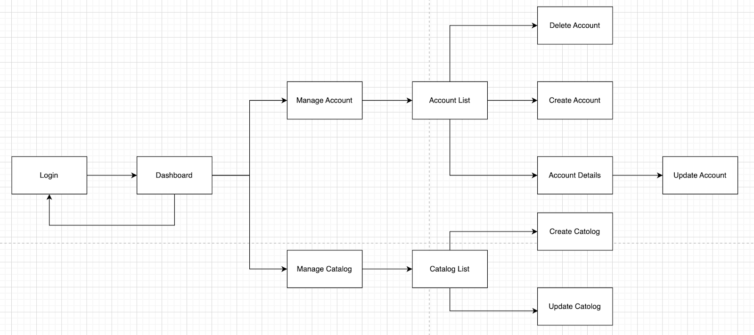

1. <Manager> Web Application Screen Flow

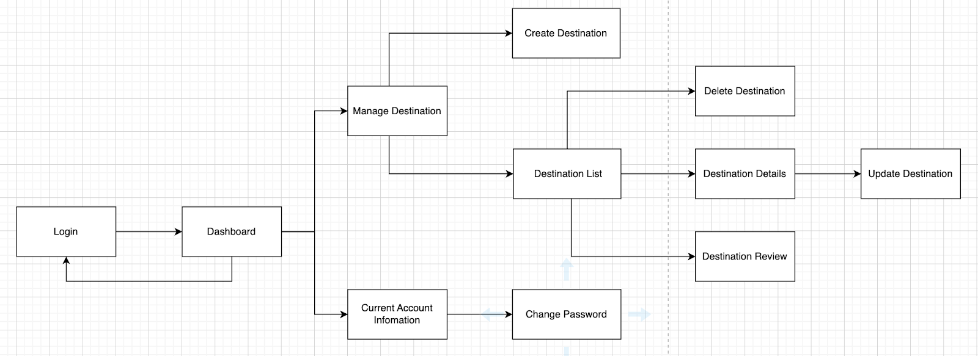

1. **<Supplier> Web Application Screen Flow**

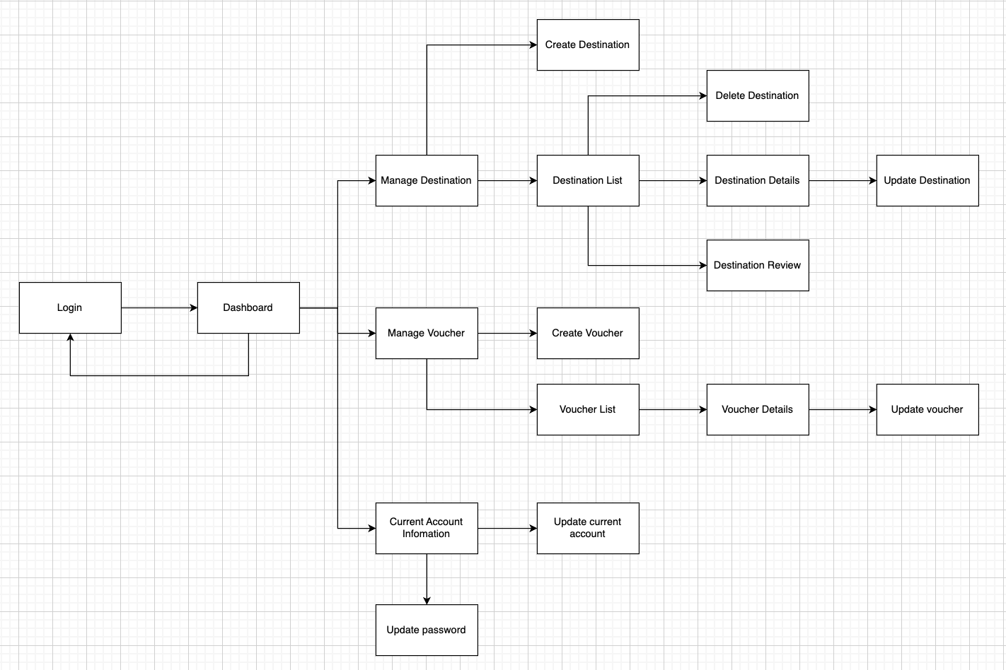

1. **<Traveler> Mobile Application Screen Flow**

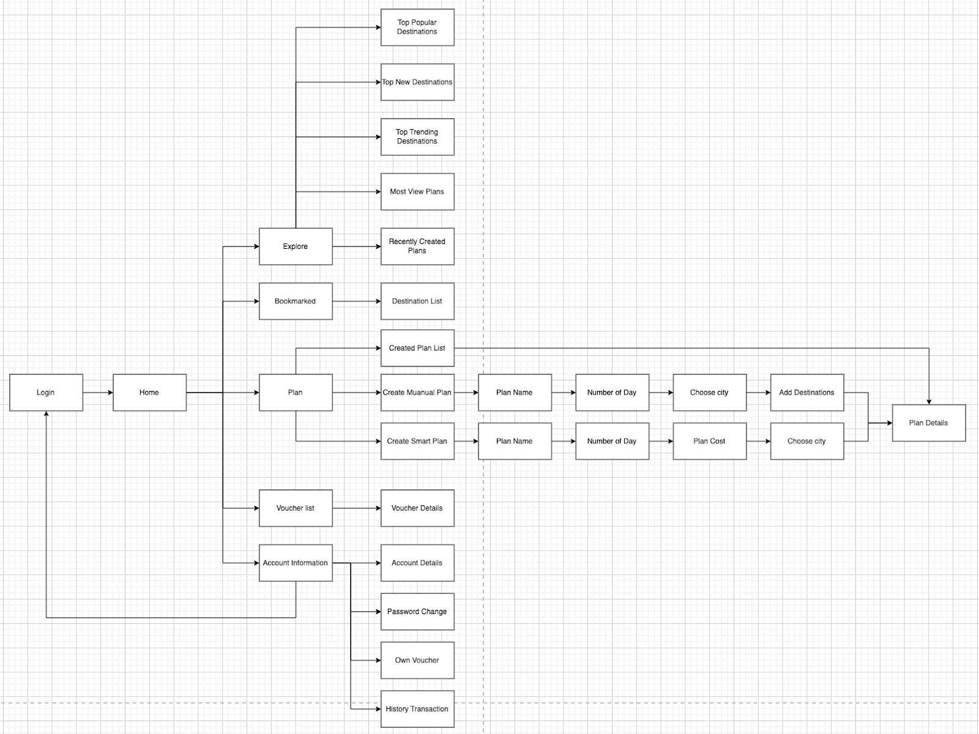

1. **Screen Descriptions**
2. **Web Application Admin Screen Details**

|  |  |  |  |
| --- | --- | --- | --- |
| **#** | **Feature** | **Screen/Popup** | **Description** |
| 1 | Login | Login | Allows users to login with an Sketter account. |
| 2 | View profile | User information | Allow users to view account information. |
| 3 | View account list | Account list | Account list screen allows the users to view the list of accounts |
| 4 | View account details | Popup | Account details popup allows the users to with the detailed information of an account. |
| 5 | Create account | Create account | Create account popup allows the user to create a new account for all role. |
| 6 | Update account | Popup | Update account allows the user to update accounts. |
| 7 | Delete account | Account list | Delete account screen allows the user to disable accounts. |
| 8 | Search account | Account list | Account list screen allows to search account name from list of accounts. |
| 9 | Create catalog | Manage catalog | Manage catalog screen allows users to create a new catalog. |
| 10 | View catalog list | Manage catalog | Manage catalog screen allows users to view list of catalogs. |
| 11 | Enable catalog | Manage catalog | Manage catalog screen allows users to enable a catalog. |
| 12 | Disable catalog | Manage catalog | Manage catalog screen allows users to disable a catalog. |

1. **Web Application Manager Screen Details**

|  |  |  |  |
| --- | --- | --- | --- |
| **#** | **Feature** | **Screen** | **Description** |
| 1 | Login | Login | Allows users to login with an Sketter account. |
| 2 | View profile | User information | Allow users to view account information. |
| 3 | Change password | User information | Allow users to change password of account. |
| 4 | View destination list | Destination list | Destination list screen allows users to view list of destination. |
| 5 | View destination details | Popup | Destination details popup allows users to all detail’s information of a destination. |
| 6 | Create destination | Create destination | Create destination screen allows users to create a new destination. |
| 7 | View destination list | Destination list | Destination list screen allows user to view list of destinations. |
| 8 | Update destination | Popup | Update destination popup allows users to update information detail’s destination. |
| 9 | Delete destination | Destination list | Destination list screen allows user to delete a destination out of the list. |
| 10 | View destination review | Popup | Destination review popup allows users to view rating, reviews of a destination. |

1. **Web Application Supplier Screen Details**

|  |  |  |  |
| --- | --- | --- | --- |
| **#** | **Feature** | **Screen** | **Description** |
| 1 | Login | Login | Allows users to login with an Sketter account. |
| 2 | View profile | User information | Allow users to view account information. |
| 3 | Change password | User information | Allow users to change password of account. |
| 4 | View destination list | Destination list | Destination list screen allows users to view list of destination. |
| 5 | View destination details | Popup | Destination details popup allows users to all detail’s information of a destination. |
| 6 | Create destination | Create destination | Create destination screen allows users to create a new destination. |
| 7 | View destination list | Destination list | Destination list screen allows user to view list of destinations. |
| 8 | Update destination | Popup | Update destination popup allows users to update information detail’s destination. |
| 9 | Delete destination | Destination list | Destination list screen allows user to delete a destination out of the list. |
| 10 | View destination review | Popup | Destination review popup allows users to view rating, reviews of a destination. |
| 11 | Create draft voucher | Create voucher | Create voucher screen allows users to create vouchers. |
| 12 | Active voucher | Popup | Active voucher popup allows users to active voucher from unactuated to activated. |
| 13 | Stop voucher | Popup | Active voucher popup allows users to active voucher from activated to stop. |
| 14 | Search voucher | Voucher list | Voucher list screen allows users to search voucher name. |
| 15 | View voucher list | Voucher list | Voucher list screen allows users to view list of vouchers. |
| 16 | View voucher information | Popup | Voucher popup screen allows users to view information detail’s voucher. |
| 17 | View voucher code list | Voucher list | Voucher list screen allows users to view list of used voucher details. |
| 18 | Update voucher | Popup | Voucher popup screen allows users to view information detail’s voucher. |
| 19 | Duplicate voucher | Voucher list | Voucher list screen allows users to duplicate voucher. |
| 20 | Delete voucher | Voucher list | Voucher list screen allows users to delete voucher. |

1. **Mobile Application Traveler Screen Details**

|  |  |  |  |
| --- | --- | --- | --- |
| **#** | **Feature** | **Screen/Popup** | **Description** |
| 1 | Login | Sign in | Sign in screen allows users to login with Sketter account. |
| 2 | Register | Sign up | Sign up screen allows users to register new account. |
| 3 | Verify email | Verify email | Verify email screen allows users to verify account. |
| 4 | Update profile | Profile details | Profile details screen allows users to update personal profile. |
| 5 | View profile | Profile details | Profile details screen allows users to view personal profile. |
| 6 | Change password | Change password | Change password screen allows users to change password. |
| 7 | Forgot password | Forgot password | Forgot password allows users to recover password. |
| 8 | Logout | Account | Account screen allows users to logout. |
| 9 | View bookmarked list | Collection | Collection screen allows users to view bookmarked list. |
| 10 | Add bookmark | Destination details | Destinaton details screen allows users to bookmark destination. |
| 11 | Delete bookmark | Destination details | Destinaton details screen allows users to delete bookmarked destination. |
| 12 | Review destination | Destination details | Destinaton details screen allows users to review destination. |
| 13 | Delete destination review | Destination details | Destinaton details screen allows users to delete destination’s review. |
| 14 | View most viewed destinations | Explore | Explore screen allows users to view most viewed destinations. |
| 15 | View newest destinations | Explore | Explore screen allows users to view newest destinations. |
| 16 | View trending destinations | Explore | Explore screen allows users to view trending destinations. |
| 17 | View recently created plans | Explore | Explore screen allows users to view recently created plans. |
| 18 | View most viewed plans | Explore | Explore screen allows users to view most viewed plans. |
| 19 | Duplicate plan | Plan details | Plan details screen allows users to duplicate plan. |
| 20 | Create manual plan | Plan | Plan screen allows users to create manual plan. |
| 21 | Create smart plan | Plan | Plan screen allows users to create smart plan. |
| 22 | Update plan | Plan details | Plan details screen allows users to update plan. |
| 23 | Delete Plan | Plan details | Plan details screen allows users to detele plan. |
| 24 | View suggested smart plans | Smart plan list | Smart plan list screen allows users to view suggested smart plans. |
| 25 | View plan details | Plan details | Plan details screen allows users to view plan details. |
| 26 | Save smart plan | Plan details | Plan details screen allows users to save smart plan. |
| 27 | View personal plans | Created plan list | Created plan list screen allows users to view personal plans. |
| 28 | Recommend destinations | popup | Recommend destination allows users to recommend destinations. |
| 29 | Complete draft plan | Plan details | Plan details screen allows users to complete draft plan. |
| 30 | Check in | Plan details | Plan details screen allows users to check in destination. |
| 31 | Buy voucher | Voucher details | Voucher details screen allows users to buy voucher. |
| 32 | Use voucher | Voucher details | Voucher details screen allows users to use voucher. |
| 33 | Complete plan | Plan details | Plan details screen allows users to complete plan. |
| 34 | View own voucher | Privated voucher | Privated voucher screen allows users to view own voucher. |
| 35 | View payment history | History transaction | History transaction screen allows users to view payment history. |
| 26 | View destination vouchers | Voucher list | Voucher list screen allows users to view all vouchers of a destination. |

1. **Screen Authorization**
2. **Web Application Screen Authorization**

|  |  |  |  |
| --- | --- | --- | --- |
| **Screen** | **Admin** | **Manager** | **Supplier** |
| Login | x |  |  |
| Dashboard | x | x | x |  |  |  |
| User Information | x | x | x |
| Account list | x |  |  |
| Create account | x |  |  |
| Manage catalog | x |  |  |
| Destination list |  | x | x |
| Create destination |  | x | x |
| Create voucher |  | x |  |
| Voucher list |  | x |  |

1. **Mobile Application Screen Authorization**

|  |  |
| --- | --- |
| **Screen** | **Traveler** |
| Sign in | X |
| Sign up | X |
| Verify code | X |
| Explore page | X |
| Destination list | X |
| Destination detail | X |
| Public Plan list | X |
| Created Plan list | X |
| Plan detail | X |
| Collection page | X |
| Plan page | X |
| Personal plan list | X |
| Personal plan detail | X |
| Manual plan page | X |
| Plan name | X |
| Plan duration | X |
| Plan city | X |
| Plan stay | X |
| Plan destination | X |
| Plan timeline | X |
| Smart plan list | X |
| Plan cost | X |
| Plan personality | X |
| Voucher list | X |
| Voucher detail | X |
| Account page | X |
| Personal information | X |
| Change password | X |
| Private voucher list | X |
| History transaction | X |

1. **Non-Screen Functions**
2. **Entity Relationship Diagram**
3. **Concept Entity Relationship Diagram**

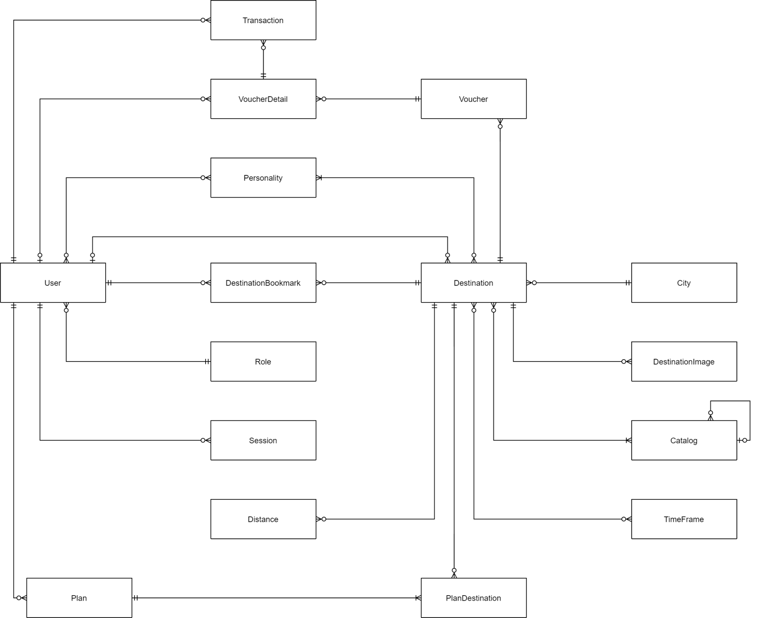

**Entity Description**

|  |  |  |
| --- | --- | --- |
| **#** | Entity | Description |
| 1 | User | Describe all user in system |
| 2 | Transaction | Describe voucher transaction |
| 3 | Voucher | Describe all voucher in system |
| 4 | VoucherDetail | Describe traveler owned voucher |
| 5 | Personality | Describe all personalities in system |
| 6 | Destination | Describe all destination in system |
| 7 | DestinationBookmark | Describe bookmarked destination of traveler |
| 8 | Role | Describe all role in system |
| 9 | Session | Describe session of user in system |
| 10 | Distance | Describe distance between destination in system |
| 11 | Plan | Describe all plan in system |
| 12 | PlanDestination | Describe all destination in plan |
| 13 | City | Describe all city in system |
| 14 | DestinationImage | Describe all images that destination have |
| 15 | Catalog | Describe all type of destination catalog in system |
| 16 | TimeFrame | Describe all time frame in system |

1. **Logic Entity Relationship Diagram**

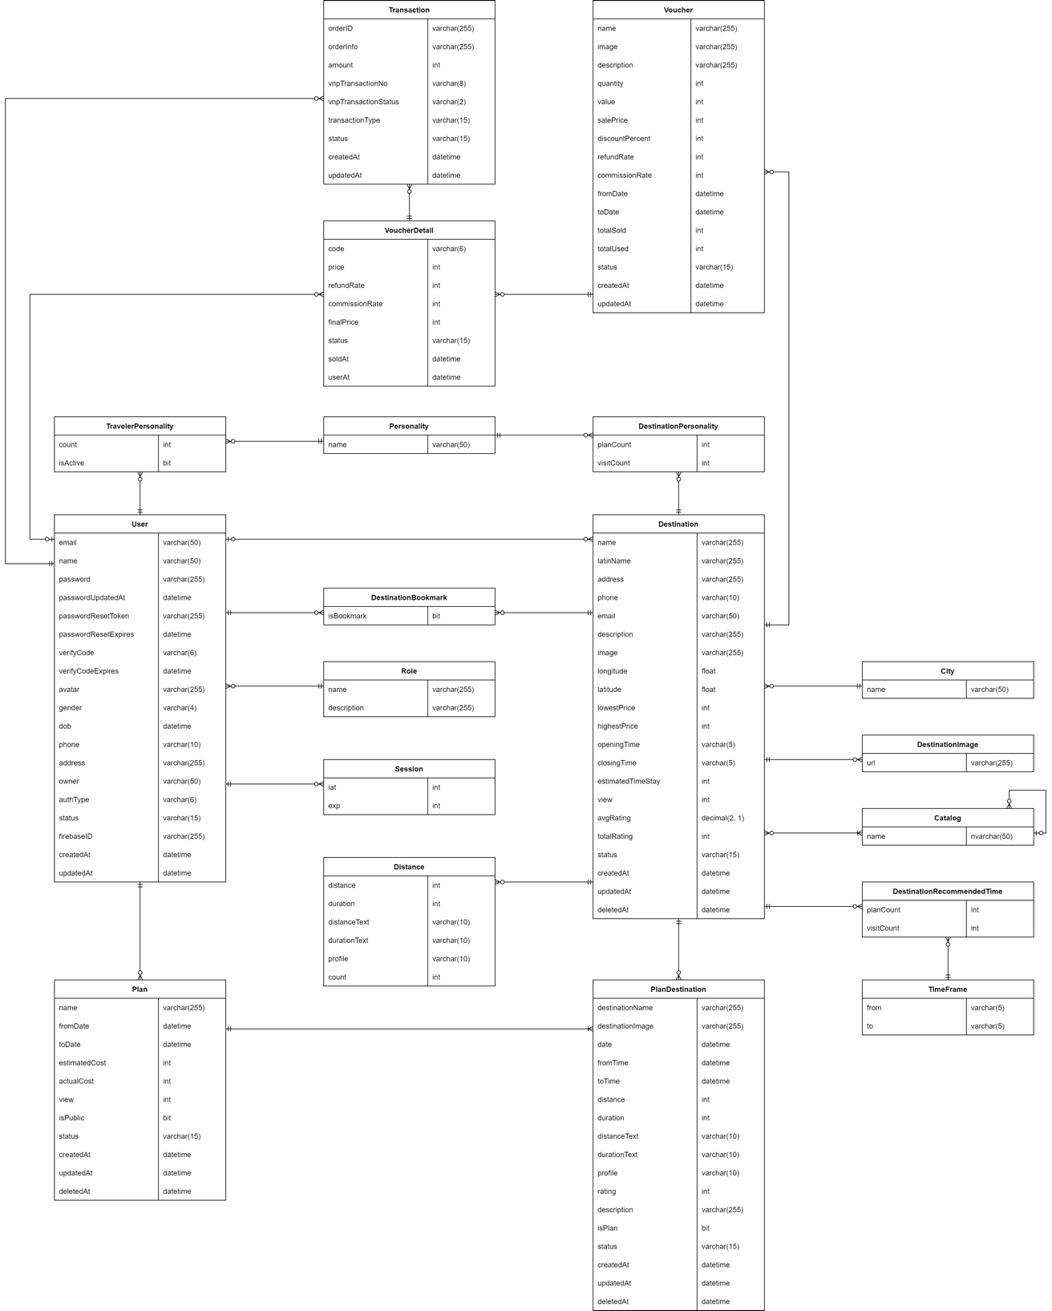

|  |  |  |
| --- | --- | --- |
| Entity Name | Attribute | Description |
| User | email | Registered email |
| name | Name of user |
| password | Account’s password |
| passwordUpdatedAt | Time when user update password |
| passwordResetToken | Token to update password |
| passwordResetExpires | Time when token to update password expires |
| verifyCode | Activated code of user |
| verifyCodeExpires | Time when activated code of user expires |
| avatar | Avatar of user |
| gender | Gender of user |
| dob | Date of birth of user |
| phone | Phone number of user |
| address | Address of user |
| owner | Name of owner (if role is supplier) |
| authType | Type of authentication |
| status | Status of user’s account |
| firebaseID | The firebase’s identifier |
| createdAt | Time when the user’s account is created |
| updateAt | Time when the user’s account is updated |
| Plan | name | Name of plan |
| fromDate | The begin date of plan |
| toDate | The end date of plan |
| estimatedCost | Estimated cost of whole plan |
| actualCost | Actual cost of whole plan |
| view | View of plan |
| isPublic | Status of public plan |
| status | Status of plan |
| createdAt | Time when the plan is created |
| updatedAt | Time when the plan is updated |
| deletedAt | Time when the plan is deleted |
| Destination | name | Name of destination |
| latinName | None tonal symbols name |
| address | Address of destination |
| phone | Phone of destination |
| email | Email of destination |
| description | Description of destination |
| image | Image of destination |
| longitude | Coordinate (longitude) of destination |
| latitude | Coordinate (latitude) of destination |
| lowestPrice | Minimum price of destination |
| highestPrice | Maximum price of destination |
| openingTime | Time when destination open |
| closingTime | Time when destination close |
| estimatedTimeStay | Average time when staying at destination |
| view | User view number of destination |
| avgRating | Average rating of destination |
| totalRating | Total rating of destination |
| status | Status of destination |
| createdAt | Time when the destination is created |
| updatedAt | Time when the destination is updated |
| deletedAt | Time when the destination is deleted |
| PlanDestination | destinationName | Name of destination |
| destinationImage | Image of destination |
| date | Date of destination |
| fromTime | Begin traveling time of destination |
| toTime | End traveling time of destination |
| distance | Distance from previous destination |
| duration | Duration from previous destination |
| ditanceText | Distance as text |
| durationText | Duration as text |
| profile | Type of transport |
| rating | Number of stars rated |
| description | Description of destination |
| isPlan | Status of plan |
| status | Status of destination |
| createAt | Time when the destination in plan is created |
| updatedAt | Time when the destination in plan is updated |
| deletedAt | Time when the destination in plan is deleted |
| TravelerPersonality | count | Number of traveler Personality |
| isActive | Status of active personality |
| DestinationPersonality | planCount | Number of users have the same personality with destination that add to their plan |
| visitCount | Number of users have checked in destination |
| Personality | name | Name of personality |
| DestinationBookmark | isBookmark | Status of bookmarked destination |
| Role | name | Name of role |
| description | Description of role |
| Session | iat | Login time |
| exp | Expired time |
| Distance | distance | Distance to destination |
| duration | Time traveling to destination |
| distanceText | Distance to destination as text |
| durationText | Time traveling to destination as text |
| profile | Type of transport |
| count | Number of pair distiance |
| City | name | Name of city |
| Destinationmage | url | Url of gallery |
| Catalog | name | Name of catalog |
| Destination RecommendedTime | planCount | Number of users have the same personality with destination that add to their plan |
|  | visitCount | Number of users have checked in destination |
| TimeFrame | from | Time frame start from |
|  | to | Time frame start to |
| Voucher | name | Name of voucher |
| image | Image of voucher |
| description | description of voucher |
| quantity | Quantity of voucher |
| value | Value of voucher |
| salePrice | Sale price of voucher |
| discountPercent | Discount percent of voucher |
| commissionRate | Commission rate of voucher |
| fromDate | Start date of voucher |
| toDate | End date of voucher |
| totalSold | Number of sold voucher |
| totalUsed | Number of vouchers used |
| status | Status of voucher |
| createdAt | Time when the voucher is created |
| updatedAt | Time when the voucher is updated |
| Transaction | orderID | Identifier of order |
| orderInfo | Information of order |
| amount | Amount of order |
| vnpTransactionNo | Number of VNP transaction |
| vnpTransactionStatus | Status of VNP transaction |
| transactionType | Type of transaction |
| status | Status of transaction |
| createdAt | Time when the transaction is created |
| updatedAt | Time when the transaction is updated |
| VoucherDetail | code | Code of voucher |
| price | Price of voucher |
| refundRate | Refund rate of voucher |
| commisstionRate | Commission rate of voucher |
| finalPrice | Final price of voucher |
| status | status of voucher |
| soldAt | Time when the voucher is sold |
| usedAt | Time when the voucher is used |

1. **Manage destination**
2. **View destination list**

### Function trigger: Manager sends request to view list of destination by click on “Danh Sách Địa Điểm” sidebar.

### Function description: This function allows manager to view list of destinations.

### **Screen layout:**

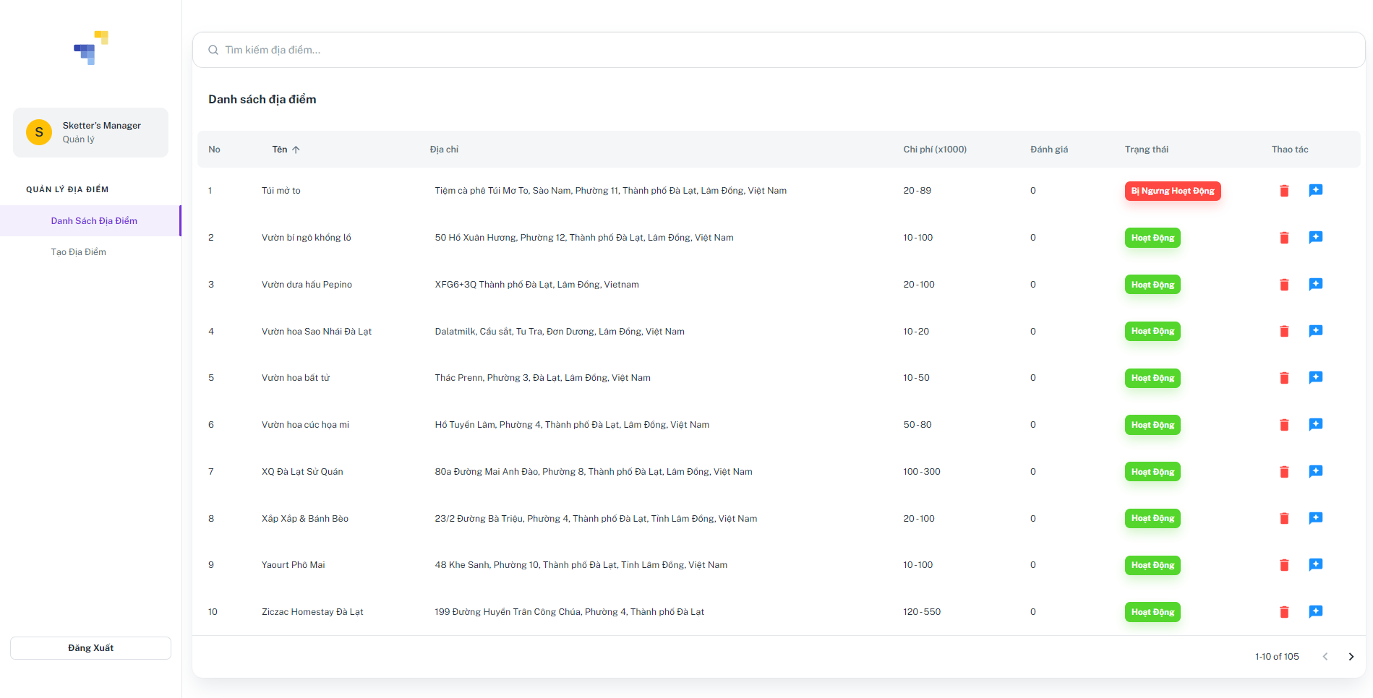

### **Function details:**

* Manager click on the “Danh sách địa điểm” sidebar.
* Sketter shows list of destinations, including information:
* Tên: Text
* Địa chỉ: Text
* Chi phí: Number
* Đánh giá: Number
* Trạng thái: Button
* Thao tác:
* Xoá “”: Icon button
* Xem đánh giá “”: Icon button.

1. **Create destination**

### **Function trigger**: Manager sends request to create destination by click on “Tạo địa điểm” sidebar.

### **Function description:** This function allows manager to create a new destination.

### **Screen layout:**

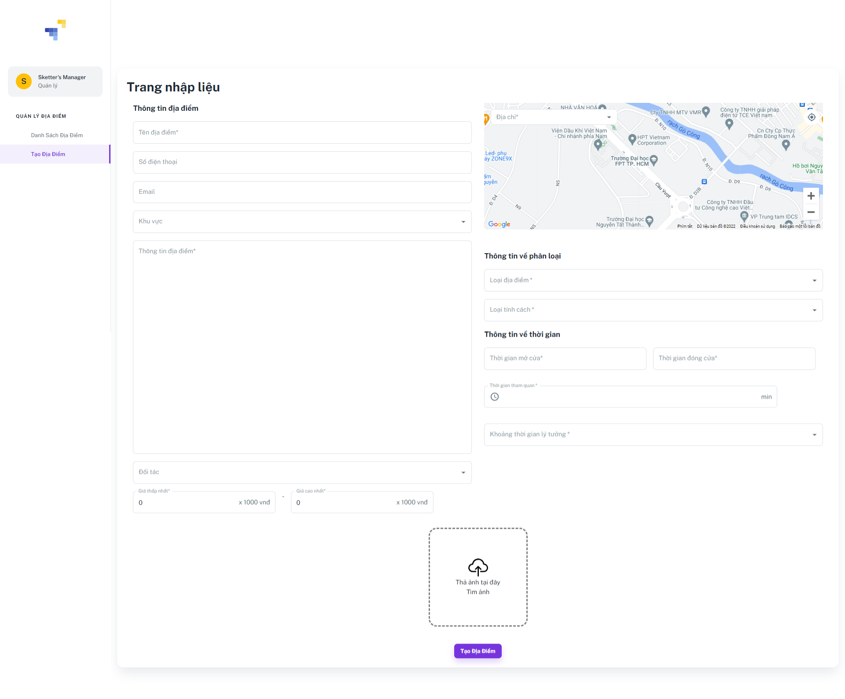

### **Function details:**

* Manager clicks on the “Tạo địa điểm” on the left sidebar.
* Sketter shows a popup, including:
* Tên địa điểm: Text input
* Số điện thoại: Text input
* Email: Text input
* Khu vực: Dropdown box
* Thông tin địa điểm: Text input
* Đối tác: Dropdown box
* Giá thấp nhất: Number input
* Giá cao nhất: Number input
* Map: Text input
* Loại địa điểm: Multiple choice dropdown box
* Loại tính cách: Multiple choice dropdown box
* Thời gian mở cửa: Time picker
* Thời gian đóng cửa: Time picker
* Khoảng thời gian lý tưởng: Multiple choice dropdown box
* Ảnh: Image.
* Manager inputs information and clicks on the “Tạo tài khoản” button.
* Sketter creates new destination and shows MSG00.

1. **View destination list**

### **Function trigger**: Manager sends request to view list of destinations.

### **Function description**: This function allows manager to view list of destinations.

### **Screen layout:**



### **Function details:**

* Manger double clicks on “Danh Sách Đia Điểm”.

### Sketter shows the list of destination**s.**

1. **Update destination**

### **Function trigger**: Manager sends request to update destination.

### **Function description**: This function allows manager to update destination.

### **Screen layout:**

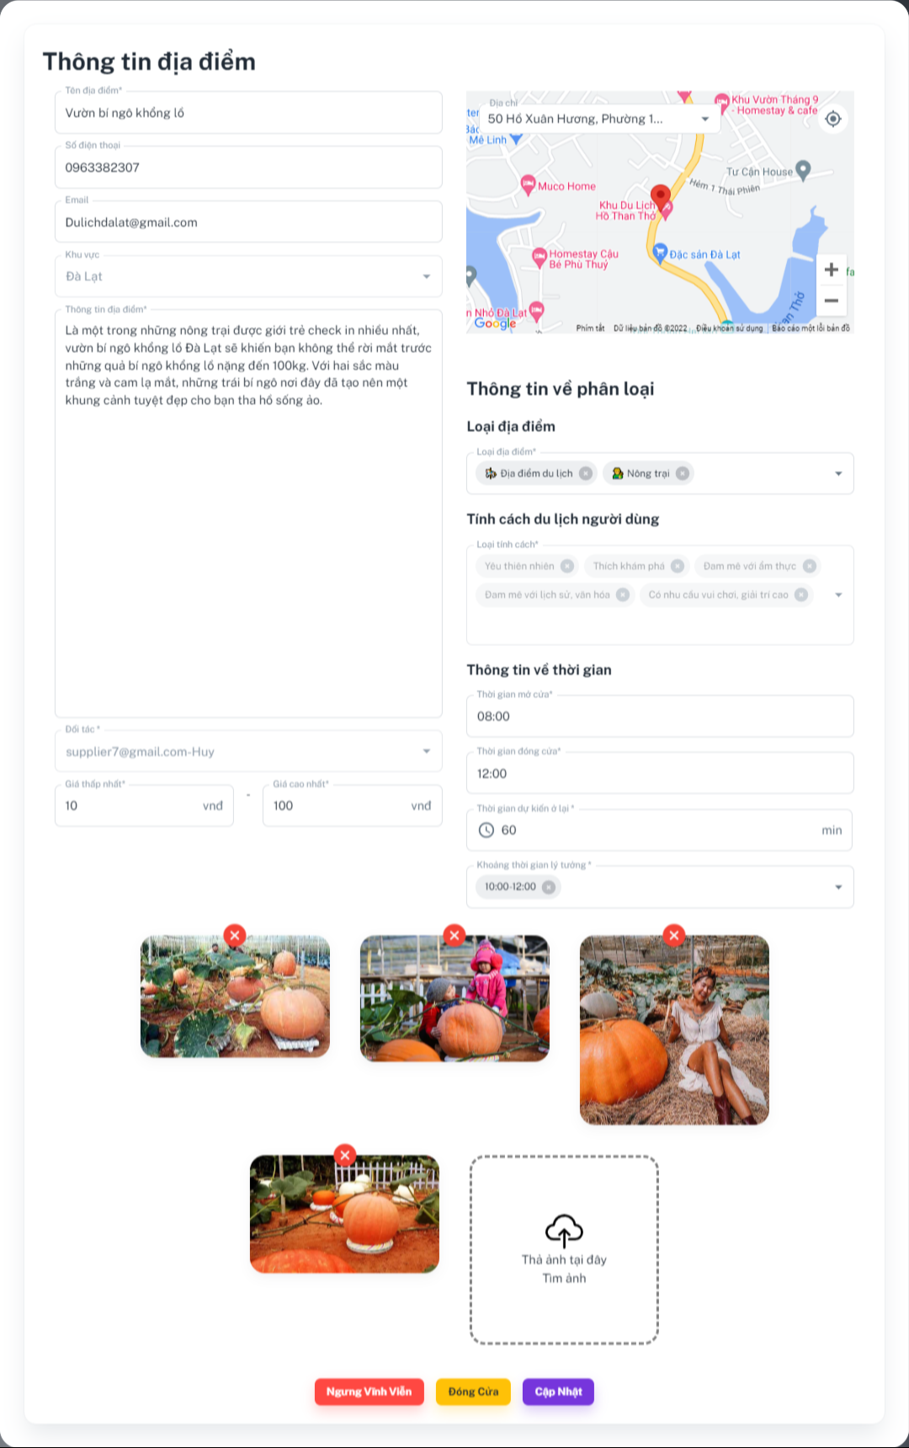

### **Function details:**

* The manager double clicks on the table row
* Sketter shows destination information, including:
* Tên địa điểm: Text input
* Số điện thoại: Text input
* Email: Text input
* Khu vực: Dropdown box
* Thông tin địa điểm: Text input
* Đối tác: Dropdown box
* Giá thấp nhất: Number input
* Giá cao nhất: Number input
* Map: Text input
* Loại địa điểm: Multiple choice dropdown box
* Loại tính cách: Multiple choice dropdown box
* Thời gian mở cửa: Time picker
* Thời gian đóng cửa: Time picker
* Khoảng thời gian lý tưởng: Multiple choice dropdown box
* Ảnh: Image.
* Manager inputs information and clicks on the “Cập nhật” button.

### Sketter updatesdestination and shows MSG00.

1. **Delete destination**

### **Function trigger**: ***Manager*** sends request to delete destination.

### **Function description**: This function allows manager to delete destination.

### **Screen layout:**

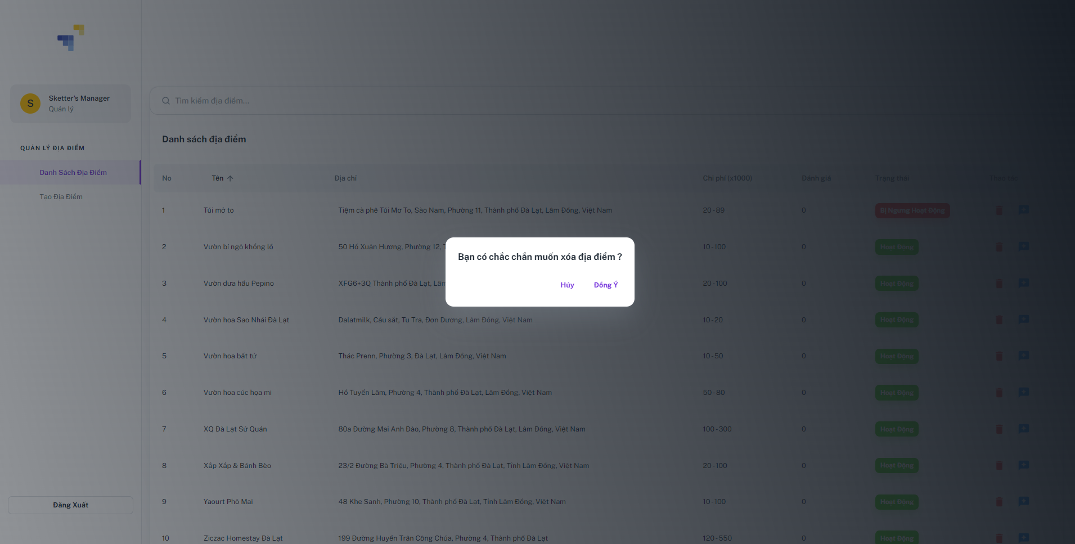

### **Function details:**

* The manager clicks on the “” icon button.
* Sketter shows a confirmation dialog with message “Bạn có chắc chắn muốn xoá địa điểm này?” with two buttons.
* Huỷ: Button
* Đồng ý: Button.
* Manager clicks on the “Đồng ý” button.

### Sketter validates the resolving content:

### Success: Sketter changes the destination “status” from True to False and shows the success message and reload destination list.

* Fail: Sketter returns and shows error message. (MSG)

1. **View destination review**

### **Function trigger**: Manager sends request to view destination review.

### **Function description**: This function allows manager to view destination review.

### **Screen layout:**

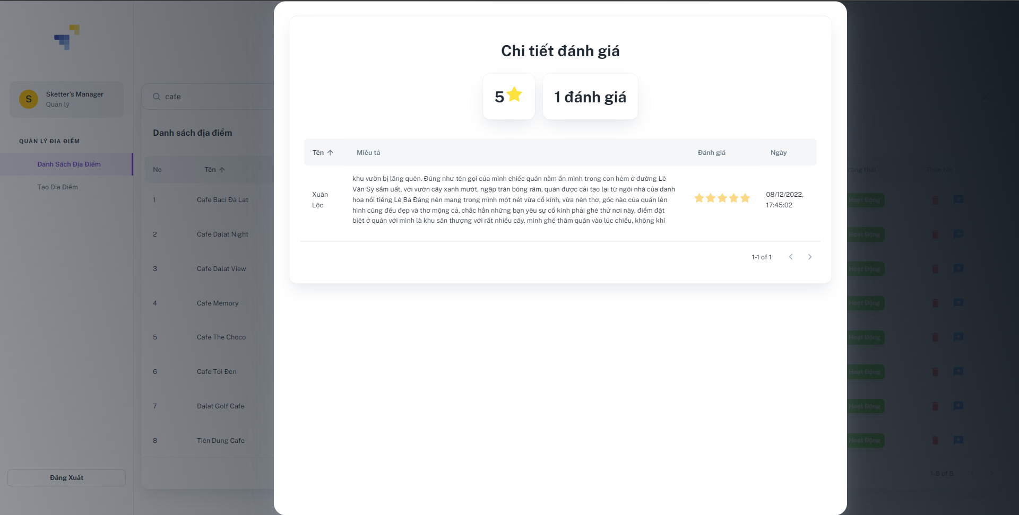

### **Function details:**

* Manager click on the “Đánh giá” icon button of a destination on a row.
* Sketter shows destination reviews including information:

### Trung bình tổng đánh giá: Number star icon

### Số lượt đánh giá: Text

* Tên: Text
* Miêu tả: Text
* Đánh giá: Icon
* Ngày: Date

1. **Planning**
2. **Create manual plan**

### **Function trigger**: Traveler send requests to create manual for plan.

### **Function description**: This function allows travelers to create manual for plan.

### **Screen layout:**

### **Function details:**

### Traveler input name, duration time, city for plan, choose stay destination, choose list of destination for each day and clicks on “Tiếp tục” button. Information including:

### Tên lịch trình: Text

### Lịch tháng: Date picker

### Thành phố: Button

### Chọn nơi lưu trú: Button

### Chọn địa điểm du lịch: Button

### Trở lại: Button

### Tiếp tục: Button

* Sketter validates the resolving content:
* Success: Sketter save all information to draft plan and then go to plan timeline screen.
* Fail: Sketter returns and shows error message. (MSG00)

1. **Update plan**
2. **View manual plan timeline**

### **Function trigger**: Traveler send requests to view plan timeline.

### **Function description**: This function allows traveler to view plan timeline.

### **Screen layout:**

### **Function details:**

### Traveler clicks on “Tiếp tục” button.

### Sketter shows a plan details, including information:

### Tổng chi phí: Number

### Số ngày du lịch: List button

### Nơi lưu trú: Text button

### Lich trình chuyến đi: Timeline

### Thời gian di chuyển giữa 2 điểm: Number

### Khoảng cách di chuyển giữa 2 điểm: Number

### Thời gian đi: Number

### Thời gian đến: Number

### Khuyến mãi: Icon

### Địa điểm du lịch: Text button

### Ảnh: Image

### Thao tác

### Trở lại: Button

### Tiếp tục: Button

### Lưu vào nháp: Button

* Lưu vào kế hoạch: Button

1. **Change stay destination**

### **Function trigger**: Traveler send requests to change stay destination.

### **Function description**: This function allows traveler to change stay destination.

### **Screen layout:**

### **Function details:**

### Traveler tap on stay destination.

### Sketter shows a popup with list stay destinations.

### Traveler tap on a destination to view more details and tap “Chọn” button.

### Sketter replace destination for plan and reload the screen.

1. **Change traveling time**

### **Function trigger**: Traveler send requests to change traveling time.

### **Function description**: This function allows traveler to change traveling time.

### **Screen layout:**

### **Function details:**

* Traveler tap on “” icon button.

### Sketter shows a popup with range time picker.

### Traveler choose fromTime, toTime and tap “Tiếp tục” button.

### Sketter update spending time at a destination of plan and reload the screen.

1. **Change destination**

### **Function trigger**: Traveler send requests to change a destination.

### **Function description**: This function allows traveler to change a destination.

### **Screen layout:**

### **Function details:**

* Traveler tap on “Thay đổi” button.

### Sketter shows a popup with list of destinations.

### Traveler tap on a destination to view more details and tap “Chọn” button.

### Sketter update new stay destination for plan and reload the screen.

1. **Delete destination**

### **Function trigger**: Traveler send requests to change a destination.

### **Function description**: This function allows traveler to change a destination.

### **Screen layout:**

### **Function details:**

* Traveler tap on “Xoá” button.

### Sketter shows a popup confirm, including information:

### Bạn đang xoá địa điểm khỏi lịch trình. Vui lòng bấm “Xác nhận” để tiếp tục : Text

### Thao tác:

### Huỷ: Button

### Xác nhận: Button

### Traveler tap on “Xác nhận” button.

### Sketter delete selected destination out of plan timeline and reload the screen.

1. **Delete plan**

### **Function trigger**: Traveler send requests to delete plan.

### **Function description**: This function allows travelers to delete plan.

### **Screen layout:**

### **Function details:**

* Traveler clicks on the “” icon button.
* Sketter shows a small popup with 2 buttons:
* Thao tác:
* Xoá: Button
* Traveler clicks on the “Xoá” button.
* Sketter show a popup dialog including information:
* Bạn có muốn xoá lịch trình này: Text
* Thao tác:
* Không: Button
* Có: Button
* Supplier clicks on the “Có” button.

Sketter change plan status from “True” to “False” and shows messages MSG00

1. **Recommend destinations**

### **Function trigger**: Traveler send requests to recommend destinations.

### **Function description**: Traveler send requests to recommend destinations.

### **Screen layout:**

### **Function details:**

* Traveler clicks on the “” icon button.
* Sketter shows a small popup with a list of destinations.
* Traveler clicks on one destination in list destinations.
* Sketter shows a screen with destination information.
* Thao tác:
* Chọn: Button
* Traveler clicks on the “Chọn” button.
* Sketter change the old destination to new destination.

1. **View plan details**

### **Function trigger**: Traveler send requests to view plan.

### **Function description**: This function allows traveler to view plan.

### **Screen layout:**

### 

### **Function details:**

### Sketter shows a plan details, including information:

### Tổng chi phí: Number

### Số ngày du lịch: List button

### Nơi lưu trú: Text button

### Lich trình chuyến đi: Timeline

### Thời gian di chuyển giữa 2 điểm: Number

### Khoảng cách di chuyển giữa 2 điểm: Number

### Thời gian đi: Number

### Thời gian đến: Number

### Khuyến mãi: Icon

### Địa điểm du lịch: Text button

### Ảnh: Image

### Thao tác

### Trở lại: Button

### Tiếp tục: Button

### Lưu vào nháp: Button

* Lưu vào kế hoạch: Button

1. **Create smart plan**

### **Function trigger**: Traveler send requests to create smart plan.

### **Function description**: This function allows traveler to create smart plan.

### **Screen layout:**

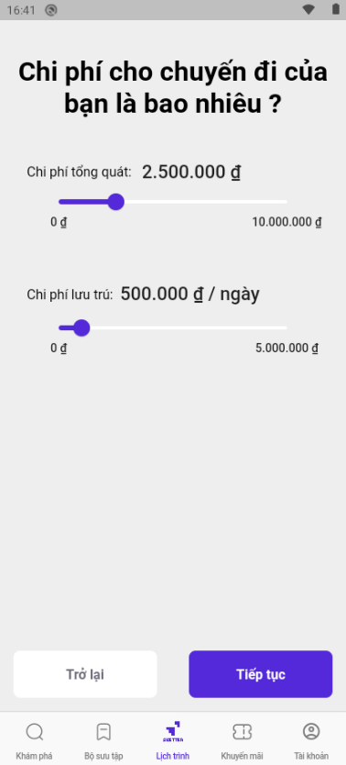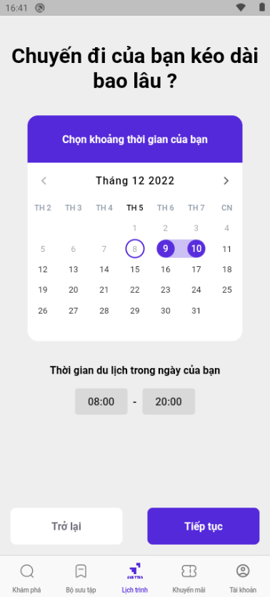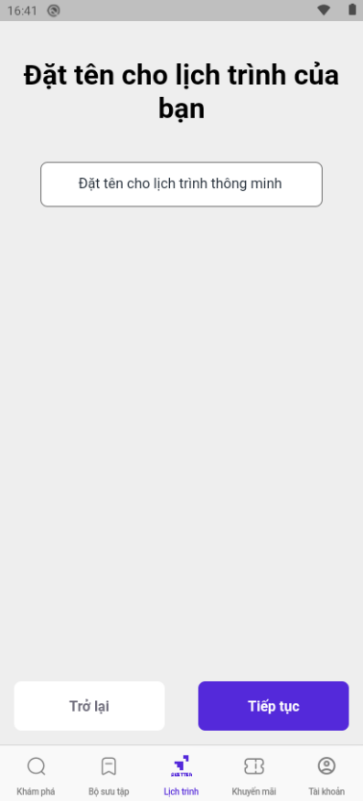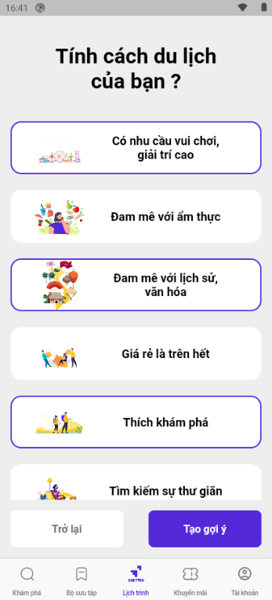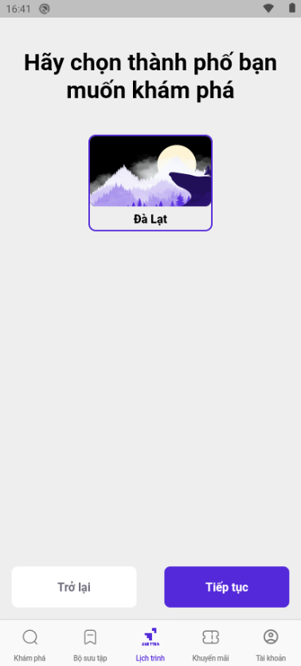

### **Function details:**

### Traveler input name, duration time, plan cost, city for plan, choose personality type and clicks on “Tạo gợi ý” button. Information including:

### Tên lịch trình: Text

### Số ngày du lịch: Date picker

### Thời gian bắt đầu : Time picker

### Thời gian kết thúc: Time picker

### Chi phí tổng quát: SfSlider

### Chi phí lưu trú: SfSlider

### Thành phố: Button

### Tính cách du lịch: Button

### Trở lại: Button

### Tiếp tục: Button

* Sketter validates the resolving content:
* Success: Sketter generates a list of smart plans.
* Fail: Sketter returns and shows error message. (MSG00)

1. **View suggested smart plans**

### **Function trigger**: Traveler send requests to view suggested smart plans.

### **Function description**: This function allows traveler to view list suggested smart plans.

### **Screen layout:**

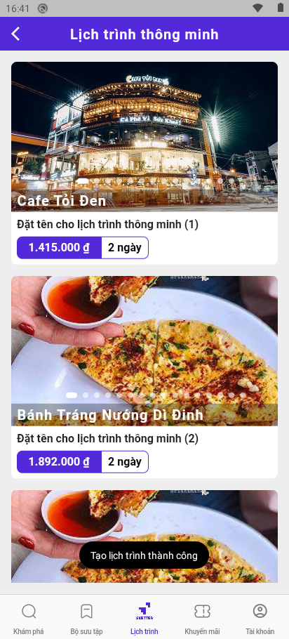

### **Function details:**

### Sketter shows a list of smart plans, including information:

### Tên: Text

### Chi phí ước tính: Number

### Số ngày du lịch: Number

### Ảnh: Image Slider

1. **Save plan**

### **Function trigger**: Traveler send requests to save plan.

### **Function description**: This function allows traveler to save plan.

### **Screen layout:**

### 

### **Function details:**

* Traveler tap on “Cập nhật” button.
* Sketter save all information from plan timeline into plan which status is “Draft” and then show a popup message “Lưu thành công”.

1. **View personal plans**

### **Function trigger**: Traveler send requests to view personal plans.

### **Function description**: This function allows traveler to view personal plans.

### **Screen layout:**

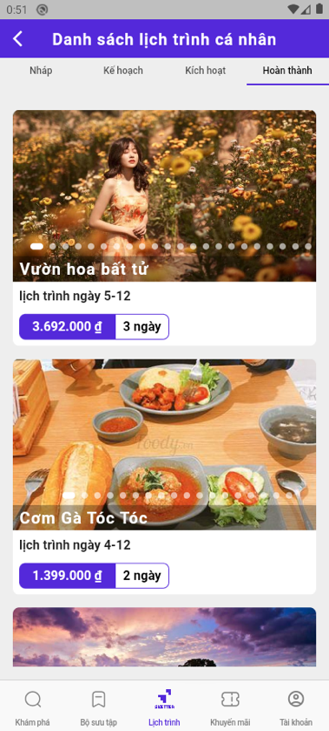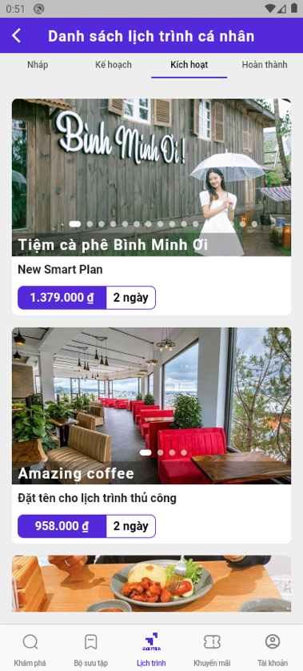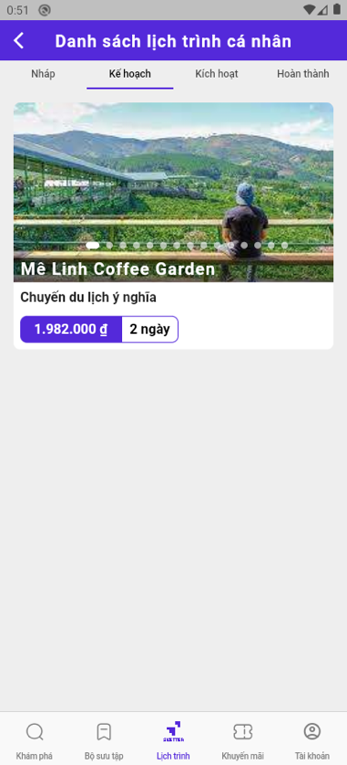

### **Function details:**

* Traveler tap on “Lịch trình của bạn” button.
* Sketter shows 4 tabs with 4 types of plans.

1. **Complete draft plan**

### **Function trigger**: Traveler send requests to complete draft plan.

### **Function description**: This function allows traveler to complete draft plan.

### **Screen layout:**

### **Function details:**

* Traveler clicks on “Hoàn tất” button.
* Sketter save all information from plan timeline into plan which status is “Planned” and then show a popup message “Cùng bắt đầu chuyến đi”.

1. **Check in**

### **Function trigger**: Traveler send requests to check in destination.

### **Function description**: This function allows traveler to check in destination.

### **Screen layout:**

### **Function details:**

* Traveler tap on “Check in” button.
* Sketter show a rating popup, including information:
  + Bạn cảm thấy địa điểm này như thế nào: Text
  + Rating star: Rating bar
  + Đánh giá địa điểm: Text input
  + Gừi: Button

* Traveler tap on “Gửi” button.
* Sketter update destination’s status in plan to “Checkin” with rating information.

1. **Complete plan**

### **Function trigger**: Traveler send requests to

### **Function description**: This function allows traveler to

### **Screen layout:**

### **Function details:**

* Traveler tap on “Có” button.
* Sketter update plan and change plan’s status from “Activated” to “Completed”, and show success message.

1. **Voucher management**
2. **Create draft voucher**

### **Function trigger**: Supplier send requests to create draft voucher.

### **Function description**: This function allows traveler to create draft voucher.

### **Screen layout:**

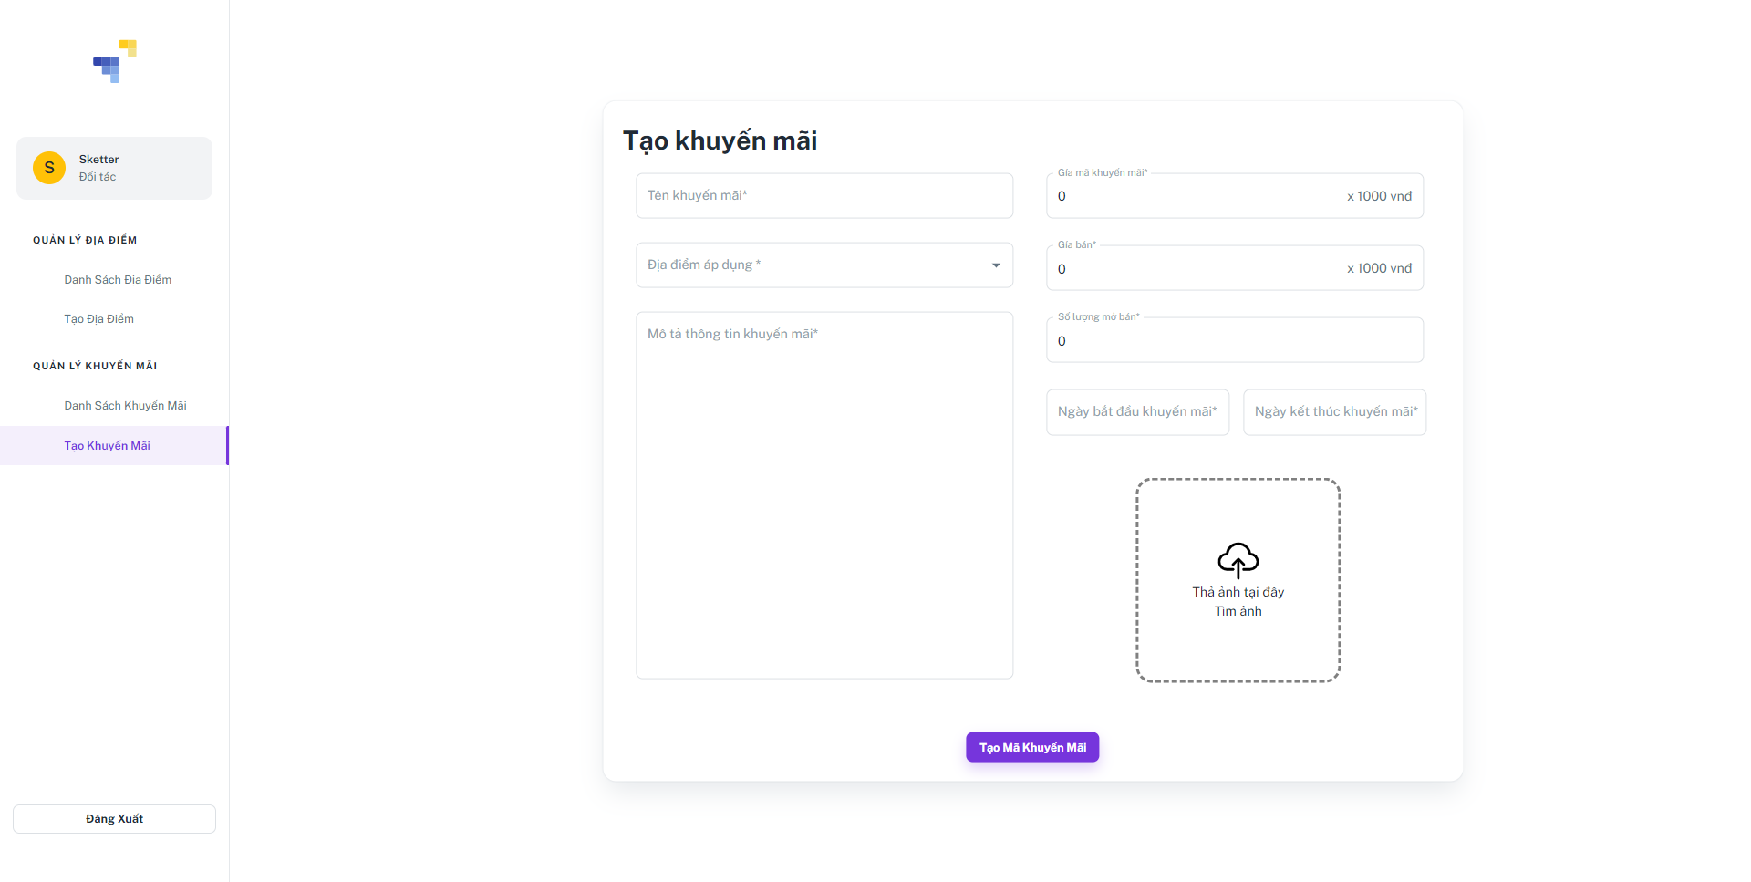

### **Function details:**

* Supplier clicks on the “Tạo khuyến mãi” tab on the left sidebar.
* Sketter shows a popup screen including information:
* Tên khuyến mãi; Text input
* Địa điểm áp dụng: Text input
* Mô tả thông tin khuyến mãi: Text input
* Giá mã khuyến mãi: Number input
* Giá bán: Number input
* Số lương mở bán: Number input
* Ngày bắt đầu khuyến mãi: Datetime picker
* Ngày kết thúc khuyến mãi: Datetime picker
* Ảnh: Image
* Thao thác:
  + Tạo: Button
* Supplier clicks on the “Tạo mã khuyến mãi” button

### Sketter creates a new voucher and shows messages MSG00

1. **Active voucher**

### **Function trigger**: Supplier send requests to active voucher.

### **Function description**: This function allows traveler to active voucher.

### **Screen layout:**

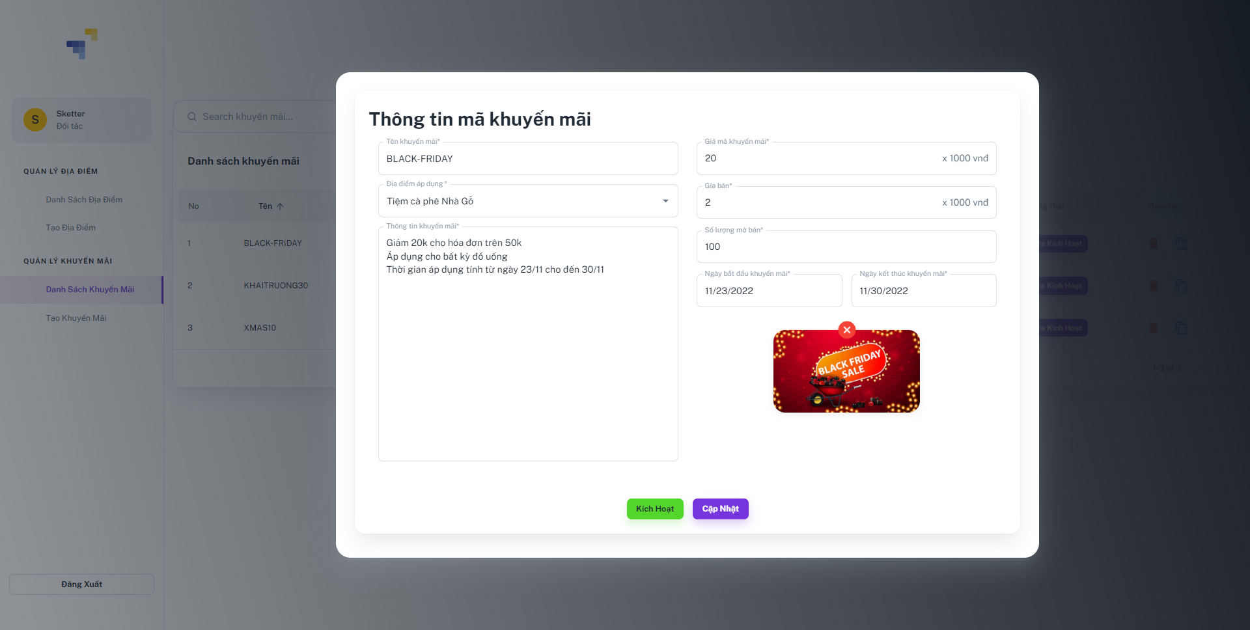

### **Function details:**

* Supplier double clicks on voucher.
* Sketter shows a popup screen including information:
* Tên khuyến mãi; Text input
* Địa điểm áp dụng: Text input
* Mô tả thông tin khuyến mãi: Text input
* Giá mã khuyến mãi: Number input
* Giá bán: Number input
* Số lương mở bán: Number input
* Ngày bắt đầu khuyến mãi: Datetime picker
* Ngày kết thúc khuyến mãi: Datetime picker
* Ảnh: Image
* Thao tác:
* Kích hoạt: Button
* Cập nhật: Button
* Supplier clicks on the “Kích hoạt” button.

### Sketter update voucher’s status from “Unactivated” to “Activated”.

1. **Stop voucher**

### **Function trigger**: Supplier send requests to stop voucher.

### **Function description**: This function allows traveler to stop voucher.

### **Screen layout:**

### **Function details:**

* Supplier double clicks on voucher.
* Sketter shows a popup screen including information:
* Tên khuyến mãi: Text input
* Địa điểm áp dụng: Text input
* Mô tả thông tin khuyến mãi: Text input
* Giá mã khuyến mãi: Number input
* Giá bán: Number input
* Số lương mở bán: Number input
* Ngày bắt đầu khuyến mãi: Datetime picker
* Ngày kết thúc khuyến mãi: Datetime picker
* Ảnh: Image
* Ngưng khuyến mãi: Button
* Supplier click on the “Ngưng khuyến mãi” button.

### Sketter update voucher’s status from “Activated” to “Stop”.

1. **View voucher list**

### **Function trigger**: Traveler send requests to view list of vouchers.

### **Function description**: This function allows traveler to view list of vouchers.

### **Screen layout:**

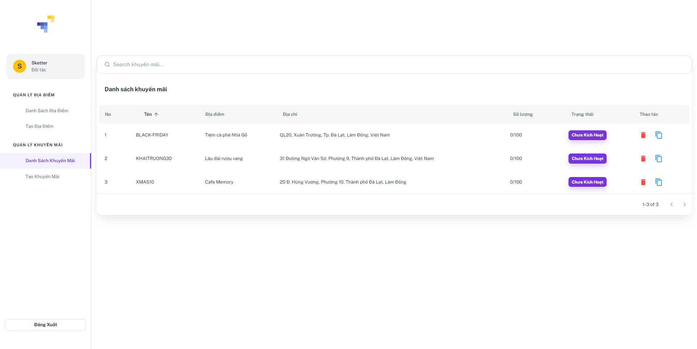

### **Function details:**

* Supplier click on the “Danh sách khuyến mãi” tab on the left sidebar.
* Sketter shows all voucher including information:
* No: Number
* Tên: Text
* Địa điểm: Text
* Địa chỉ: Text
* Số lượng: Number
* Trạng thái:
* Kích hoạt: Text
* Chưa kích hoạt: Text
* Thao tác:
* Xoá: Icon button
* Chỉnh sửa: Icon button

1. **View voucher information**

### **Function trigger**: Traveler send requests to view voucher details.

### **Function description**: This function allows traveler to view voucher details.

### **Screen layout:**

### **Function details:**

* Supplier double clicks on voucher.
* Sketter shows a voucher details includes information:
* Tên khuyến mãi: Text
* Địa điểm áp dụng: Text
* Thông tin khuyến mãi: Text
* Số lương mở bán: Number
* Giá mã khuyến mãi: Number
* Giá bán: Number
* Ngày bắt đầu khuyến mãi: Datetime
* Ngày kết thúc khuyến mãi: Datetime

### Ảnh: Image

1. **Update voucher**

### **Function trigger**: Supplier send requests to update voucher.

### **Function description**: This function allows supplier to update voucher.

### **Screen layout:**



### **Function details:**

* Supplier double clicks on voucher.
* Sketter shows a popup screen including information:
* Tên khuyến mãi; Text input
* Địa điểm áp dụng: Text input
* Mô tả thông tin khuyến mãi: Text input
* Giá mã khuyến mãi: Number input
* Giá bán: Number input
* Số lương mở bán: Number input
* Ngày bắt đầu khuyến mãi: Datetime picker
* Ngày kết thúc khuyến mãi: Datetime picker
* Ảnh: Image
* Thao tác:
* Kích hoạt: Button
* Cập nhật: Button
* Supplier clicks on the “Cập nhật” button.
* Sketter updates voucher details and shows message MSG00

1. **Duplicate voucher**

### **Function trigger**: Supplier send requests to duplicate voucher.

### **Function description**: This function allows to duplicate voucher.

### **Screen layout:**

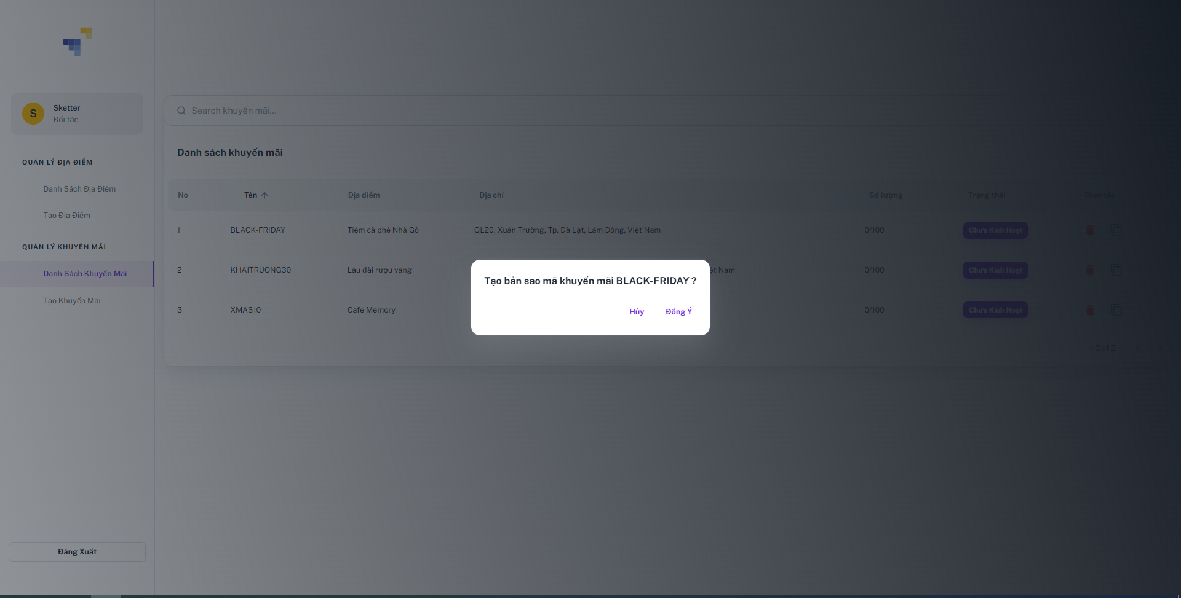

### **Function details:**

* Supplier clicks on Copy “” icon button.
* Sketter shows a confirmation dialog with message “Tạo bản sao mã khuyến mãi ?” with two buttons.
* Huỷ: Button
* Đồng ý: Button.
* Supplier clicks on the “Đồng ý” button.
* Sketter duplicate voucher and shows message MSG00

1. **Delete voucher**

### **Function trigger**: Supplier send requests to delete voucher.

### **Function description**: This function allows supplier to delete voucher.

### **Screen layout:**



### **Function details:**

* Supplier clicks on the “” icon button.
* Sketter show confirm popup including information:
* Bạn có chắc chắn muốn xoá mã khuyến mãi này: Text
* Thao tác:
* Huỷ: Button
* Đồng ý: Button
* Supplier clicks on the “Đồng ý” button.
* Sketter delete voucher and shows messages MSG00.

1. **Search voucher**

### **Function trigger**: Supplier send requests to search voucher.

### **Function description**: This function allows supplier to search voucher.

### **Screen layout:**

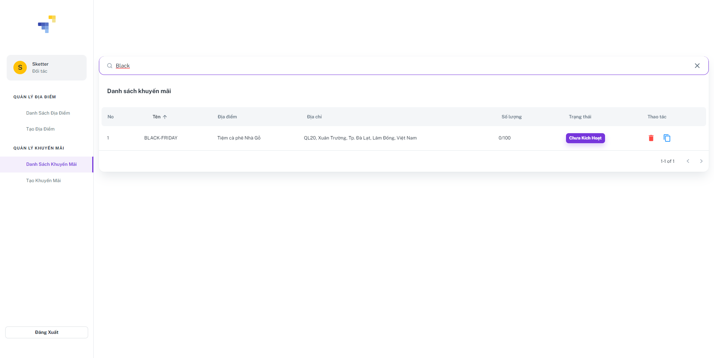

### **Function details:**

* Supplier inputs name into search bar.

### Sketter shows the list of vouchers.

1. **View voucher code list**

### **Function trigger**: Traveler send requests to view used voucher list.

### **Function description**: This function allows traveler to view used voucher list.

### **Screen layout:**

### **Function details:**

* Supplier double clicks on voucher.
* Sketter shows a voucher details includes information:

1. **Non-Functional Requirements**
2. **External Interfaces**
3. **User Interfaces**

**UI-1**: GUI must be simple, and friendly.

**UI-2**: Icons used must be easy to recognize.

**UI-3**: Language used in the application is Vietnamese.

**UI-4**: UI can be responsive on multiple screens.

**UI-5**: The UI has many attractive  images and uses scrolling horizontal appearance.

**UI-6**: Background and font colors have great contrast.

1. **Software Interfaces**

**SI-1**:File Storage Service

**SI-1.1**:Sketter can integrate with Firebase Storage Service and use its upload file API.

**SI-2**: Web Application: browser Google Chrome (Version 100.0.4896.88 or higher) and Firefox (version 60 or higher), Microsoft Edge (Version 100.0.1185.44) or any web browser that supports HTML5 & CSS3.

**SI-3**:Mobile Application: Android Q, v10.0 or newer.

1. **Hardware Interfaces**

**HI - 1**: Desktop or laptop.

1. **Quality Attributes**

#### **Usability**

* Mobile UI/UX follows Material Design to be convenient and easy to use.
* Web Application follows  which is friendly and clear.
* Users are not required to have technical knowledge before using.
* Sketter supports managing destination, promotion and planning.

#### **Reliability**

* The likelihood of the system failure is less than 90%
* The availability of the system is over 70%.

#### **Performance**

* Response time is equal to or less than 5 seconds for each request.
* Processing time is 100-200 seconds for each frame.

#### **Dependability**

* JWT is used for authentication and authorization.
* Each role can only access its own functions.
* Using SHA-256 to hash passwords.
* All data must be validated before saving to the database.

#### **Supportability**

* Sketter is available for both Web Application and Mobile Application.
* System is modularized to support maintenance and further development.

#### **Design Constraints**

* Language used for Web Application and Mobile Application is Vietnamese.
* Using technologies:
  + Mobile Application: Flutter, Dart, MVP pattern
  + Web Application: ReactJS library, HTML, CSS
  + Server:  NodeJS , repository pattern
  + Database management system: PostgreSQL Server, Sequelize

#### **Support Documents**

* User Guides are provided for guiding to assist users using the Sketter System, written in step-by-step, with Visual content, including images, annotated screenshots, graphics.
* Documenting the requirement specification, system design, and testing to support maintenance and further development.

1. **Requirement Appendix**
2. **Business Rules**

|  |  |
| --- | --- |
| **ID** | **Rule Definition** |
|  | One account can be login by many platforms |
|  | When logging in, the system will save the account’s device id to send a notification if needed. |
|  | When login by another device, the old device will not sign out automatically. |
|  | One email can be used to create only one account. |
|  | Cannot use the old email that is created even if that account is disabled. |
|  | The account must have an email when created and verified. |
|  | Cannot use the same email for multiple accounts. |
|  | Cannot update email |
|  | Only the admin can create suppliers and supplier manager accounts. |
|  | Admin can see managers, suppliers, travelers and information that they manage. |
|  | Only admin can see all account information that is not being deleted in the system |
|  | Suppliers and Travelers can only see their own account information. |
|  | Traveler and Supplier can update the account information. |
|  | The new password must be different from the old password that is wanted to update. |
|  | Only travelers have to has at least one personality to create plans. |
|  | Managers and Suppliers can create destinations. |
|  | Suppliers must provide complete and truthful information about the destination. |
|  | In the web application, after logging out, the user cannot log in automatically to the previous account later. |
|  | A destination cannot be added to a plan if it was deleted. |
|  | Only travelers can register by Google |
|  | Only the admin can deactivate user accounts. |
|  | Only travelers can see their own bookmarked list |
|  | Only travelers can bookmark destinations. |
|  | Only travelers can delete their own bookmarked items. |
|  | Suppliers and travelers can see a list of reviews of a destination. |
|  | Travelers can only delete their own review in a destination. |
|  | Only travelers can create reviews on a destination. |
|  | Only suppliers can create, update, delete promotions. |
|  | A promotion cannot be updated when it is released. |
|  | Only supplier managers can close their own promotion of a destination for emergency situations. |
|  | Only suppliers can close their own destination. |
|  | Traveler can only update their own plans. |
|  | Admin can view all transactions of the systems. |
|  | Travelers only view their own transactions with the system. |
|  | Only travelers can see the promotion list of their own and promotion’s status. |
|  | Travelers have to complete payments with system payment in order to buy the promotions. |
|  | Suppliers have to responsible for the information included in the promotional code |
|  | Suppliers have to complete payments with system payment in order to activate the promotions. |
|  | Suppliers only view their own transitions with the system. |
|  | Only suppliers can update promotion’s information details that were created before. |
|  | Only suppliers can view information detail, numbers, transaction days of their own promotions. |
|  | Only suppliers can view their own promotion’s list in their own destinations. |
|  | Only suppliers can create promotions for their own destinations. |
|  | Goods and services in sales promotion must be lawfully traded goods and services. |
|  | The supplier is responsible for ensuring the quality of the promoted goods and services and the goods and services used for the promotion. |
|  | Traders conducting promotions must ensure favorable conditions for customers and have the obligation to settle complaints (if any) related to the promotion program. |
|  | Promotional programs must be legally enforceable, honest, public, transparent and have to guarantee the legitimate interests of users, other organizations or individuals. |
|  | The system automatically changes the promotion status when a successful transaction is recorded. |
|  | Travelers must have paypal or momo accounts in order to finish required payments of the system. |
|  |  |

1. **Application Messages List**

|  |  |  |  |  |
| --- | --- | --- | --- | --- |
| **#** | **Message code** | **Message Type** | **Context** | **Content** |
| 1 | MSG01 | Information Message | Login Failed | Email/mật khẩu không đúng |
| 2 | MSG02 | Information Message | Email cannot be null | Vui lòng nhập |
| 3 | MSG03 | Information Message | Password cannot be null | Vui lòng nhập |
| 4 | MSG04 | Information Message | Name cannot be null | Vui lòng nhập |
| 5 | MSG05 | Information Message | Date of birth cannot be null | Vui lòng nhập |
| 6 | MSG06 | Information Message | Confirm Password cannot null and not same with password | Mật khẩu không trùng khớp |
| 7 | MSG07 | Information Message | Information account successfully updated | Cập nhật thành công |
| 8 | MSG08 | Information Message | Information account fail updated | Cập nhật thông tin không thành công |
| 9 | MSG09 | Toast Message | Unauthorized access | Bạn không có quyền sử dụng tính năng này |
| 10 | MSG10 | Toast Message | Unauthorized access cause banned account | Không thể sử dụng tính năng này do tài khoản của bạn đã bị ngưng hoạt động |
| 11 | MSG11 | Toast Message | Reactivate account | Vui lòng kích hoạt lại tài khoản của bạn để sử dụng tính năng này |
| 12 | MSG12 | Information Message | Catalog cannot be null | Loại địa điểm không được trống |
| 13 | MSG13 | Information Message | Catalog cannot be found | Không tìm thấy loại địa điểm |
| 14 | MSG14 | Toast Message | Catalog successfully activated | Kích hoạt loại địa điểm thành công |
| 15 | MSG15 | Toast Message | Catalog successfully deactivated | Vô hiệu hoá loại địa điểm  thành công |
| 16 | MSG16 | Toast Message | Bookmark success | Đã thêm địa điểm vào mục yêu thích |
| 17 | MSG17 | Toast Message | Review success | Đánh giá địa điểm thành công |
| 18 | MSG18 | Toast Message | Review successfully edited | Chỉnh sửa đánh giá thành công |
| 19 | MSG19 | Toast Message | Review cannot be found | Không tìm thấy đánh giá này |
| 20 | MSG20 | Toast Message | Review successfully deleted | Đánh giá của bạn đã được xoá |
| 21 | MSG21 | Toast Message | Plan must have at least a destination | Chi tiết lịch trình không được trống |
| 22 | MSG22 | Toast Message | Destination cannot be found | Không tìm thấy địa điểm này |
| 23 | MSG23 | Toast Message | Destination successfully updated | Cập nhật địa điểm thành công |
| 24 | MSG24 | Toast Message | Location cannot be null | Vui lòng chọn địa chỉ |
| 25 | MSG25 | Toast Message | Image cannot be null | Vui lòng thêm ảnh vào địa điểm |
| 26 | MSG26 | Toast Message | Recommend Time cannot be null | Vui lòng thêm khung giờ lý tưởng vào địa điểm |
| 27 | MSG27 | Toast Message | Plan successfully created | Tạo lịch trình thành công |
| 28 | MSG28 | Toast Message | Plan cannot be found | Không tìm thấy lịch trình này |
| 29 | MSG29 | Toast Message | Plan successfully updated | Cập nhật lịch trình thành công |
| 30 | MSG30 | Toast Message | Plan successfully deleted | Xoá lịch trình thành công |
|  |  |  |  |  |

1. **Software Design Description**
2. **System Design**
3. **System Architecture**

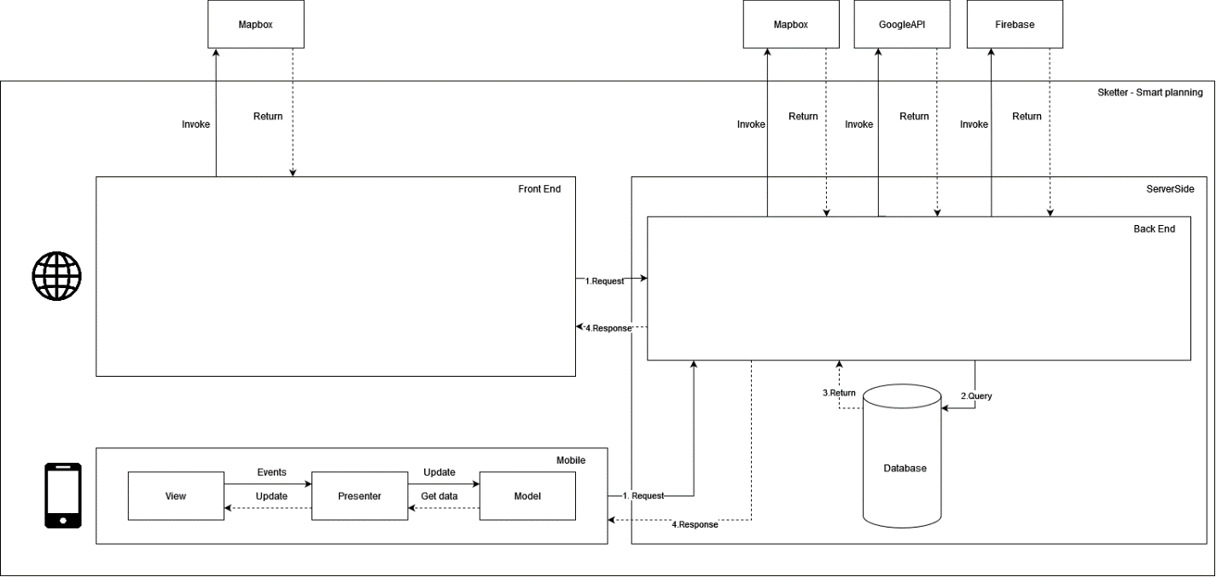

1. **Package Diagram**
2. **Web package diagram**

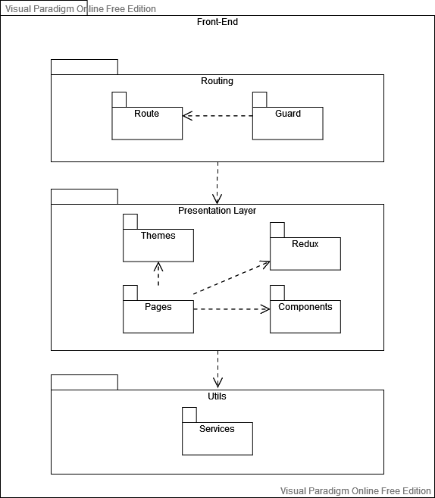

|  |  |  |
| --- | --- | --- |
| **No** | **Package** | **Description** |
| 01 | Route | The package contains classes responsible for routing pages based on purpose |
| 02 | Guard | The package contains classes responsible for authentication |
| 03 | Themes | The package contains classes responsible for basic interface configuration such as: background, spacing, color, fonts… |
| 04 | Redux | The package contains classes responsible for storing state to access |
| 05 | Components | The package contains classes responsible for handling interface components |
| 06 | Pages | The package contains classes responsible for grouping components and themes to a complete interface |
| 07 | Services | The package contains classes responsible for handling third-party configuration and services |

1. **Mobile package diagram**

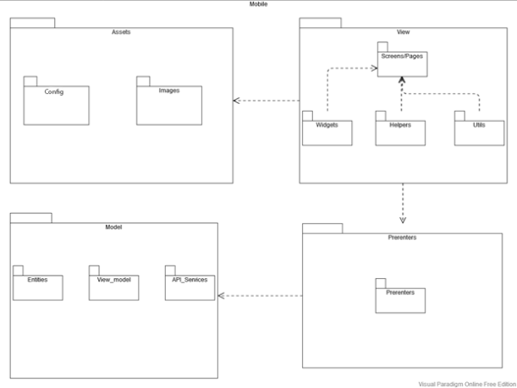

|  |  |  |
| --- | --- | --- |
| **No** | **Package** | **Description** |
| 01 | Config | This package contains config class, responsible for to the system. |
| 02 | Images | This package contains images used in the app. |
| 03 | Screens/Pages | This package contains the main screen of the application |
| 04 | Widgets | This package contains components that reuse many times on screen. |
| 05 | Helpers | This package contains some classes that help validate and format data.. |
| 06 | Utils | The package contains utility functions for the config screen size of devices. |
| 07 | Presenters | This package contains class connections between views and models. |
| 08 | Entities | This package contains entities that call API services to get data. |
| 09 | Model | This package contains view models and entities that call API services to get data. |
| 10 | API Services | This package contains classes to send and receive HTTP requests from API. |

1. **Database Design**

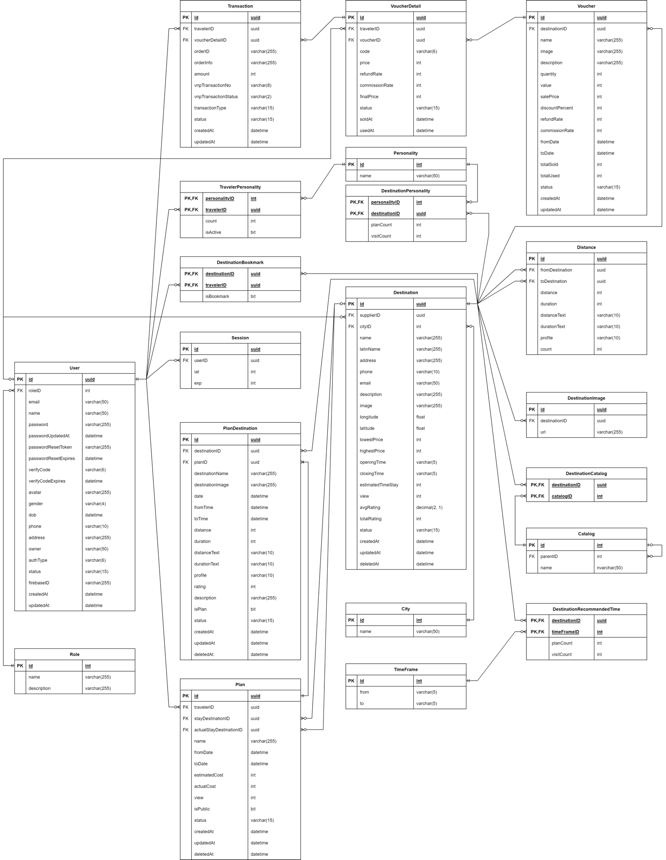

**Table Descriptions**

|  |  |  |
| --- | --- | --- |
| **No** | **Table** | **Description** |
| 01 | catalog | Describe all type of destination catalog in system  - Primary keys: “id”  - Foreign keys: *none* |
| 02 | city | Describe all city in system  - Primary keys: “id”  - Foreign keys: *none* |
| 03 | destination | Describe all destination in system  - Primary keys: “id”  - Foreign keys: “cityID”, ”supplierID” |
| 04 | destination_bookmark | Describe bookmarked destination of traveler  - Primary keys: “travelerID”, “destinationID”  - Foreign keys: “travelerID”, “destinationID” |
| 05 | destination_catalog | Describe all catalog that destination have  - Primary keys: “destinationID”, ”catalogID”  - Foreign keys: “destinationID”, ”catalogID” |
| 06 | destination_image | Describe all images that destination have  - Primary keys: “id”  - Foreign keys: “destinationID” |
| 07 | destination_personality | Describe all personalities that destination have  - Primary keys: “destinationID”, “personalityID”  - Foreign keys: “destinationID”, “personalityID” |
| 08 | destination_recommended_time | Describe all recommended time frame that destination have  - Primary keys: “destinationID”, “timeFrameID”  - Foreign keys: “destinationID”, “timeFrameID” |
| 09 | distance | Describe distance between destination in system  - Primary keys: “id”  - Foreign keys: “fromDestination”, “toDestination” |
| 10 | personality | Describe all personalities in system  - Primary keys: “id”  - Foreign keys: *none* |
| 11 | plan | Describe all plan in system  - Primary keys: “id”  - Foreign keys: “stayDestinationID”, “travelerID”, ”actualStayDestinationID” |
| 12 | plan_destination | Describe all destination in plan  - Primary keys: “id”  - Foreign keys: “planID”, “destinationID” |
| 13 | role | Describe all role in system  - Primary keys: “id”  - Foreign keys: *none* |
| 14 | session | Describe session of user in system  - Primary keys: “id”  - Foreign keys: “userID” |
| 15 | time_frame | Describe all time frame in system  - Primary keys: “id”  - Foreign keys: *none* |
| 16 | traveler_personalities | Describe all personalities of traveler have  - Primary keys: “travelerID”, “personalityID”  - Foreign keys: “travelerID”, “personalityID” |
| 17 | user | Describe all user in system  - Primary keys: “id”  - Foreign keys: “roleID” |
| 18 | voucher | Describe all voucher in system  - Primary keys: “id”  - Foreign keys: “destinationID” |
| 19 | voucher_detail | Describe traveler owned voucher  - Primary keys: “id”  - Foreign keys: “travelerID”,”voucherID” |
| 20 | transaction | Describe voucher transaction  - Primary keys: “id”  - Foreign keys: “travelerID”,”voucherDetailID” |

1. **Detailed Design**
2. **Manage Destination**
3. **Class Diagram**

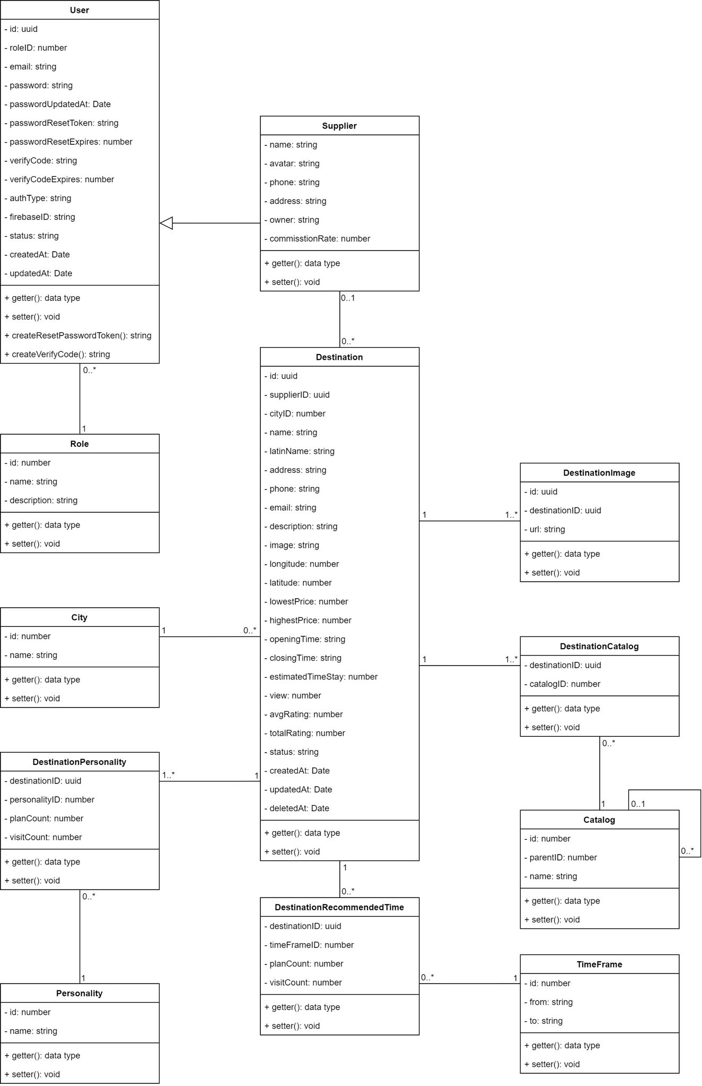

#### **Users Class**

|  |  |  |
| --- | --- | --- |
| **Field name** | **Type** | **Description** |
| **id** | uuid | Unique identifier of users |
| **roleID** | number | The identifier of role |
| **email** | string | Email of user |
| **password** | string | Password of user |
| **passwordUpdatedAt** | Date | Time when user update password |
| **passwordResetToken** | string | Time when user token be updated |
| **passwordResetExpires** | date | Time when password reset token expires |
| **verifyCode** | string | Activated code of user |
| **verifyCodeExpires** | date | Time when activated code expires |
| **authType** | string | Type of authentication |
| **firebaseID** | uuid | The identifier of firebase |
| **createdAt** | date | Time when user be created |
| **updateAt** | date | Time when user be updated |
| **status** | string | Status of the user |

|  |  |  |
| --- | --- | --- |
| **Method** | **Return type** | **Description** |
| getter | data type | Get attribute value |
| setter | void | Set value of attribute |
| createResetPasswordToken | string | Create new token to reset password |
| createVerifyCode | string | Create new code to verify |

1. **Roles Class**

|  |  |  |
| --- | --- | --- |
| **Field name** | **Type** | **Description** |
| id | number | Unique identifier of role |
| name | string | Name of role |
| description | string | Description of role |

|  |  |  |
| --- | --- | --- |
| **Method** | **Return type** | **Description** |
| getter | data type | Get attribute value |
| setter | void | Set value of attribute |

1. **Personality Class**

|  |  |  |
| --- | --- | --- |
| **Field name** | **Type** | **Description** |
| id | number | Unique identifier of personalities |
| name | string | Name of personalities |

|  |  |  |
| --- | --- | --- |
| **Method** | **Return type** | **Description** |
| getter | data type | Get attribute value |
| setter | void | Set value of attribute |

1. **City Class**

|  |  |  |
| --- | --- | --- |
| **Field name** | **Type** | **Description** |
| id | number | Unique identifier of city |
| name | string | Name of city |

|  |  |  |
| --- | --- | --- |
| **Method** | **Return type** | **Description** |
| getter | data type | Get attribute value |
| setter | void | Set value of attribute |

1. **TimeFrames Class**

|  |  |  |
| --- | --- | --- |
| **Field name** | **Type** | **Description** |
| id | number | Unique identifier of time frame |
| from | string | Time frame start from |
| to | string | Time frame end to |

|  |  |  |
| --- | --- | --- |
| **Method** | **Return type** | **Description** |
| getter | data type | Get attribute value |
| setter | void | Set value of attribute |

1. **Supplier Class**

|  |  |  |
| --- | --- | --- |
| **Field name** | **Type** | **Description** |
| name | number | Name of supplier |
| avatar | string | Avatar of supplier |
| phone | string | Phone of supplier |
| address | string | Address of supplier |
| owner | string | Owner name of the supplier |
| commissionRate | number | Percent of commission |

|  |  |  |
| --- | --- | --- |
| **Method** | **Return type** | **Description** |
| getter | data type | Get attribute value |
| setter | void | Set value of attribute |

1. **Catalogs Class**

|  |  |  |
| --- | --- | --- |
| **Field name** | **Type** | **Description** |
| id | number | Unique identifier of catalog |
| parent | string | Type of parent catalog |
| name | string | Name of catalog |

|  |  |  |
| --- | --- | --- |
| **Method** | **Return type** | **Description** |
| getter | data type | Get attribute value |
| setter | void | Set value of attribute |

1. **Destination Class**

|  |  |  |
| --- | --- | --- |
| **Field name** | **Type** | **Description** |
| id | uuid | UnIque identifier of destination |
| supplierID | uuid | The identifier of supplier |
| cityID | number | The identifier of city |
| name | string | Name of destination |
| address | string | Address of destination |
| phone | string | Phone of destination |
| email | string | Email of destination |
| description | string | Description of destination |
| longitude | number | Coordinate (Longitude) of destination |
| latitude | number | Coordinate (Latitude) of destination |
| lowestPrice | number | Minimum price of destination |
| highestPrice | number | Maximum price of destination |
| openingTime | string | Time when destination open |
| closingTime | string | Time when destination close |
| estimatedTimeStay | number | Average time when staying at destination |
| view | number | User view number of destination |
| avgRating | number | Average rating of destination |
| totalRating | number | Total rating of destination |
| status | string | Status of destination |
| createdAt | date | Time when destination be created |
| updatedAt | date | Time when destination be updated |
| deletedAt | date | Time when destination be deleted |
| image | string | Image of destination |
| latinName | string | None tonal symbols name |

|  |  |  |
| --- | --- | --- |
| **Method** | **Return type** | **Description** |
| getter | data type | Get attribute value |
| setter | void | Set value of attribute |

1. **Gallery Class**

|  |  |  |
| --- | --- | --- |
| **Field name** | **Type** | **Description** |
| id | uuid | Unique identifier of image |
| destinationID | uuid | The identifier of destination |
| url | string | URL of image |

|  |  |  |
| --- | --- | --- |
| **Method** | **Return type** | **Description** |
| getter | data type | Get attribute value |
| setter | void | Set value of attribute |

1. **DestinationCatalogs Class**

|  |  |  |
| --- | --- | --- |
| **Field name** | **Type** | **Description** |
| destinationID | uuid | The identifier of destination |
| catalogID | number | The identifier of catalog |

|  |  |  |
| --- | --- | --- |
| **Method** | **Return type** | **Description** |
| getter | data type | Get attribute value |
| setter | void | Set value of attribute |

1. **DestinationPersonality Class**

|  |  |  |
| --- | --- | --- |
| **Field name** | **Type** | **Description** |
| destinationID | uuid | The identifier of destination |
| personalityID | number | The identifier of personality |
| planCount | number | Number of user have the same personality with destination that add to their plan |
| visitCount | number | Number of user have check in destination |

|  |  |  |
| --- | --- | --- |
| **Method** | **Return type** | **Description** |
| getter | data type | Get attribute value |
| setter | void | Set value of attribute |

1. **DestinationRecommendedTime Class**

|  |  |  |
| --- | --- | --- |
| **Field name** | **Type** | **Description** |
| destinationID | uuid | The identifier of destination |
| timeFrameID | number | The identifier of time frame |
| planCount | number | Number of user have the same personality with destination that add to their plan |
| visitCount | number | Number of user have check in destination |

|  |  |  |
| --- | --- | --- |
| **Method** | **Return type** | **Description** |
| getter | data type | Get attribute value |
| setter | void | Set value of attribute |

1. **View destination list sequence diagram**

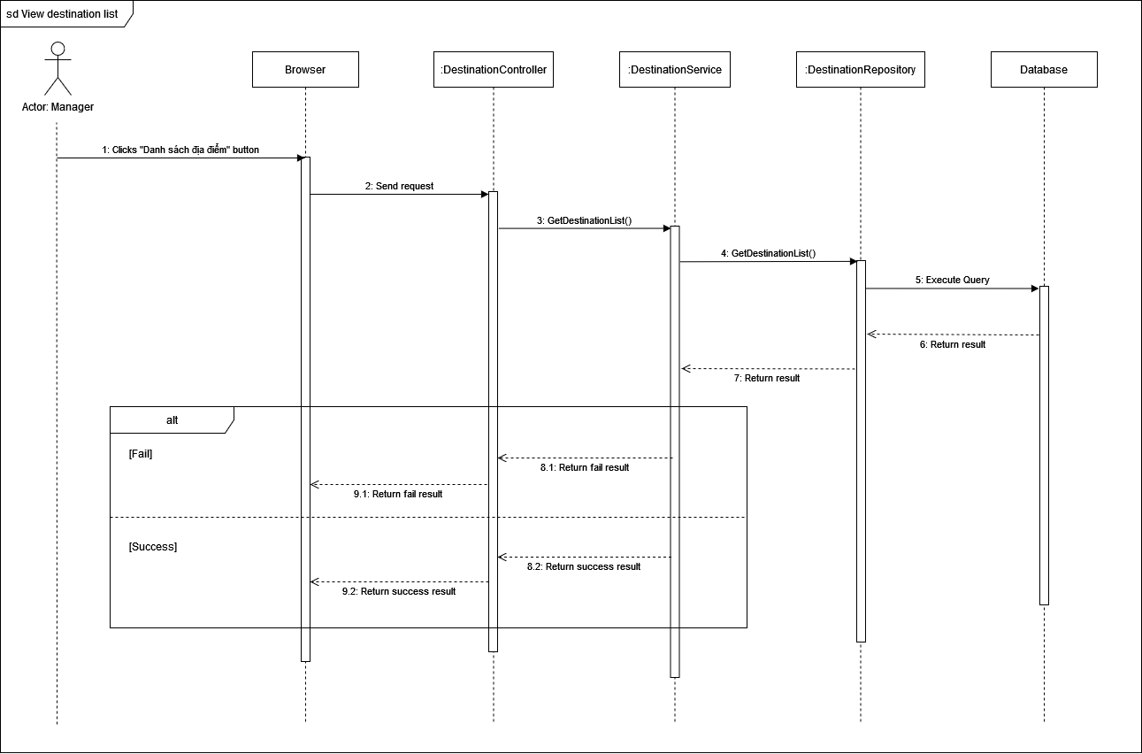

1. **View destination detail sequence diagram**

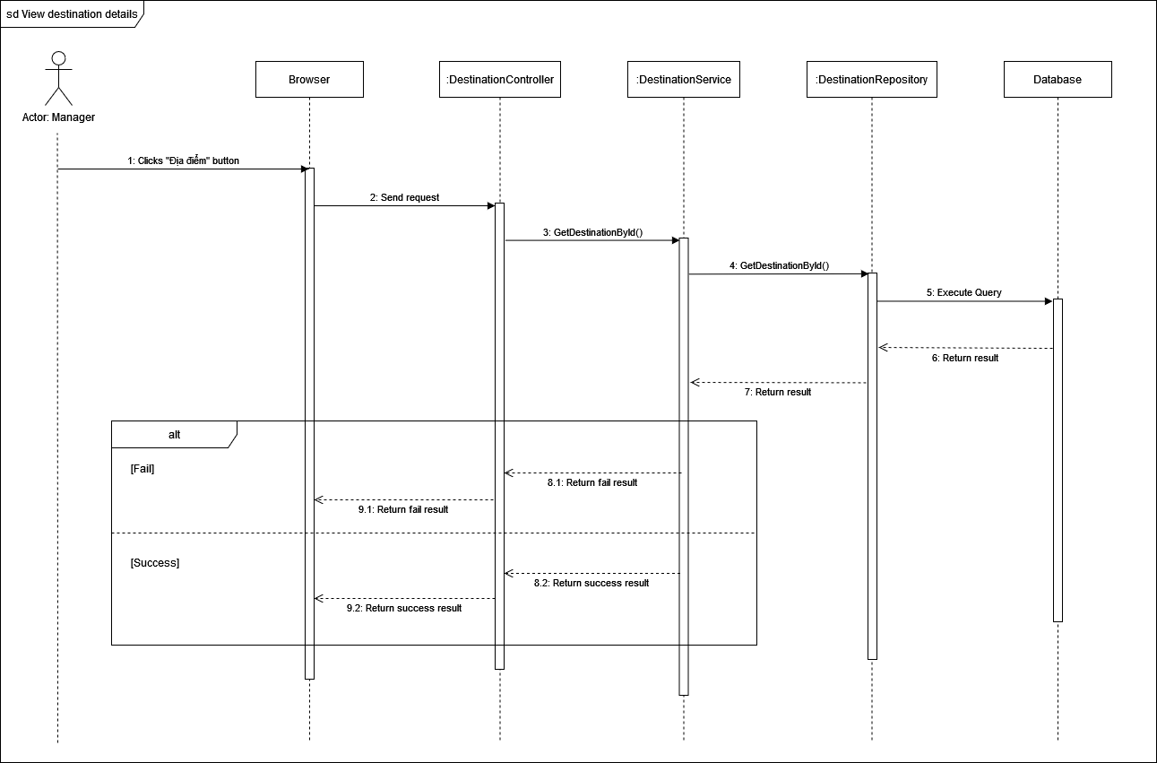

1. **Create destination sequence diagram**

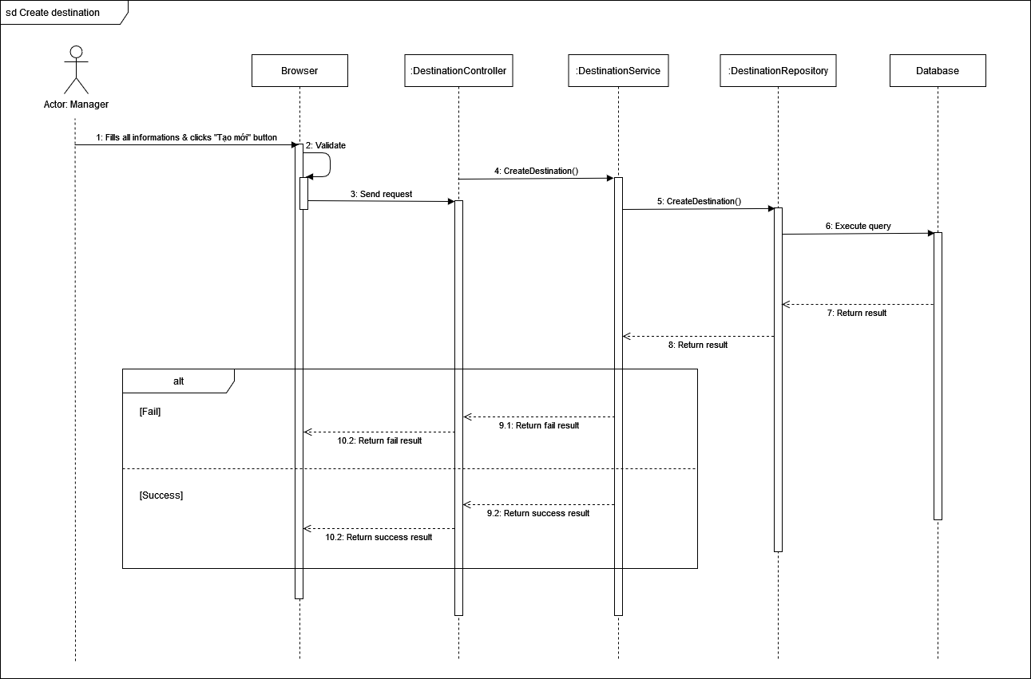

1. **Update destination sequence diagram**

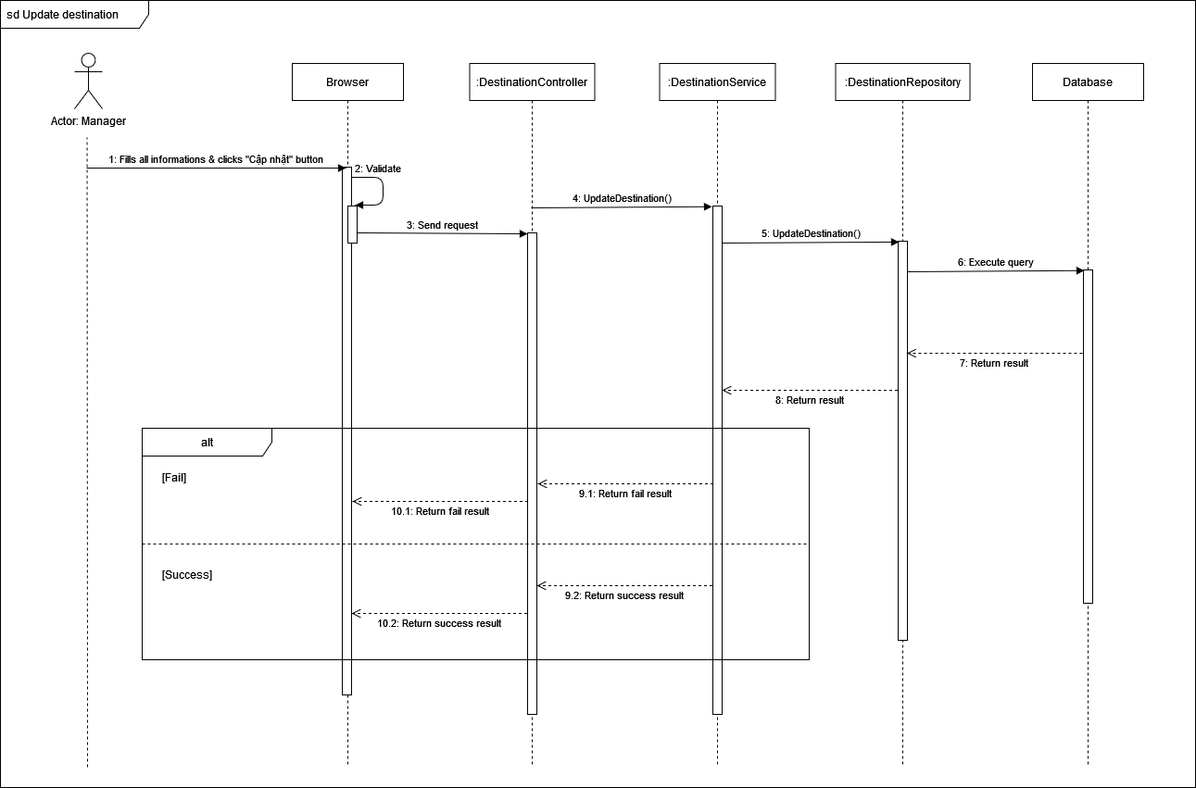

1. **Delete destination sequence diagram**

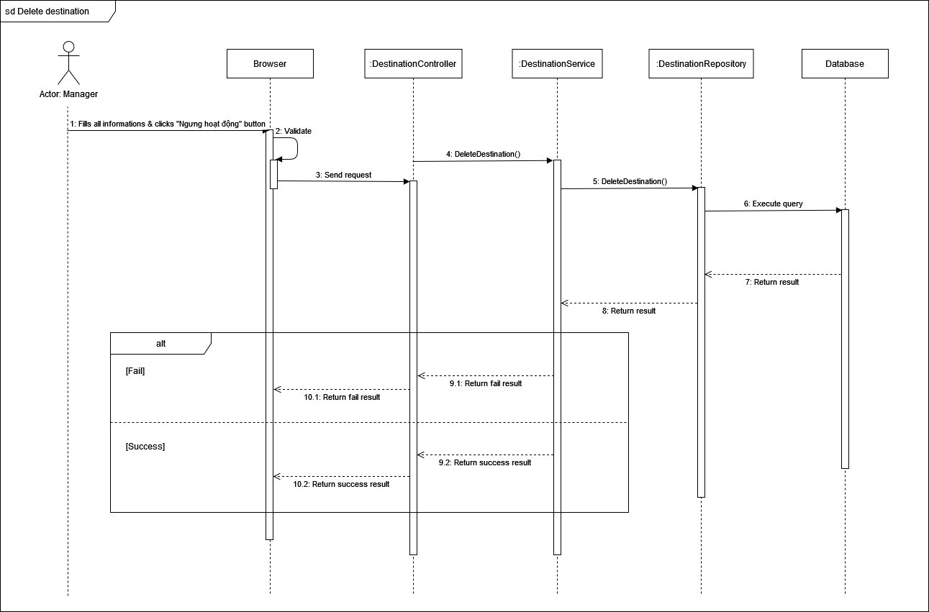

1. **Planning**
2. **Class Diagram**

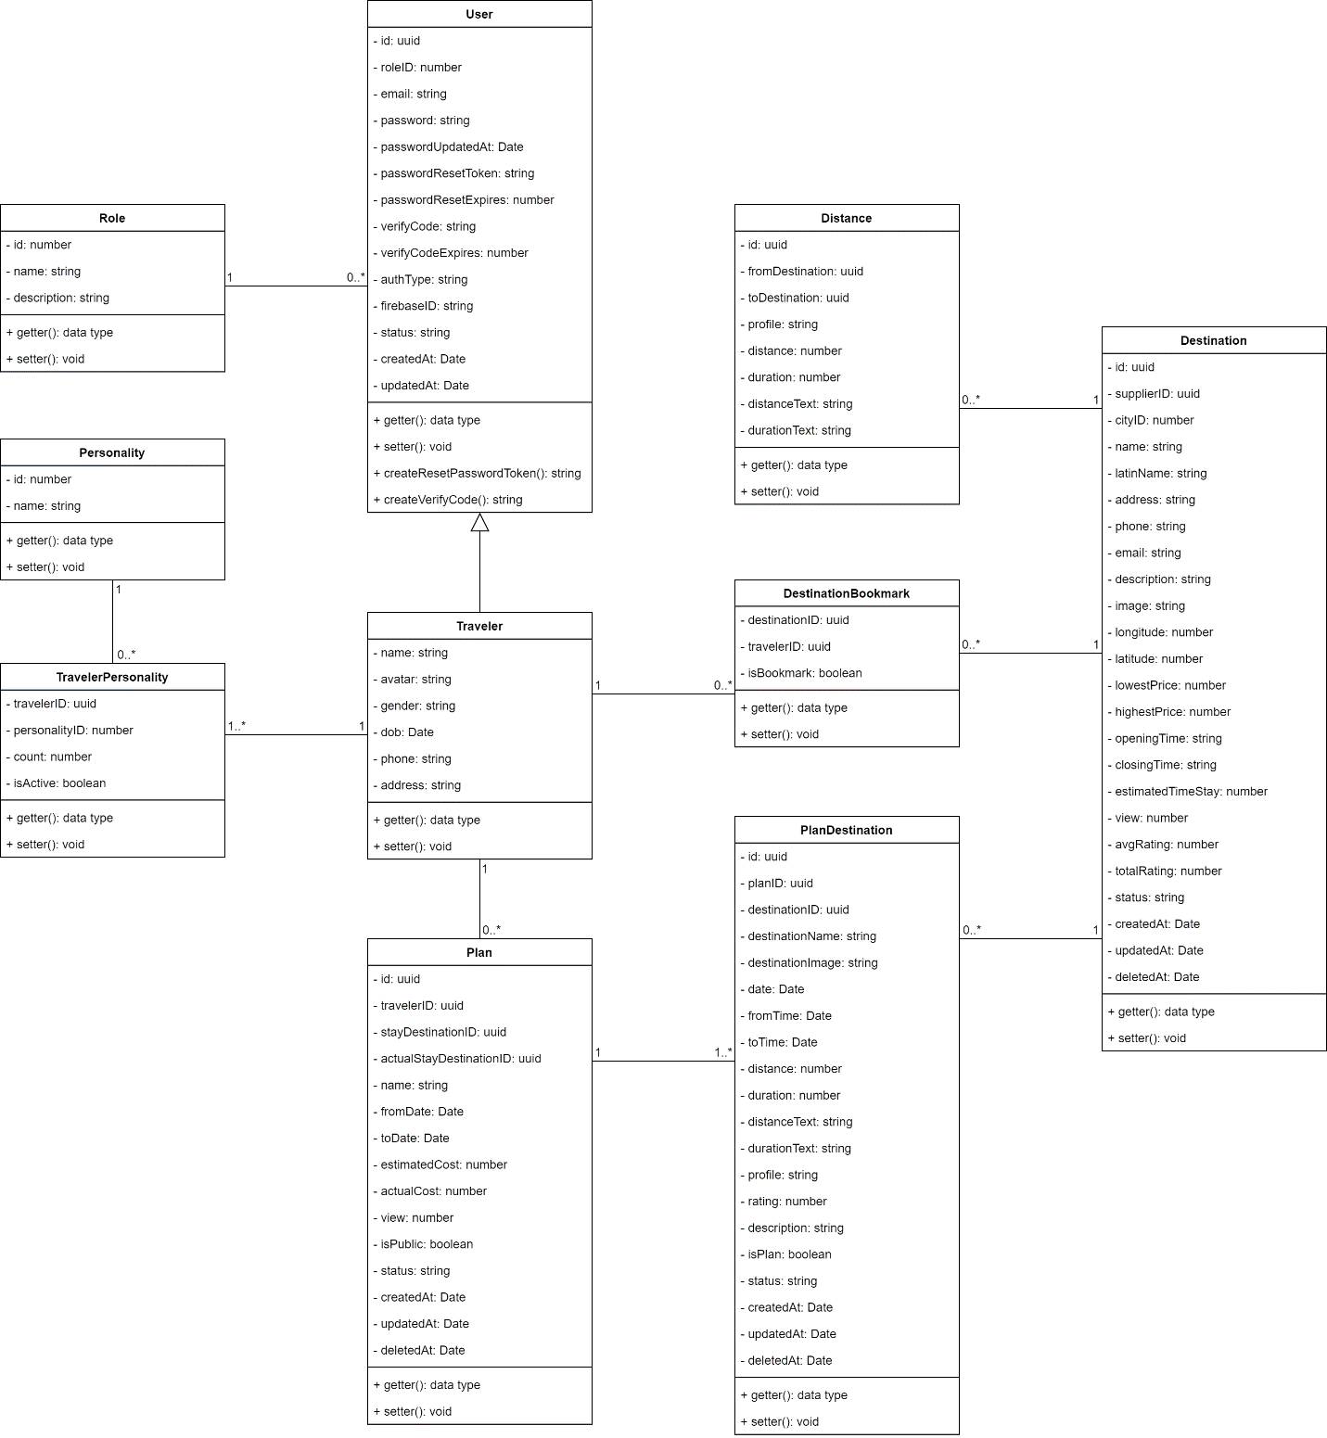

#### **User Class**

|  |  |  |
| --- | --- | --- |
| **Field name** | **Type** | **Description** |
| id | uuid | Unique identifier of users |
| roleID | number | The identifier of role |
| email | string | Email of user |
| password | string | Password of user |
| passwordUpdatedAt | Date | Time when user update password |
| passwordResetToken | string | Time when user token be updated |
| passwordResetExpires | number |  |
| verifyCode | string | Activated code of user |
| verifyCodeExpires | Date | Time when activated code expires |
| authType | string | Type of authentication |
| fiebaseID | uuid | The identifier of firebase |
| createdAt | Date | Time when user be created |
| updateAt | Date | Time when user be updated |
| status | string | Status of the user |

|  |  |  |
| --- | --- | --- |
| **Method** | **Return type** | **Description** |
| getter | data type | Get attribute value |
| setter | void | Set value of attribute |
| createResetPasswordToken | string | Create new token to reset password |
| createVerifyCode | string | Create new code to verify |

#### **Role Class**

|  |  |  |
| --- | --- | --- |
| **Field name** | **Type** | **Description** |
| id | number | Unique identifier of role |
| name | string | Name of role |
| description | string | Description of role |

|  |  |  |
| --- | --- | --- |
| **Method** | **Return type** | **Description** |
| getter | data type | Get attribute value |
| setter | void | Set value of attribute |

#### **DestinationBookmark Class**

|  |  |  |
| --- | --- | --- |
| **Field name** | **Type** | **Description** |
| destinationID | uuid | The identifier of destination |
| travelerID | uuid | The identifier of traveler |
| isBookmark | boolean | Is bookmark of not ? |

|  |  |  |
| --- | --- | --- |
| **Method** | **Return type** | **Description** |
| getter | data type | Get attribute value |
| setter | void | Set value of attribute |

#### **Traveler Class**

|  |  |  |
| --- | --- | --- |
| **Field name** | **Type** | **Description** |
| name | string | Name of traveler |
| avatar | string | Avatar of traveler |
| gender | boolean | Gender of traveler |
| dob | Date | Date of birth of traveler |
| phone | string | Phone number of traveler |
| address | string | Address of traveler |

|  |  |  |
| --- | --- | --- |
| **Method** | **Return type** | **Description** |
| getter | data type | Get attribute value |
| setter | void | Set value of attribute |

#### **Destination Class**

|  |  |  |
| --- | --- | --- |
| **Field name** | **Type** | **Description** |
| id | uuid | UnIque identifier of destination |
| supplierID | uuid | The identifier of supplier |
| cityID | number | The identifier of city |
| name | string | Name of destination |
| address | string | Address of destination |
| phone | string | Phone of destination |
| email | string | Email of destination |
| description | string | Description of destination |
| longitude | number | Coordinate (Longitude) of destination |
| latitude | number | Coordinate (Latitude) of destination |
| lowestPrice | number | Minimum price of destination |
| highestPrice | number | Maximum price of destination |
| openingTime | string | Time when destination open |
| closingTime | string | Time when destination close |
| estimatedTimeStay | number | Average time when staying at destination |
| view | number | User view number of destination |
| avgRating | number | Average rating of destination |
| totalRating | number | Total rating of destination |
| status | string | Status of destination |
| createdAt | date | Time when destination be created |
| updatedAt | date | Time when destination be updated |
| deletedAt | date | Time when destination be deleted |
| image | string | Image of destination |
| latinName | string | None tonal symbols name |

|  |  |  |
| --- | --- | --- |
| **Method** | **Return type** | **Description** |
| getter | data type | Get attribute value |
| setter | void | Set value of attribute |

#### **Personality Class**

|  |  |  |
| --- | --- | --- |
| **Field name** | **Type** | **Description** |
| id | uuid | Unique identifier of personalities |
| name | string | Name of personalities |

|  |  |  |
| --- | --- | --- |
| **Method** | **Return type** | **Description** |
| getter | data type | Get attribute value |
| setter | void | Set value of attribute |

#### **TravelerPersonality Class**

|  |  |  |
| --- | --- | --- |
| **Field name** | **Type** | **Description** |
| travelerID | uuid | The identifier of traveler |
| personalityID | number | The identifier of personality |
| count | number | Number of travel personality updated |
| isActive | boolean | Is travel personality updated or not ? |

|  |  |  |
| --- | --- | --- |
| **Method** | **Return type** | **Description** |
| getter | data type | Get attribute value |
| setter | void | Set value of attribute |

#### **Distance Class**

|  |  |  |
| --- | --- | --- |
| **Field name** | **Type** | **Description** |
| id | uuid | Unique identifier of id |
| fromDestination | number | Distance start from |
| toDestination | uuid | Distance end to |
| **profile** | string | Type of moving |
| **distance** | number | Distance from previous destination to this destination |
| **duration** | number | Time to move from previous destination to this destination |
| **distanceText** | string | Distance from previous destination to this destination in string |
| **durationText** | string | Time to move from previous destination to this destination in string |

|  |  |  |
| --- | --- | --- |
| **Method** | **Return type** | **Description** |
| getter | data type | Get attribute value |
| setter | void | Set value of attribute |

#### **Plan Class**

|  |  |  |
| --- | --- | --- |
| **Field name** | **Type** | **Description** |
| id | uuid | Unique identifier of plan |
| view | number | Number of plan’s view |
| travelerID | uuid | The identifier of traveler |
| name | string | Name of plan |
| fromDate | Date | Time when plan start |
| toDate | Date | Time when plan end |
| stayDestinationID | uuid | The identifier of stay destination |
| actualStayDestinationID | uuid | Stay destination when planned |
| estimatedCost | number | Average budget of plan |
| isPublic | boolean | Is the plan public for another traveler or not ? |
| actualCost | number | Cost when planned |
| status | string | Status of plan |
| createdAt | date | Time when plan was created |
| updatedAt | date | Time when plan was updated |
| deletedAt | date | Time when plan was deleted |

|  |  |  |
| --- | --- | --- |
| **Method** | **Return type** | **Description** |
| getter | data type | Get attribute value |
| setter | void | Set value of attribute |

#### **PlanDestination Class**

|  |  |  |
| --- | --- | --- |
| **Field name** | **Type** | **Description** |
| **id** | uuid | Unique identifier of plan’s destination |
| **planID** | uuid | The identifier of plan |
| **destinationID** | uuid | The identifier of destination |
| **destinationName** | string | Name of destination |
| **destinationImage** | string | Image of destination |
| **date** | Date | Date of destination in plan |
| **fromTime** | Date | Time when plan’s destination start |
| **toTime** | Date | Time when plan’s destination end |
| **distance** | number | Distance from previous destination to this destination |
| **status** | string | Status of plan’s destination |
| **duration** | number | Time to move from previous destination to this destination |
| **distanceText** | string | Distance from previous destination to this destination in string |
| **durationText** | string | Time to move from previous destination to this destination in string |
| **profile** | string | Type of moving |
| **rating** | number | Rating of destination in plan |
| **description** | string | Description of destination in plan |
| **isPlan** | boolean | Does traveler go to destination in plan or not ? |
| createdAt | Date | Time when plan destination was created |
| updatedAt | Date | Time when plan destination was updated |
| deletedAt | Date | Time when plan was deleted |

|  |  |  |
| --- | --- | --- |
| **Method** | **Return type** | **Description** |
| getter | data type | Get attribute value |
| setter | void | Set value of attribute |

#### **3.2.4 View plan list**

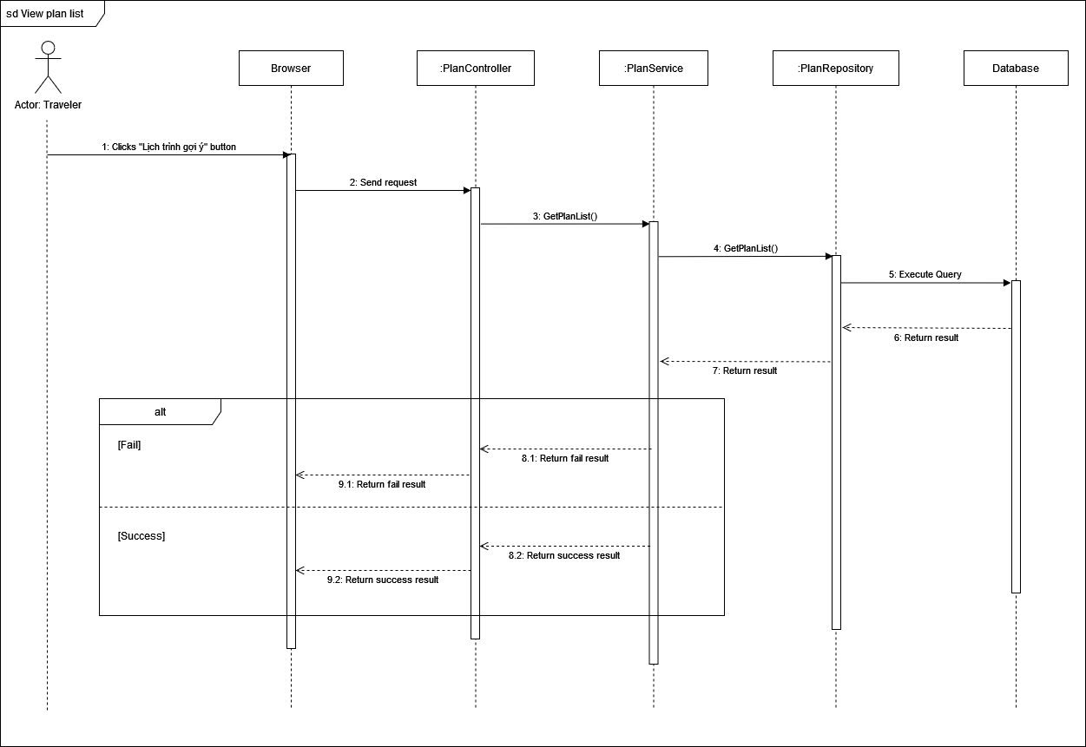

***3.2.5 View plan detail***

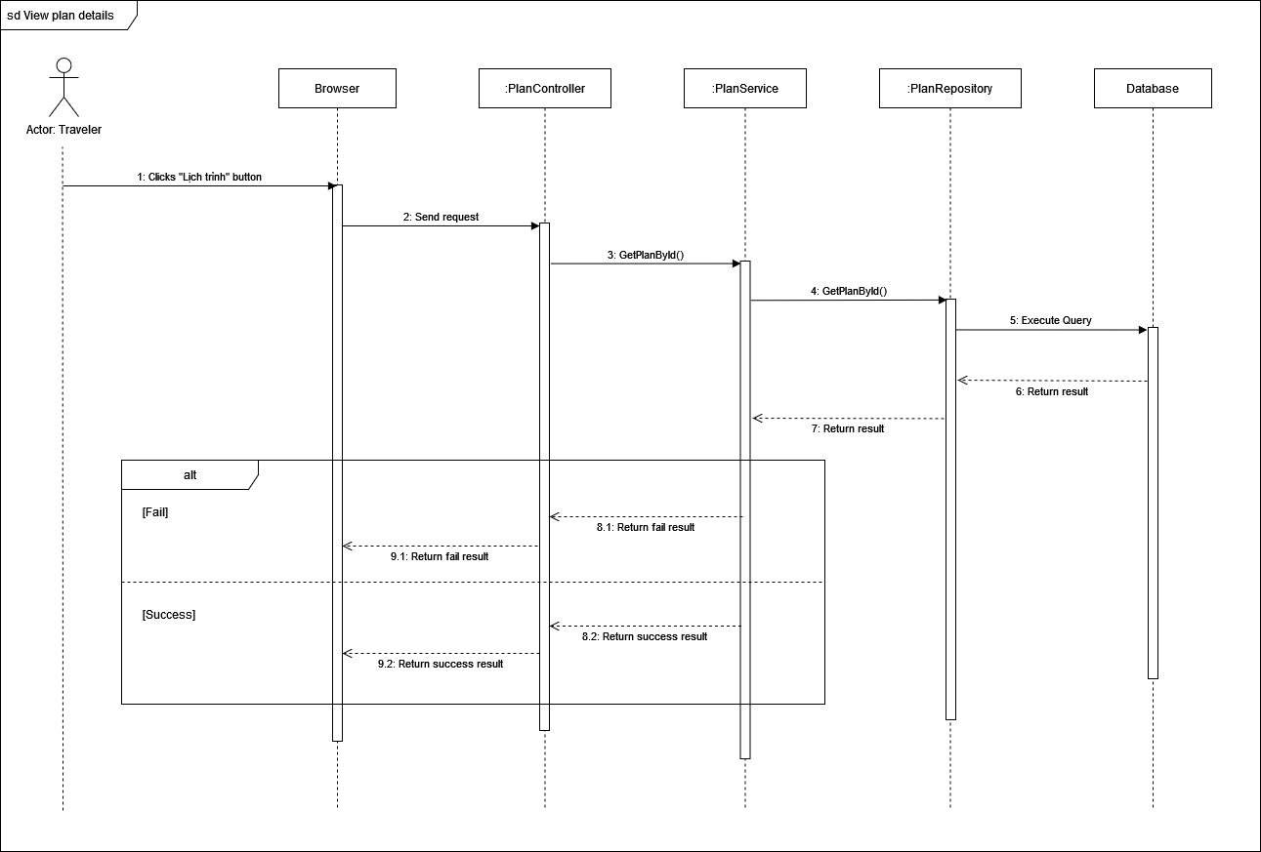

#### 3.2.8 View review list

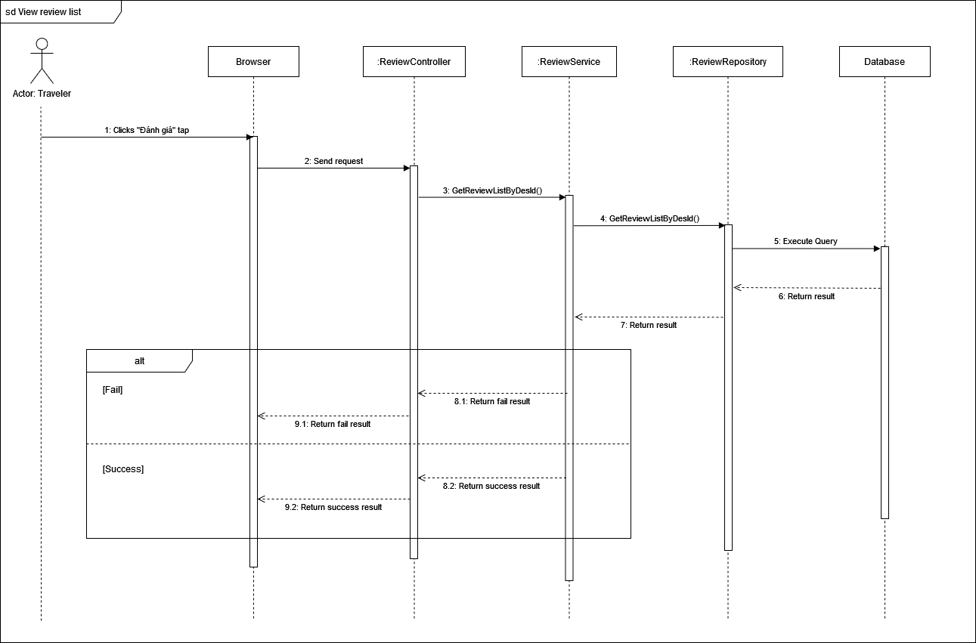

#### **3.2.9 Add review**

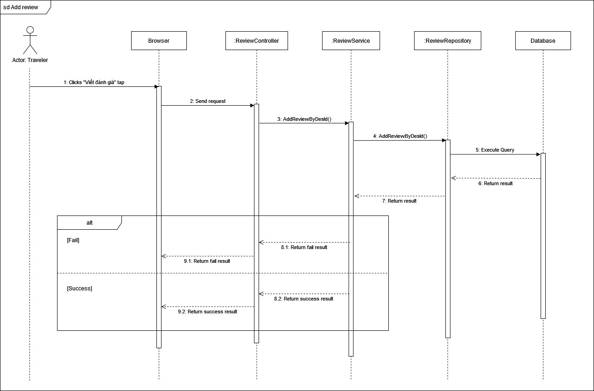

**3.2.13 Create plan**

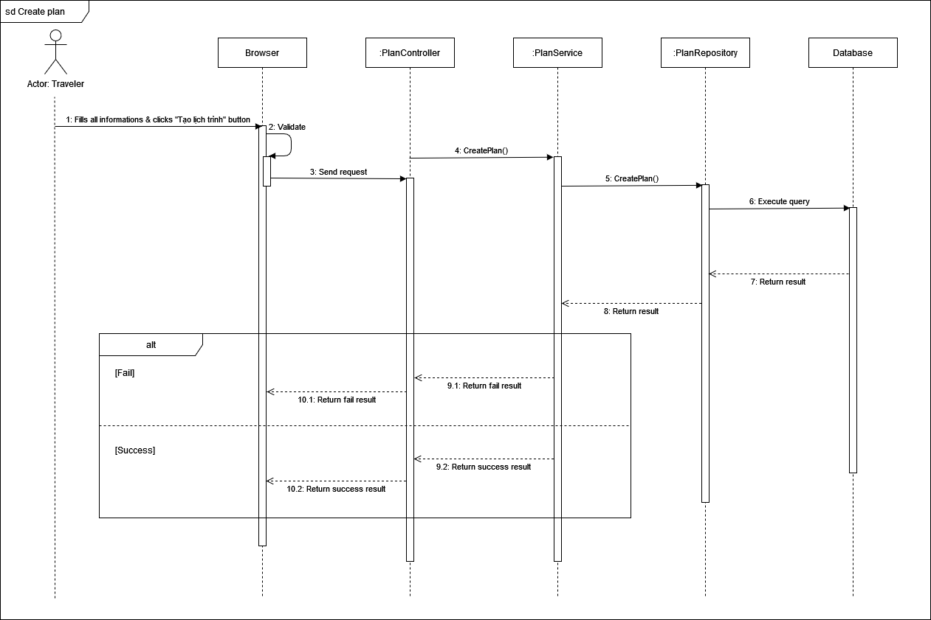

#### **3.2.14 Update plan**

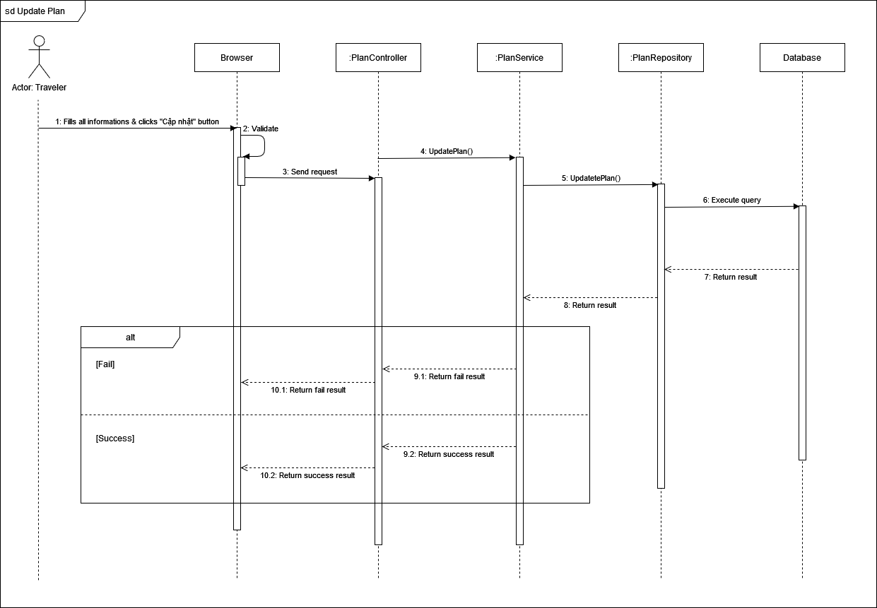

#### **3.2.15 Delete plan**

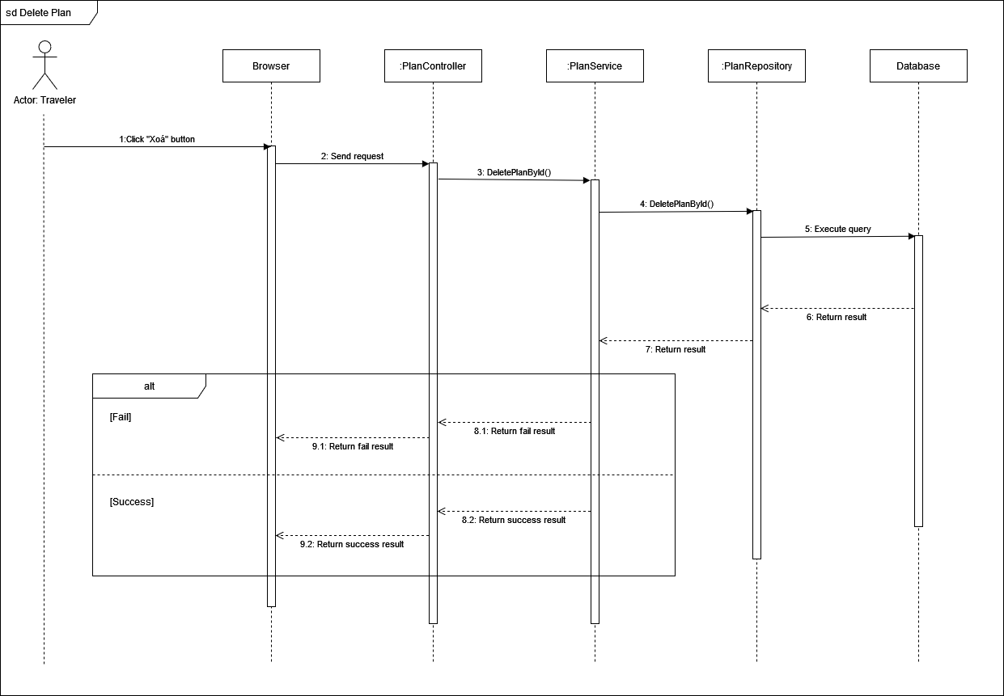

#### **3.2.16 Add bookmark**

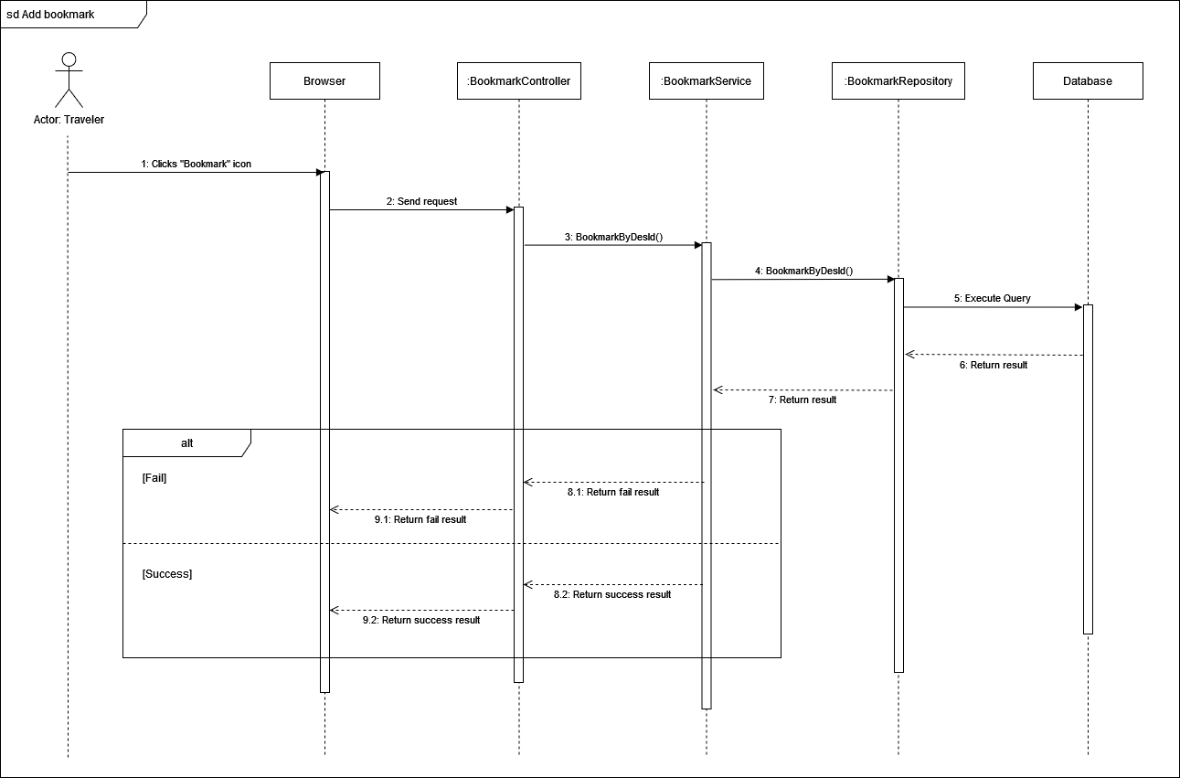

#### **3.2.17 Delete bookmark**

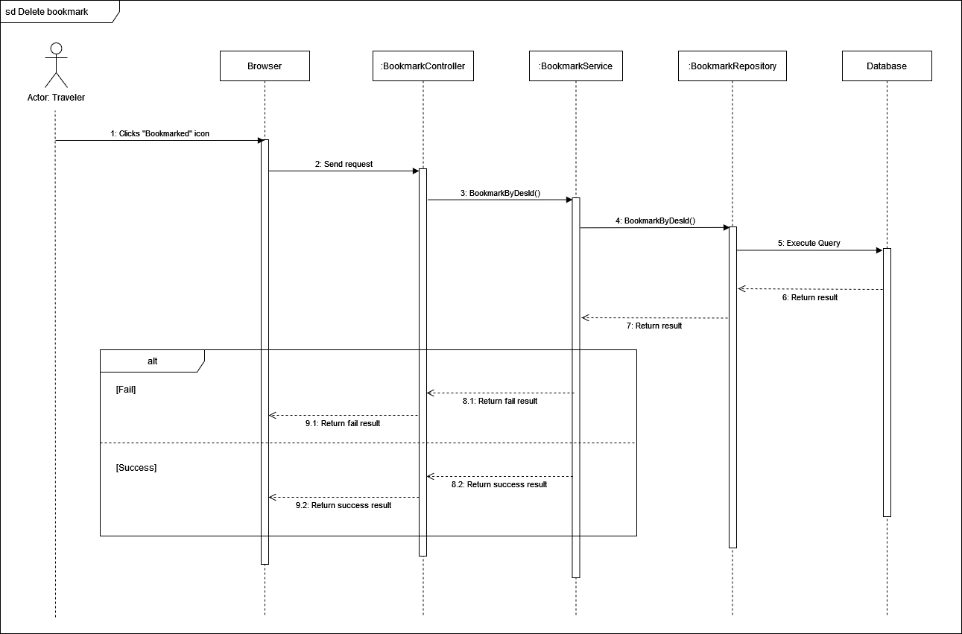

**3.2.19 Duplicate plan**

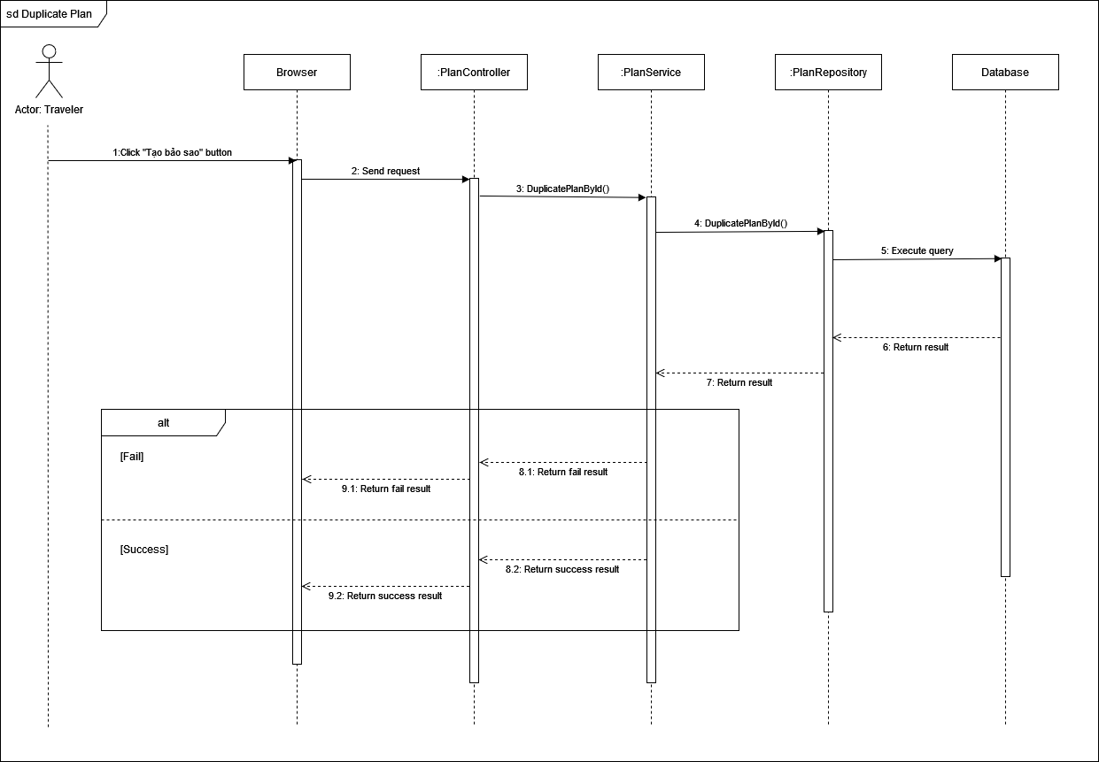

**3.2.20 View suggested smart plans**

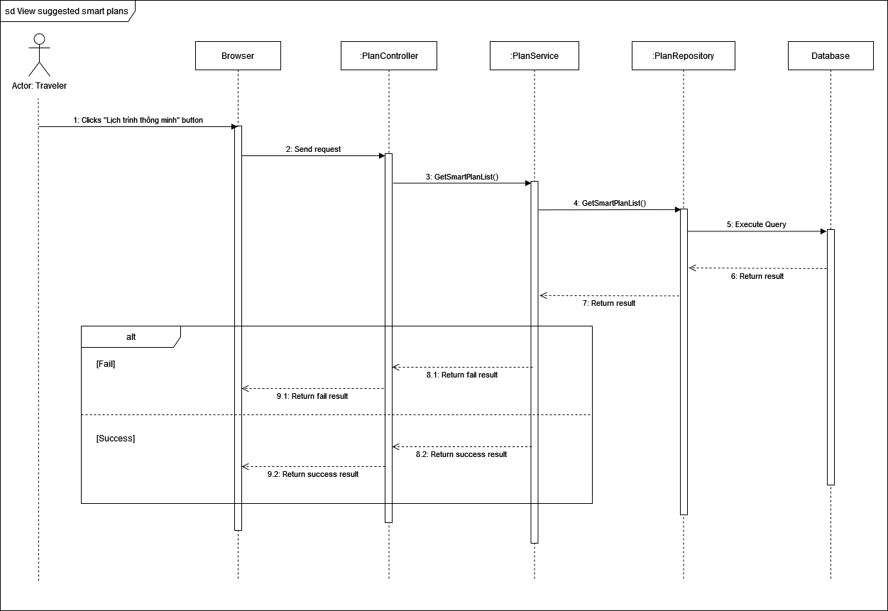

**3.2.20 Complete draft plan**

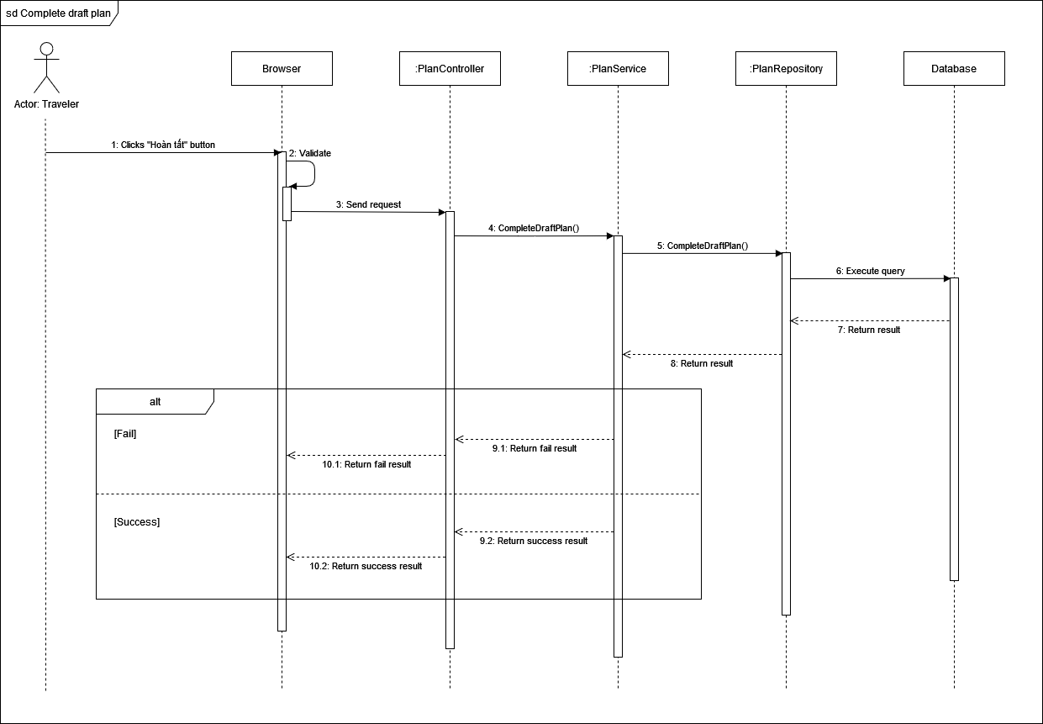

**3.2.20 Checkin**

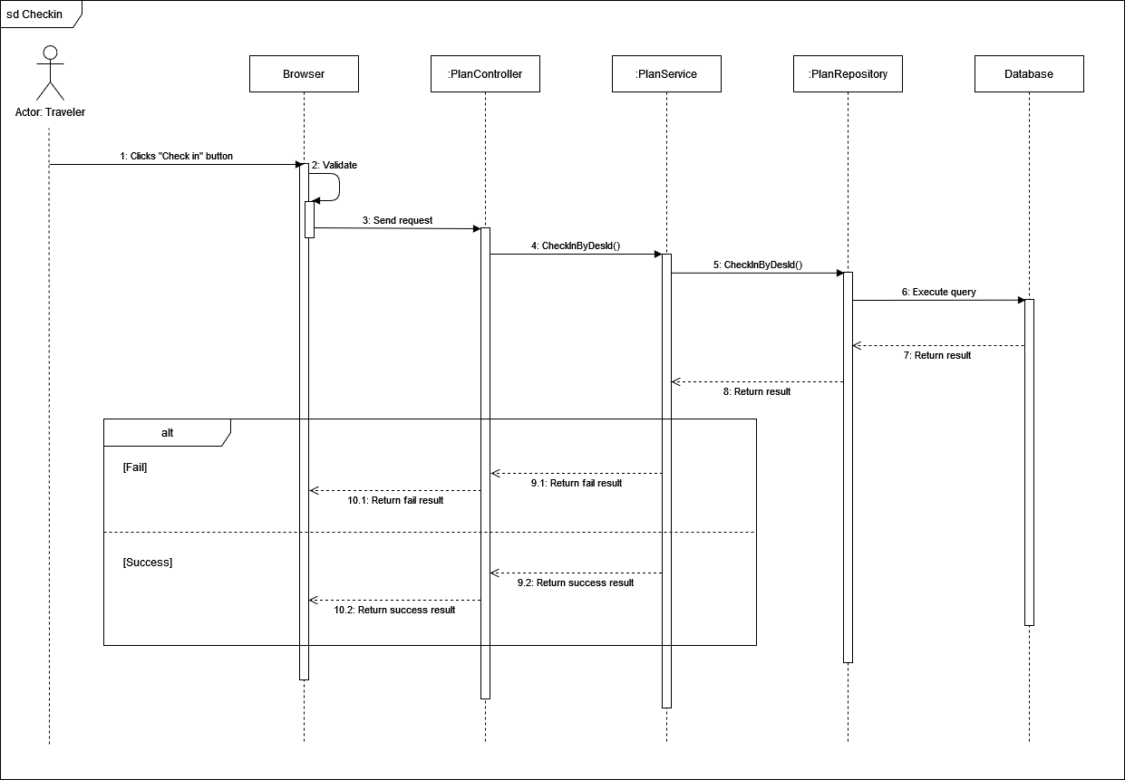

**View destination list**

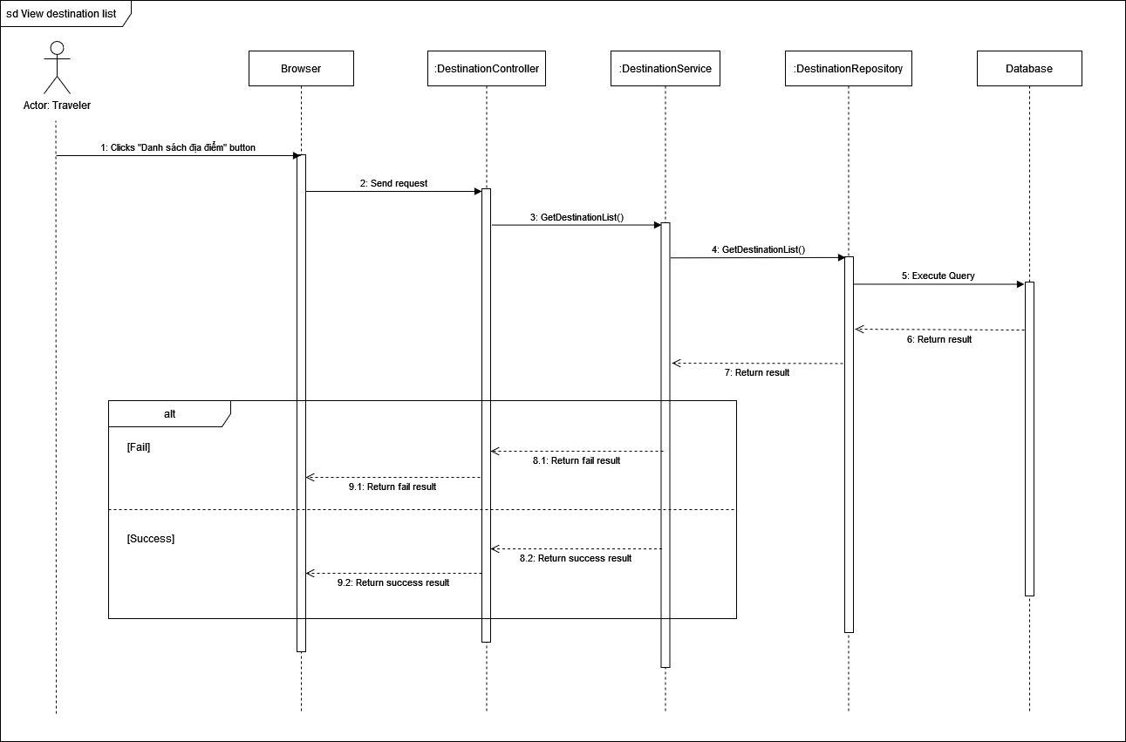

**View destination details**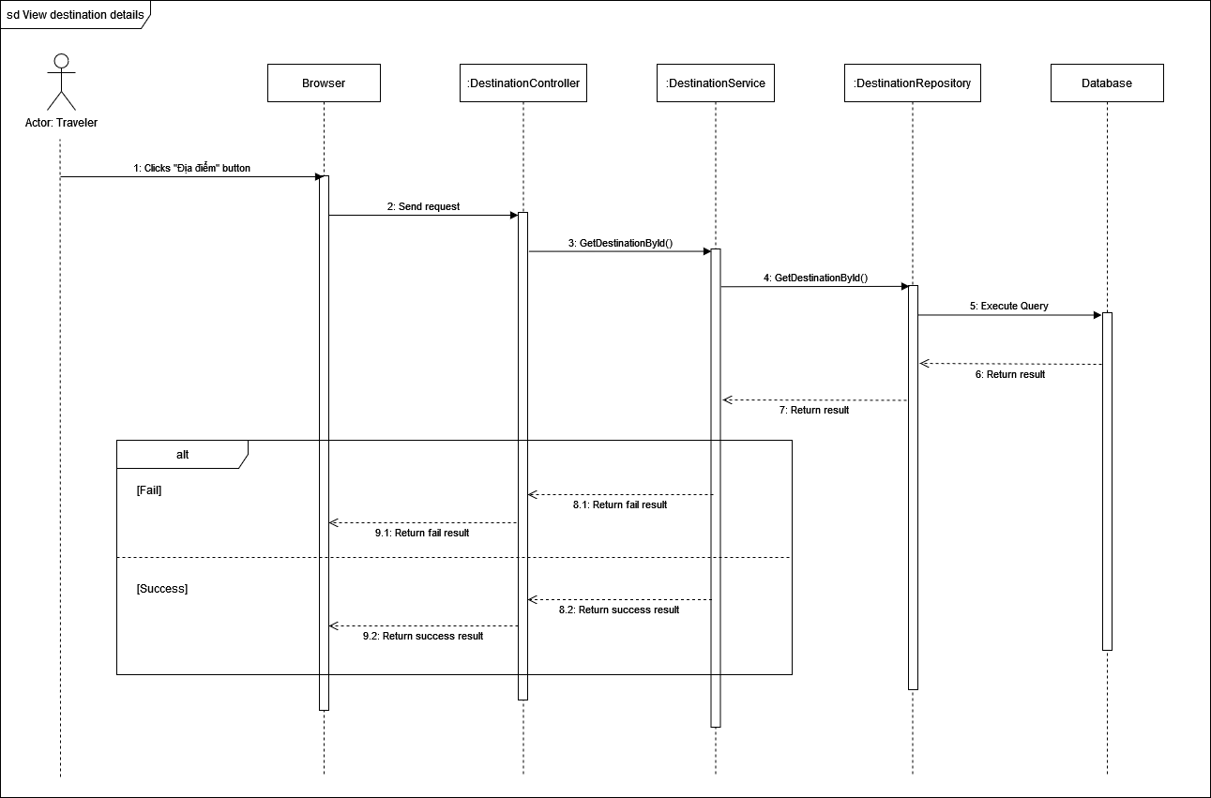

1. **Manage Voucher**
2. **Class Diagram**

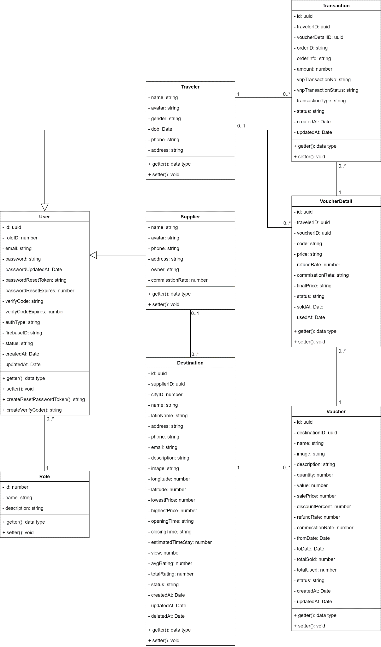

#### 3.3.1.1 User Class

|  |  |  |
| --- | --- | --- |
| **Field name** | **Type** | **Description** |
| id | uuid | Unique identifier of users |
| roleID | number | The identifier of role |
| email | string | Email of user |
| password | string | Password of user |
| passwordUpdatedAt | Date | Time when user update password |
| passwordResetToken | string | Time when user token be updated |
| passwordResetExpires | number |  |
| verifyCode | string | Activated code of user |
| verifyCodeExpires | Date | Time when activated code expires |
| authType | string | Type of authentication |
| fiebaseID | uuid | The identifier of firebase |
| createdAt | Date | Time when user be created |
| updateAt | Date | Time when user be updated |
| status | string | Status of the user |

|  |  |  |
| --- | --- | --- |
| **Method** | **Return type** | **Description** |
| getter | data type | Get attribute value |
| setter | void | Set value of attribute |
| createResetPasswordToken | string | Create new token to reset password |
| createVerifyCode | string | Create new code to verify |

#### 3.3.1.2 Role Class

|  |  |  |
| --- | --- | --- |
| **Field name** | **Type** | **Description** |
| id | number | Unique identifier of role |
| name | string | Name of role |
| description | string | Description of role |

|  |  |  |
| --- | --- | --- |
| **Method** | **Return type** | **Description** |
| getter | data type | Get attribute value |
| setter | void | Set value of attribute |

#### 3.3.1.3 Supplier Class

|  |  |  |
| --- | --- | --- |
| **Field name** | **Type** | **Description** |
| name | number | Name of supplier |
| avatar | string | Avatar of supplier |
| phone | string | Phone of supplier |
| address | string | Address of supplier |
| owner | string | Owner name of the supplier |
| commissionRate | number | Percent of commission |

|  |  |  |
| --- | --- | --- |
| **Method** | **Return type** | **Description** |
| getter | data type | Get attribute value |
| setter | void | Set value of attribute |

#### 3.3.1.3 Traveler Class

|  |  |  |
| --- | --- | --- |
| **Field name** | **Type** | **Description** |
| name | string | Name of traveler |
| avatar | string | Avatar of traveler |
| gender | boolean | Gender of traveler |
| dob | Date | Date of birth of traveler |
| phone | string | Phone number of traveler |

|  |  |  |
| --- | --- | --- |
| **Method** | **Return type** | **Description** |
| getter | data type | Get attribute value |
| setter | void | Set value of attribute |

#### 3.1.1.7 Destination Class

|  |  |  |
| --- | --- | --- |
| **Field name** | **Type** | **Description** |
| **id** | uuid | UnIque identifier of destination |
| **supplierID** | uuid | The identifier of supplier |
| **cityID** | number | The identifier of city |
| **name** | string | Name of destination |
| **address** | string | Address of destination |
| **phone** | string | Phone of destination |
| **email** | string | Email of destination |
| **description** | string | Description of destination |
| **longitude** | number | Coordinate (Longitude) of destination |
| **latitude** | number | Coordinate (Latitude) of destination |
| **lowestPrice** | number | Minimum price of destination |
| **highestPrice** | number | Maximum price of destination |
| **openingTime** | string | Time when destination open |
| **closingTime** | string | Time when destination close |
| **estimatedTimeStay** | number | Average time when staying at destination |
| **view** | number | User view number of destination |
| **avgRating** | number | Average rating of destination |
| **totalRating** | number | Total rating of destination |
| **status** | string | Status of destination |
| **createdAt** | date | Time when destination be created |
| **updatedAt** | date | Time when destination be updated |
| **deletedAt** | date | Time when destination be deleted |
| **image** | string | Image of destination |
| **latinName** | string | None tonal symbols name |

|  |  |  |
| --- | --- | --- |
| **Method** | **Return type** | **Description** |
| getter | data type | Get attribute value |
| setter | void | Set value of attribute |

#### 3.3.1.5 Voucher Class

|  |  |  |
| --- | --- | --- |
| **Field name** | **Type** | **Description** |
| **id** | uuid | Unique identifier of voucher |
| **destinationID** | uuid | The identifier of destination |
| **name** | string | Name of voucher |
| **description** | string | Description of voucher |
| **image** | string | Image of voucher |
| **quantity** | number | Quantity of voucher |
| **totalSold** | number | Number of sold voucher |
| **totalUsed** | number | Number of used voucher |
| c**ommissionRate** | number | Percent of commission |
| **value** | number | Value of voucher |
| **salePrice** | number | Price to sale of voucher |
| dis**countPercent** | number | Percent between value and salePrice |
| **fromDate** | date | Time when voucher is available to use |
| **toDate** | date | Time when voucher is unavailable to use |
| **status** | string | Status of voucher |
| **createdAt** | date | Time when voucher created |
| **updatedAt** | date | Time when voucher updated |
| **refundRate** | number | Percent of money that traveler will get when refund |

|  |  |  |
| --- | --- | --- |
| **Method** | **Return type** | **Description** |
| getter | data type | Get attribute value |
| setter | void | Set value of attribute |

#### 

#### 3.3.1.6 Voucher Detail Class

|  |  |  |
| --- | --- | --- |
| **Field name** | **Type** | **Description** |
| **id** | uuid | Unique identifier of voucher detail |
| travelerID | uuid | The identifier of traveler |
| **voucherID** | uuid | The indentifier of voucher |
| **price** | string | Price of voucher detail |
| **refundRate** | number | Percent of money traveler will get when refund |
| commissionRate | string | Percent of commission |
| finalPrice | string | Money supplier will get after subtracted commissionRate |
| soldAt | Date | Time when voucher detail sold |
| createdAt | date | Time when voucher detail created |

|  |  |  |
| --- | --- | --- |
| **Method** | **Return type** | **Description** |
| getter | data type | Get attribute value |
| setter | void | Set value of attribute |

#### 

#### 3.3.1.7 Transaction Class

|  |  |  |
| --- | --- | --- |
| **Field name** | **Type** | **Description** |
| **id** | uuid | Unique identifier of transaction |
| **travelerID** | uuid | The identifier of transaction |
| **voucherDetailD** | uuid | The identifier of voucher detail |
| orderID | String | The identifier of order |
| OrderInfo | string | Information of order |
| Amount | Number | Number of item in transaction |
| vnpTransactionNo | number | Transaction code of VNP |
| vnpTransactionStatus | string | Status of VNP transaction |
| transactionType | String | Type of transaction |
| Status | String | Status of transaction |
| createAt | Date | Time when transaction created |
| updateAt | Date | Time when transaction updated |

|  |  |  |
| --- | --- | --- |
| **Method** | **Return type** | **Description** |
| getter | data type | Get attribute value |
| setter | void | Set value of attribute |

***3.3.2 View voucher list***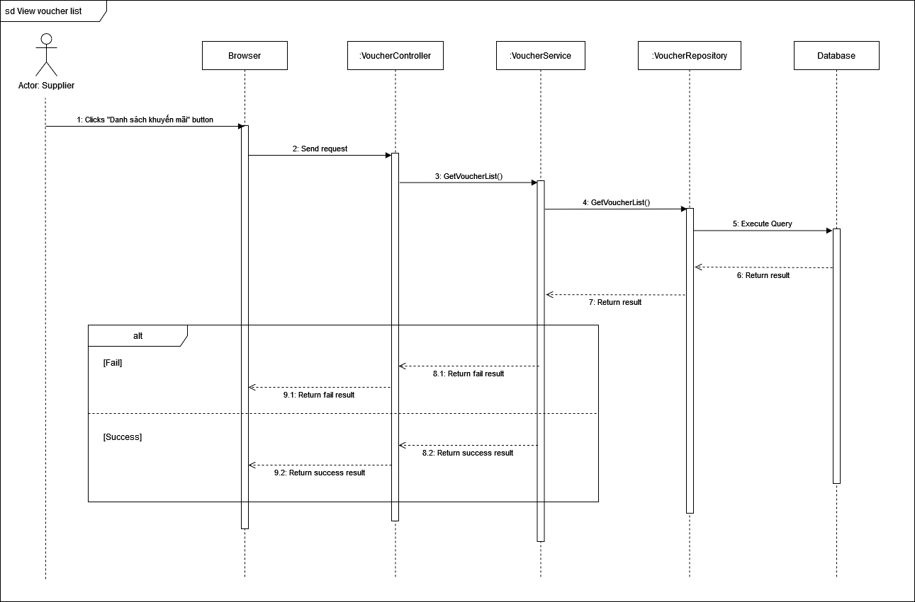

#### 3.3.3 View voucher details

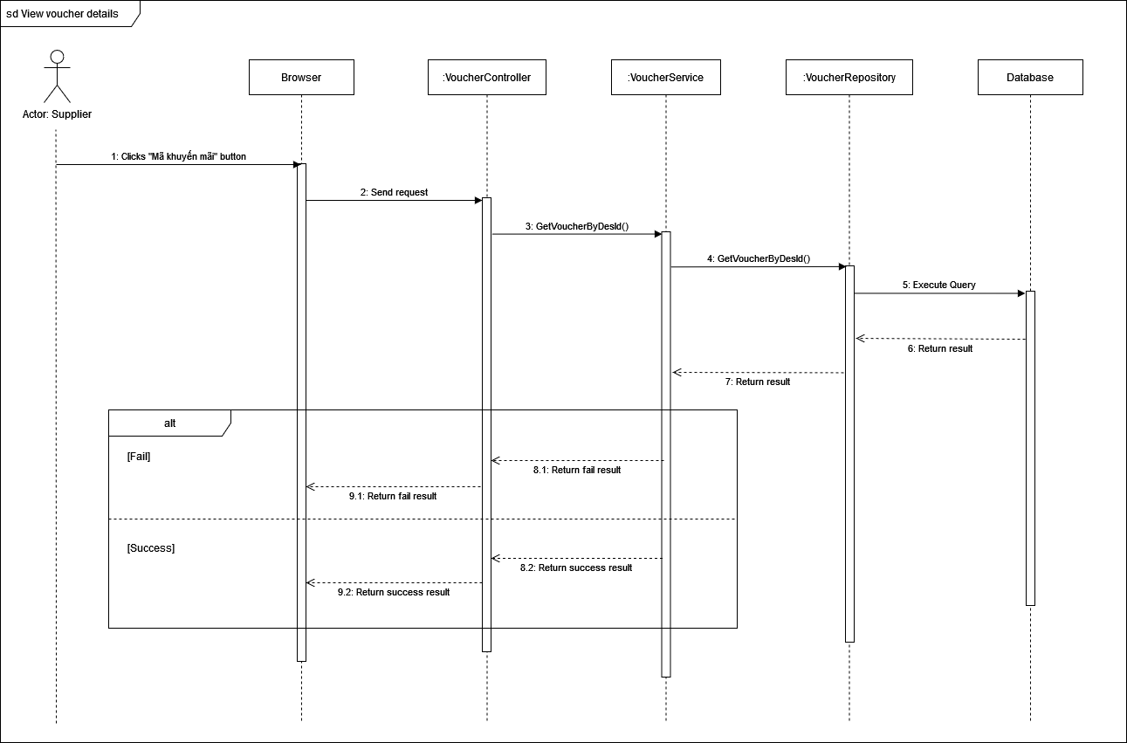

3.3.3 Create voucher

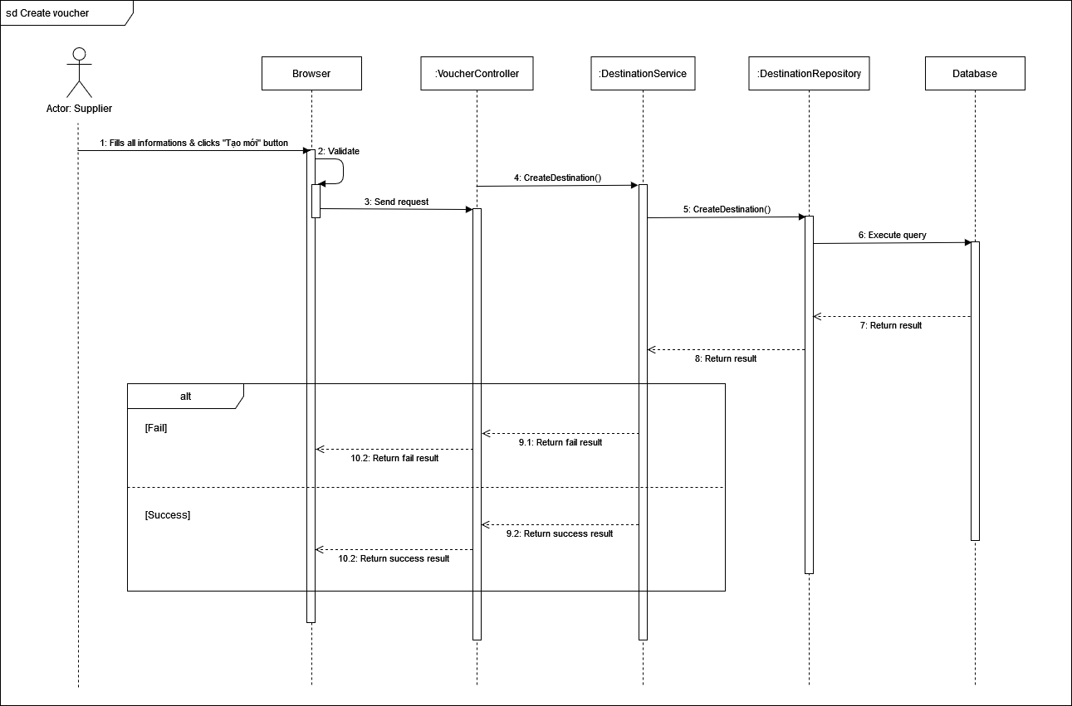

#### 3.3.3 Update voucher

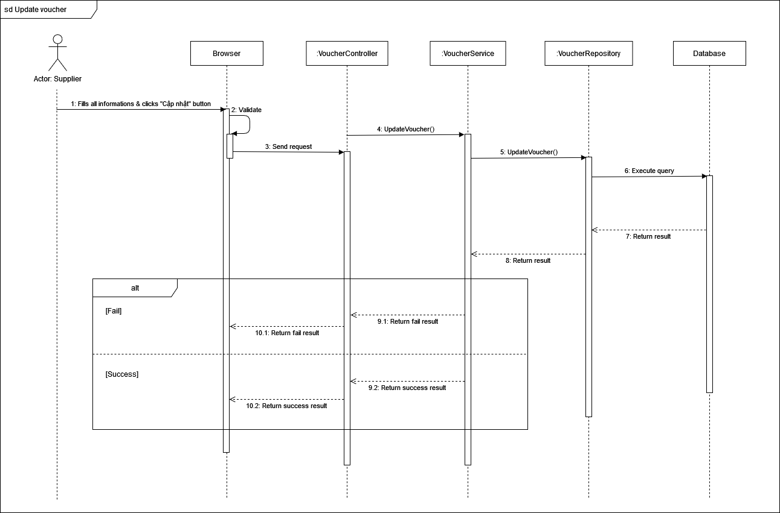

3.3.3 Cancel voucher

1. **Software Testing Documentation**
2. **Scope of Testing**
3. **Test Scope**

We plan to define test cases in main flow only.

1. **Test Model**

We use incremental testing for some approaches

* Each module is required a role to use clearly.
* Each module could test at the early-stage pf the develop process.

1. **Testing Levels**

* Testing level: User Acceptance Test.
* Testing Types: Function Testing, User Interface Testing.

1. **Test Plan**
2. **Test Stages**

| **Type of Tests** | **Deliverable Item** | | | |
| --- | --- | --- | --- | --- |
| **Unit** | **Integration** | **System** | **Acceptance** |
| Function Testing |  |  |  | X |
| User Interface Testing |  |  |  | X |

1. **Resources**

| **Worker** | **Role** | **Specific Responsibilities** |
| --- | --- | --- |
| Duong Thanh Huy | Leader | Planning, execute, verify test result |
| Quach Khong Triet | Member | Planning, execute, verify test result |
| Du Xuan Loc | Member | Planning, execute, verify test result |
| Tran Trung Hau | Member | Planning, execute, verify test result |

1. **Test Milestones**

| **No.** | **Testing Level** | **Due Date** |
| --- | --- | --- |
| 1 | Test Document | 9/12/2022 |

1. **Test Cases and Test Reports**

| **Testing Level** | **File Name** |
| --- | --- |
| User Acceptance Test | Sketter – Test Web App  Sketter – Test Mobile App |

1. **Release Package & User Guides**
2. **Deliverable Package**
3. **Source program**

| **No.** | **Section** | **Deliverable Item** | **Version** |
| --- | --- | --- | --- |
| 1 | Web App | Sketter_web_app | 1.0 |
| 2 | Mobile App | Sketter_mobile_app | 1.0 |
| 3 | Node.js | Sketter_api | 1.0 |
| 4 | PostgreSQL | Sketter_database | 1.0 |

1. **Database**

| **Section** | **Deliverable Item** | **Version** |
| --- | --- | --- |
| Table | Catalogs | 1.0 |
| Cities | 1.0 |
| DestinationBoookmarks | 1.0 |
| DestinationCatalogs | 1.0 |
| DestinationImages | 1.0 |
| DestinationPersonalities | 1.0 |
| DestinationRatings | 1.0 |
| DestinationRecommendedTImes | 1.0 |
| Destinations | 1.0 |
| Distances | 1.0 |
| Personalities | 1.0 |
| PlanDestinations | 1.0 |
| Plans | 1.0 |
| Roles | 1.0 |
| Sessions | 1.0 |
| TimeFrames | 1.0 |
| TravelPersonalities | 1.0 |
| Users | 1.0 |
| Vouchers | 1.0 |

1. **Document**

| **No.** | **Section** | **Deliverable Item** | **Version** |
| --- | --- | --- | --- |
| 1 | Project Introduction | Report1_Project Introduction.docx | 1.0 |
| 2 | Project management plan | Report2_Project Management Plan.docx | 1.0 |
| 3 | Software requirement specification | Report3_Software Requirement Specification.docx | 1.0 |
| 4 | Software design document | Report4_Software Design Document.docx | 1.0 |
| 5 | Software test document | Report5_Test Documentation.docx | 1.0 |
| Report5_Unit Test.xlsx | 1.0 |
| Report5_Test Report.xlsx | 1.0 |
| 6 | Software user guides | Report6_Software User Guides.docx | 1.0 |
| 7 | Final project report | Report7_Final Project Report.docx | 1.0 |

1. **Installation Guides**
2. **System Requirements**
3. **Web app requirements**

|  |  |
| --- | --- |
| **Type** | **Recommended requirement** |
| Hardware | |
| Processor | Intel® Core™ i3-5010U Processor or faster processor |
| RAM | 8GB or more |
| Free space storage | 2GB or more |
| Software | |
| Operating System | Windows 7 & Windows 10 |
| Web Browser | Chrome 107.0.5304.107 64 bit or latest version |
| Internet bandwidth | 5MB/s or more |

1. **Mobile app requirements**

|  |  |
| --- | --- |
| **Type** | **Recommended requirement** |
| Hardware | |
| Processor | Intel Atom® Processor Z2520 or faster processor |
| RAM | 8GB or more |
| Free space storage | 2GB or more |
| Software | |
| Operating System | Android 10.0 or higher |
| Internet bandwidth | 5MB/s or more |

1. **Installation Instruction**
2. **Backend installation guides**
   * + 1. Access link <https://www.heroku.com/>

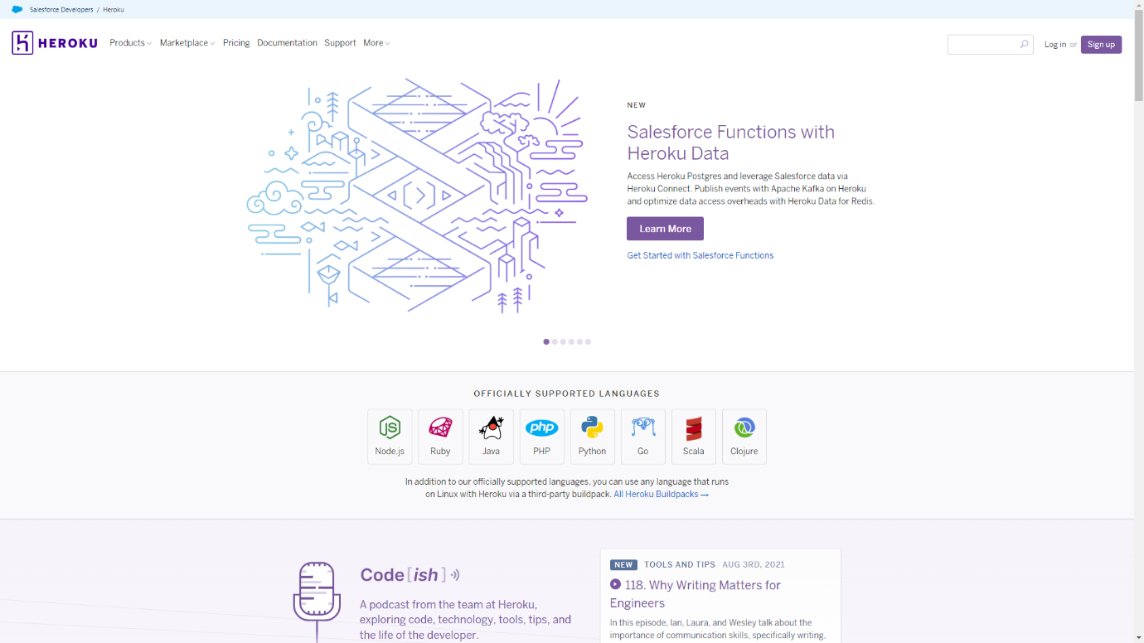

* + - 1. Click on "Log in" button

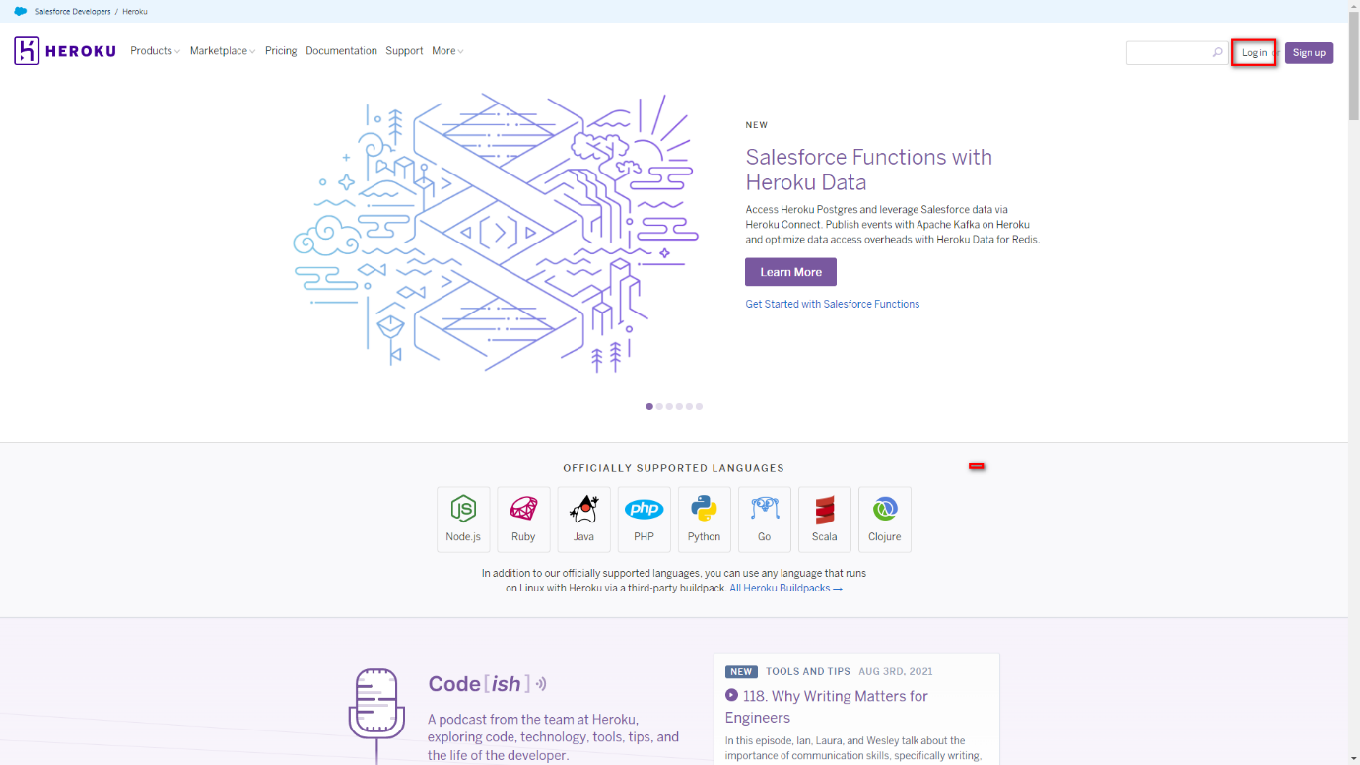

* + - 1. Login with your Heroku account

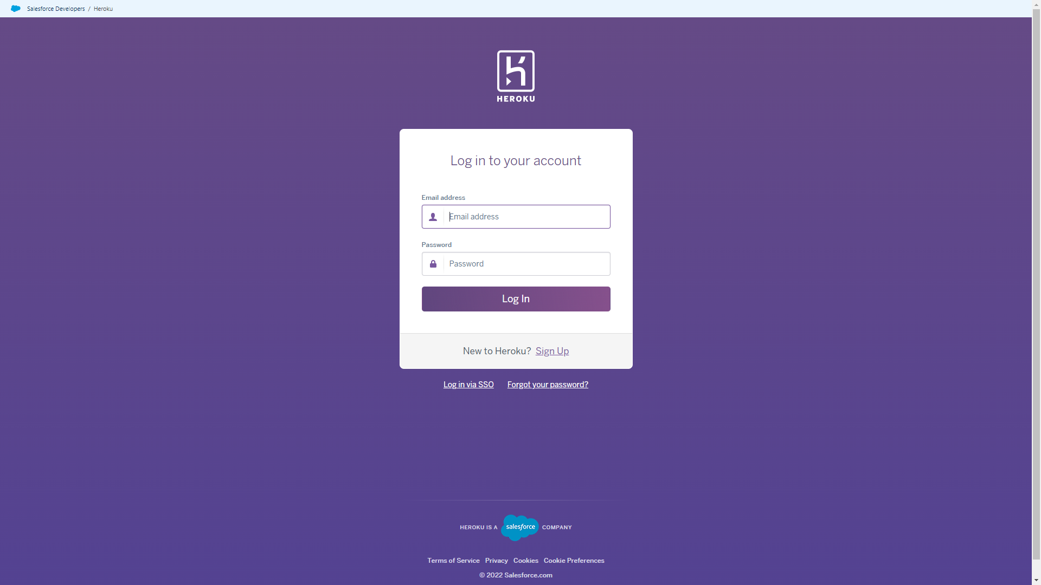

* + - 1. After logging in, click on "New" button then choose "Create new app"

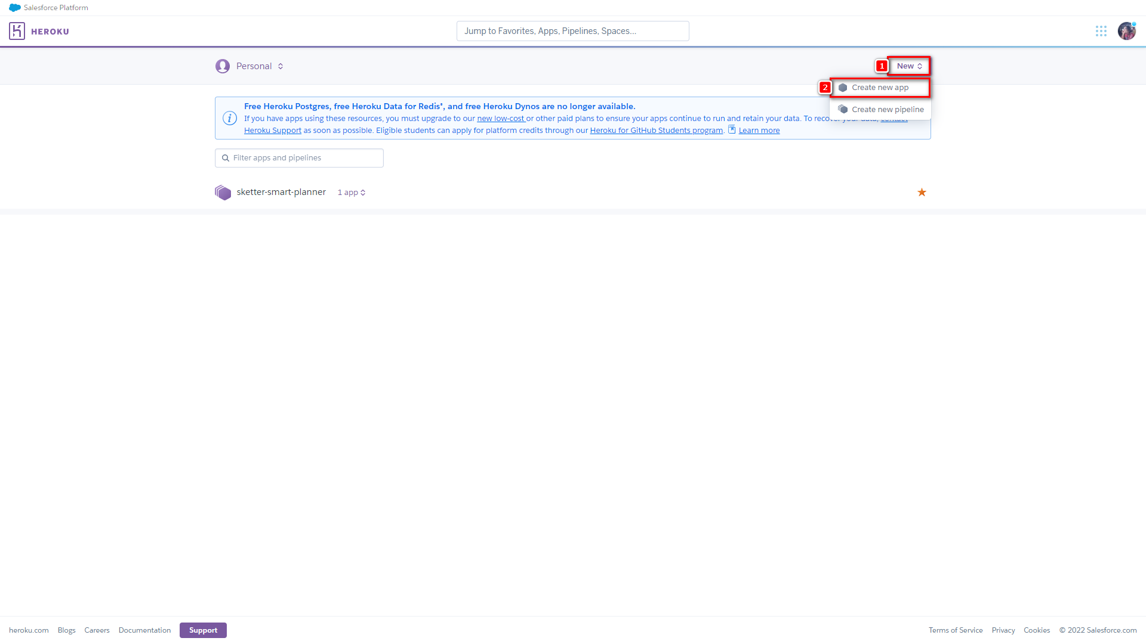

* + - 1. Input app name and choose a region and click "Create app" button

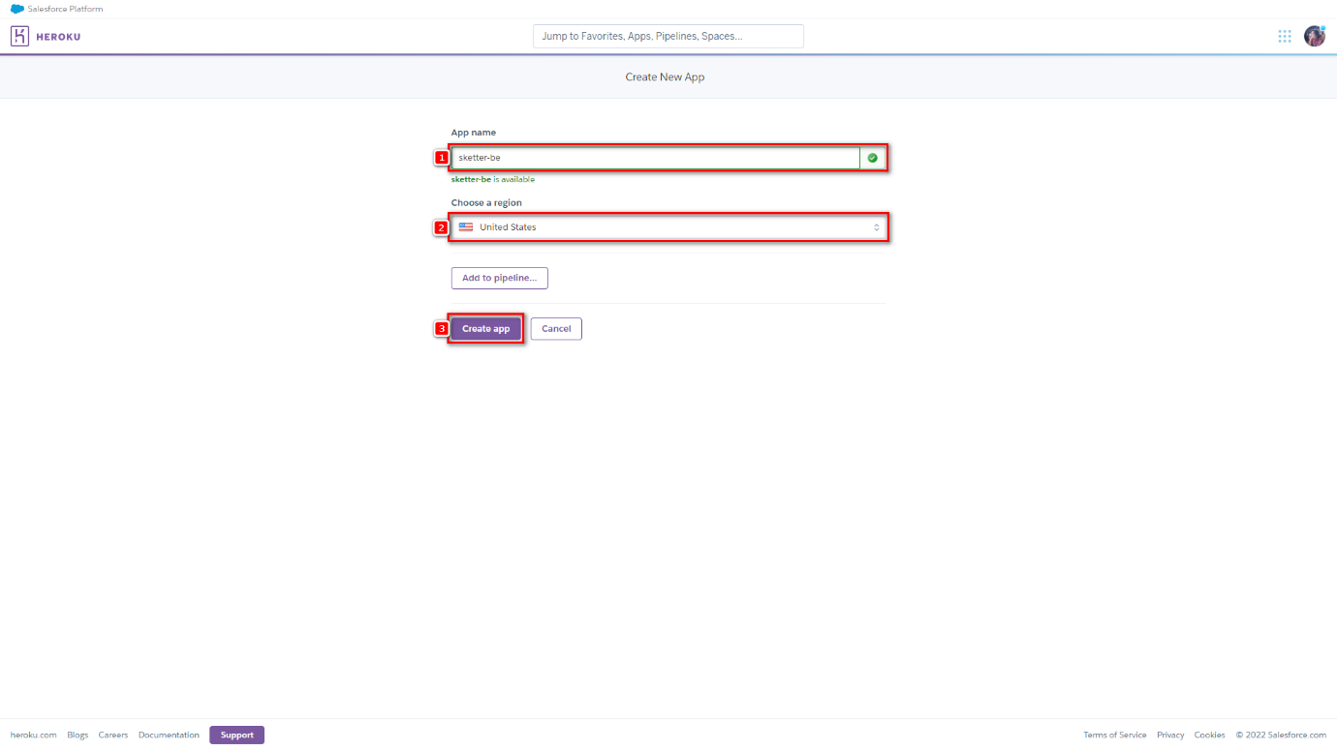

* + - 1. App has been created successfully

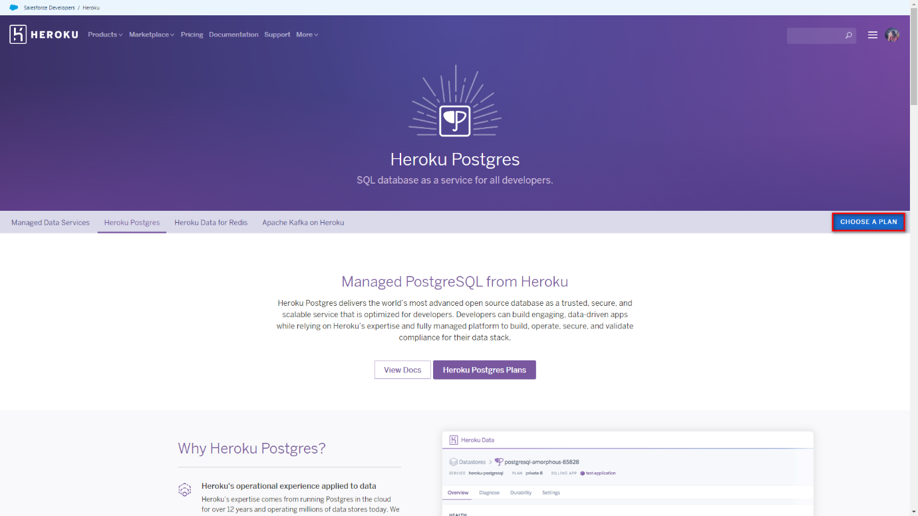

* + - 1. Open a new tab, then access link https://www.heroku.com/postgres, then click on "CHOOSE A PLAN" button

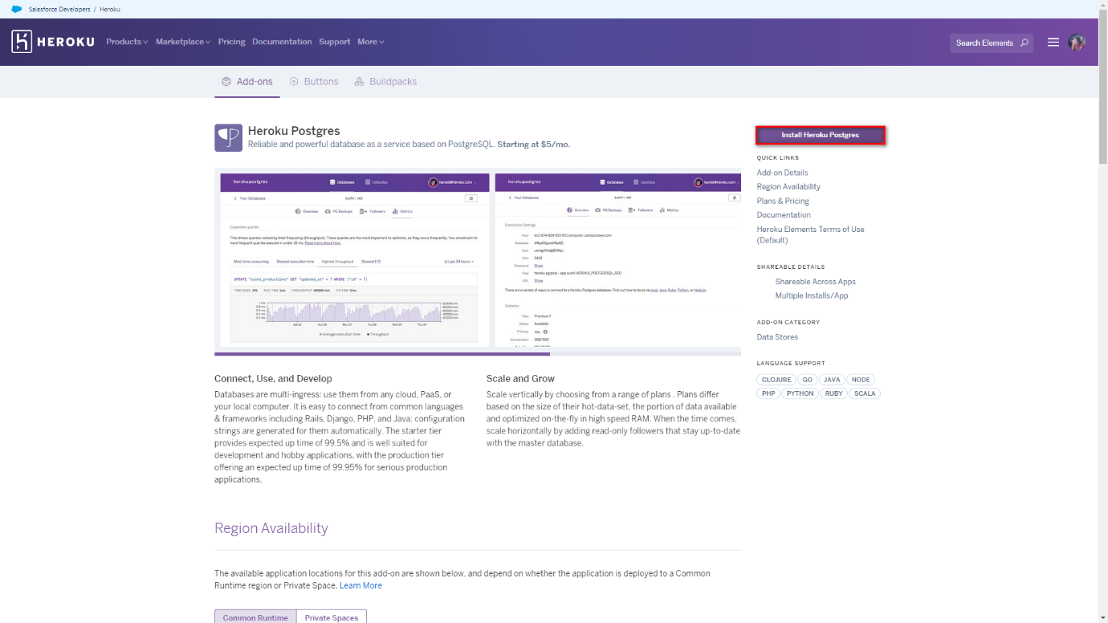

* + - 1. Click on "Install Heroku Postgres" button



* + - 1. Choose a plan and input app name which has been created before

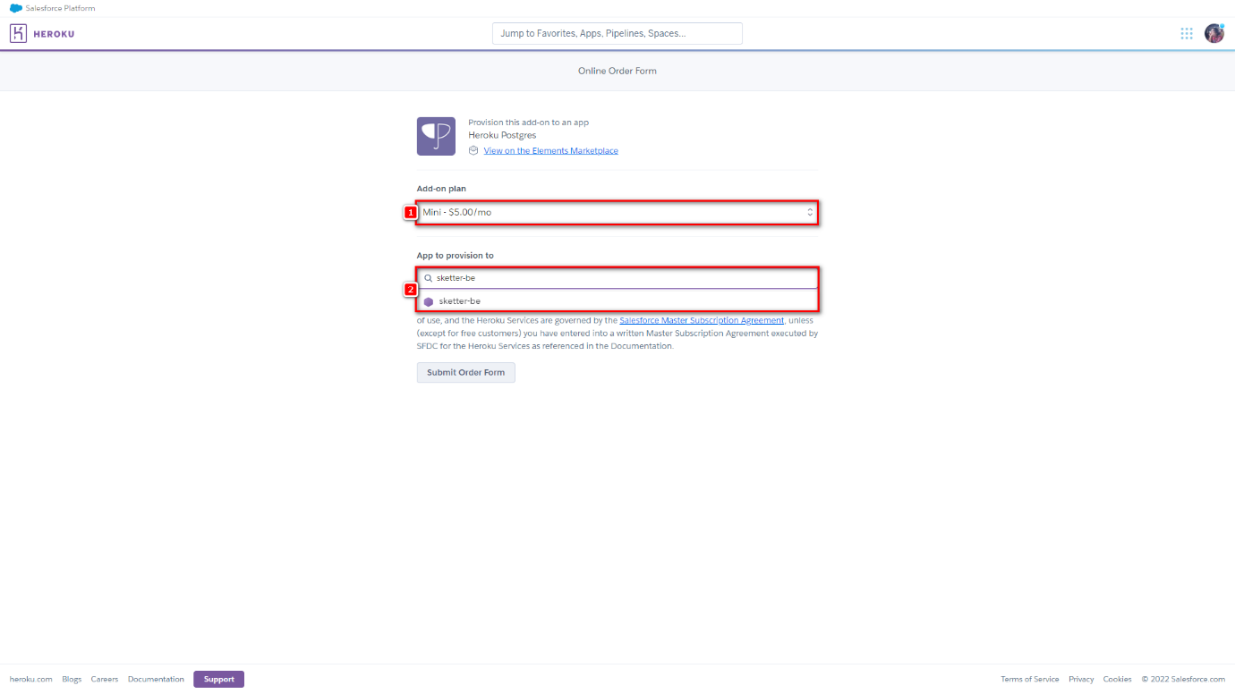

* + - 1. Click on "Submit Order Form"

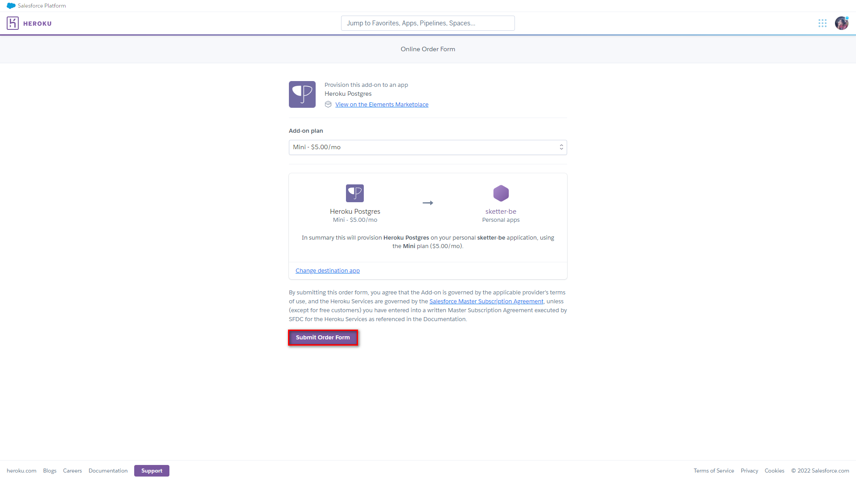

* + - 1. After ordering successfully, click on "Settings" tab

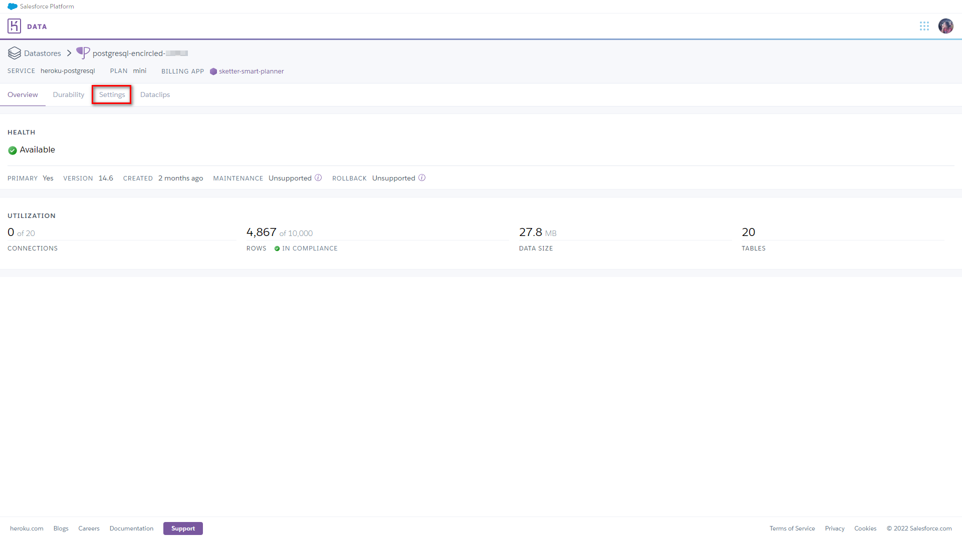

* + - 1. In "Settings" tab, click on "View Credentials..." of Database Credentials

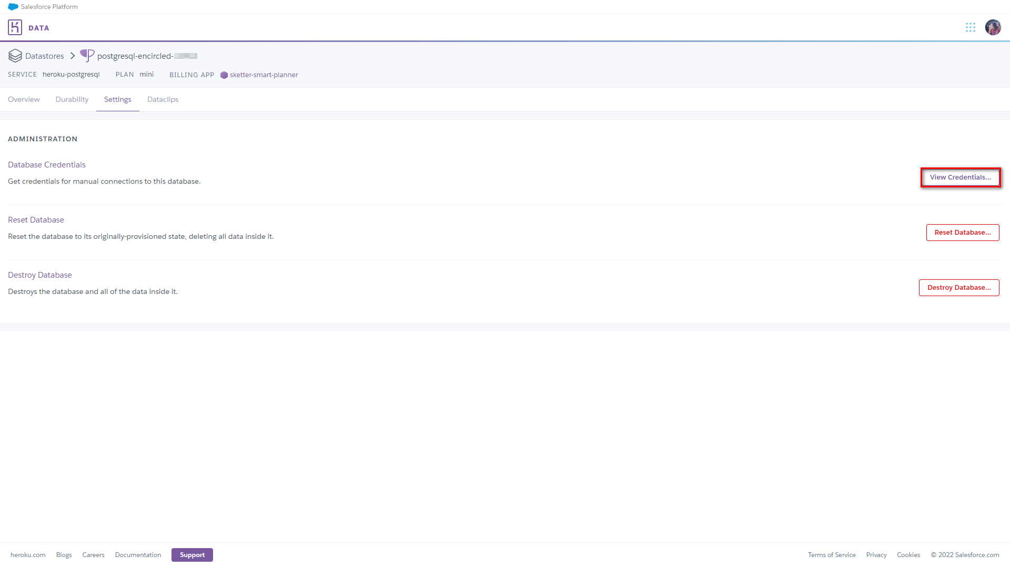

* + - 1. Database credentials detail

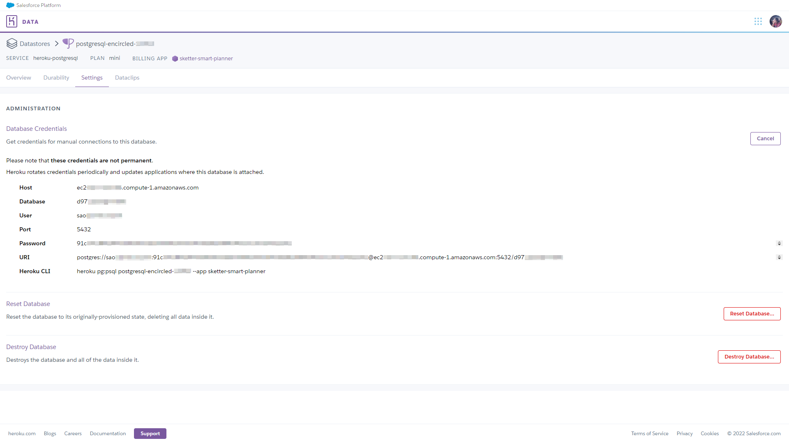

* + - 1. Open pgAdmin and input password

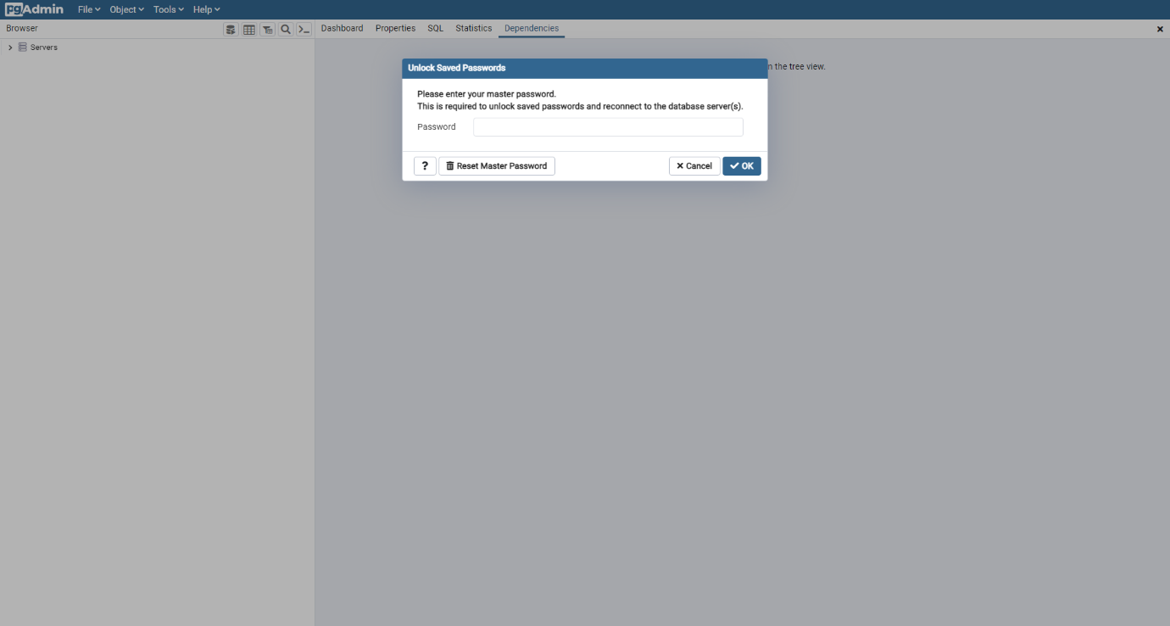

* + - 1. Right-click on "Servers" and choose "Register" > "Server..."

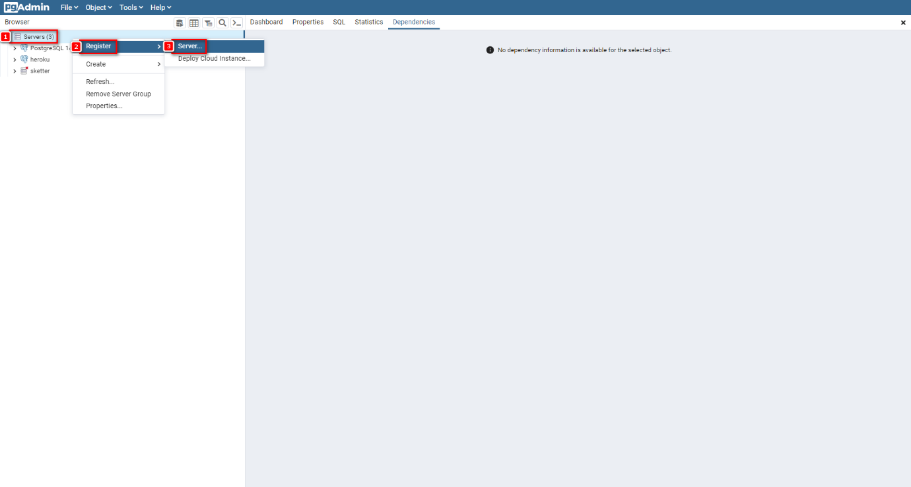

* + - 1. In General tab, input server name

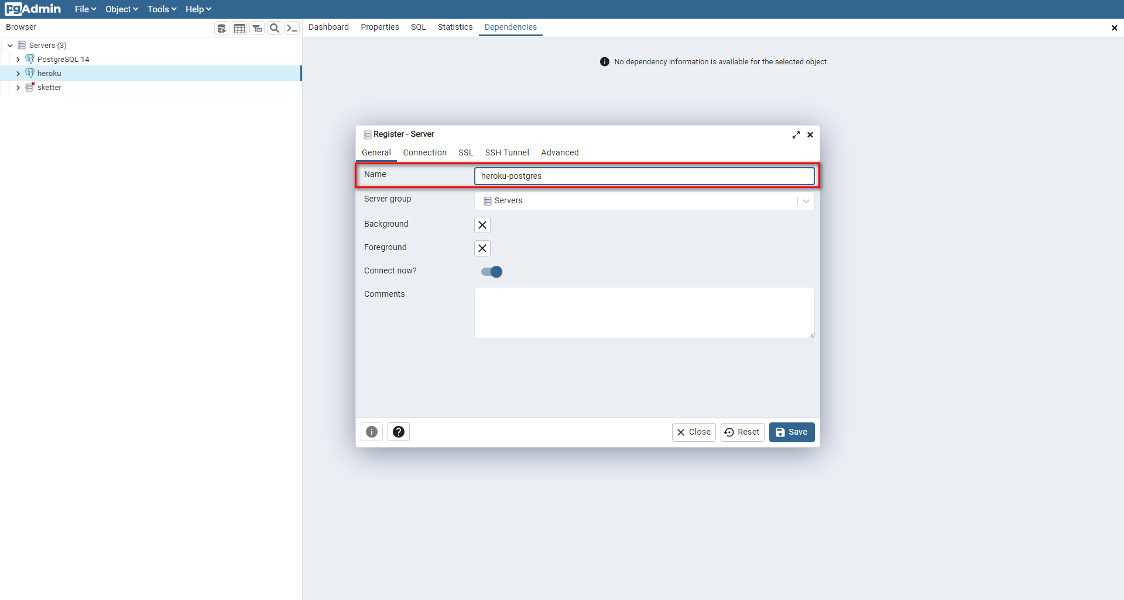

* + - 1. In Connection tab, fill form from information in Database Credentials, then click on "Save" button

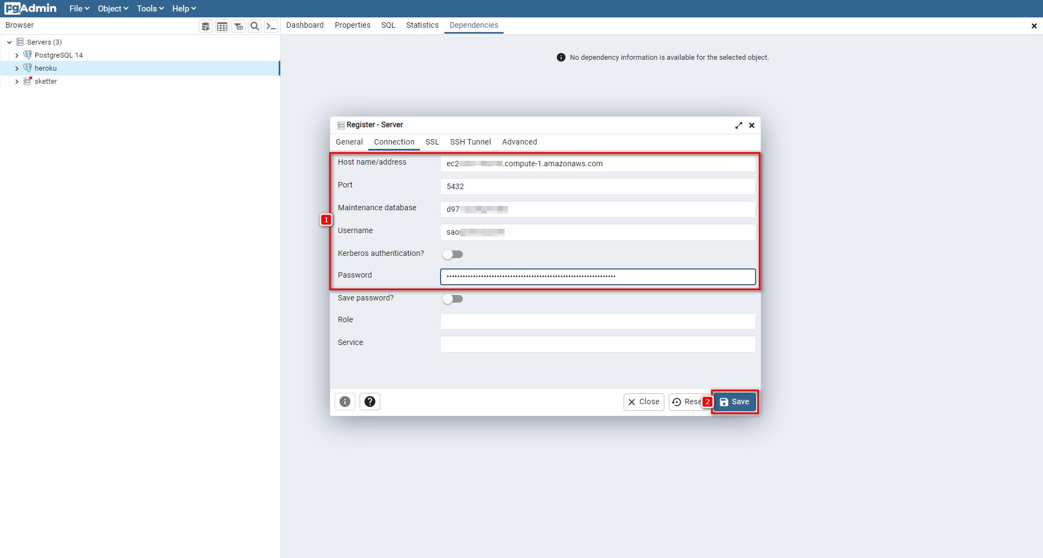

* + - 1. Expand server and database with yellow icon is your database

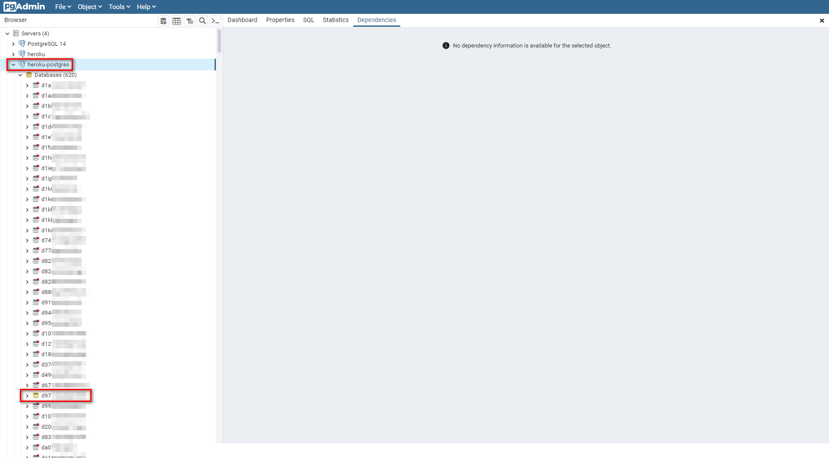

* + - 1. Open file ".env" in API Service folder (C:\Users\Admin\Documents\Capstone\sketter-api), then copy URI in Database Credentials to POSTGRES_URI in file ".env" and push to GitHub

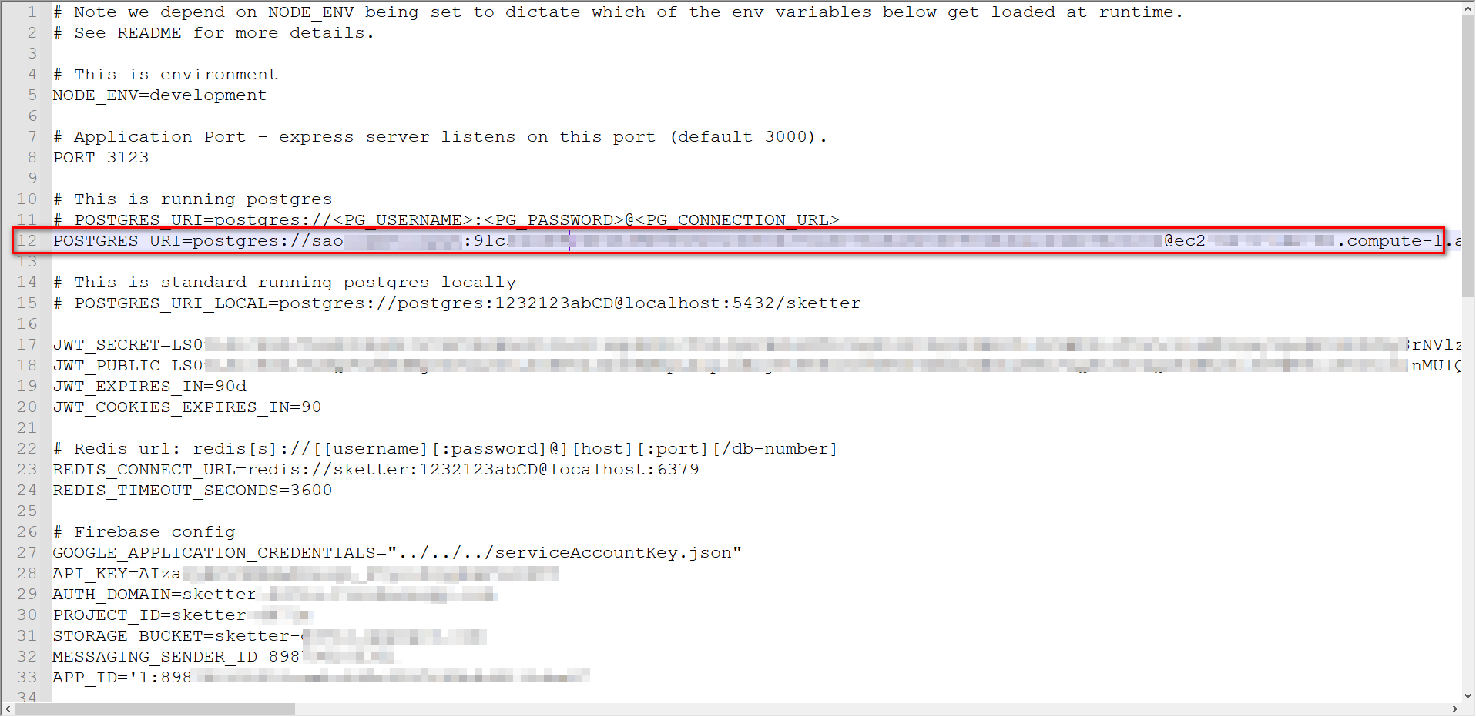

* + - 1. Back to screen on step 6, choose GitHub deployment method, then search repository name and click "Connect" button

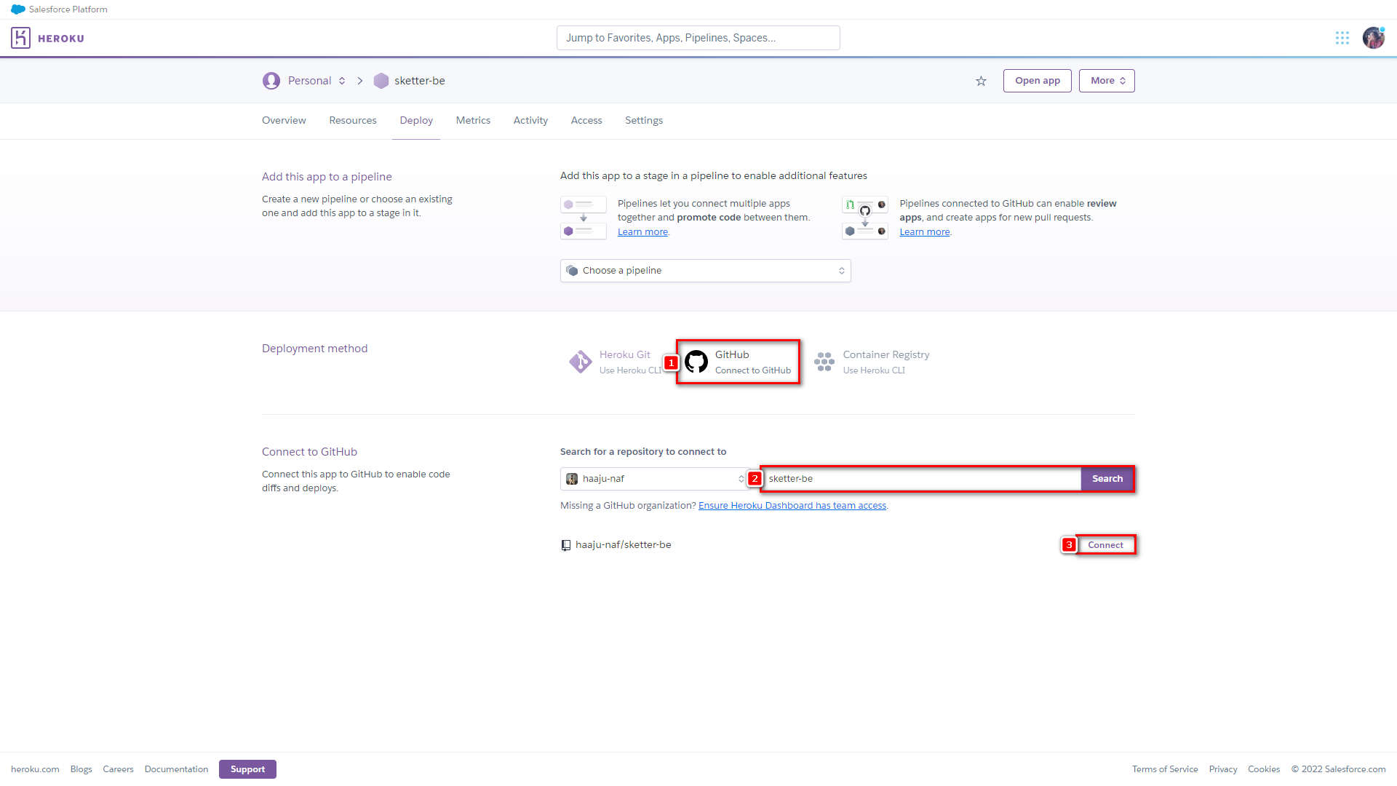

* + - 1. Choose branch to deploy and click "Deploy Branch" button

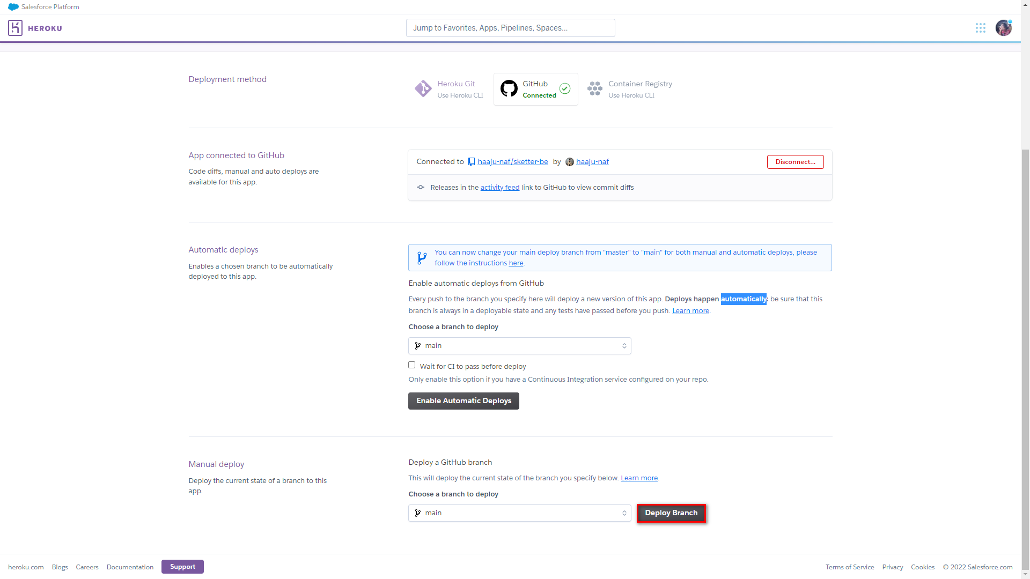

* + - 1. Wait for Heroku deploy

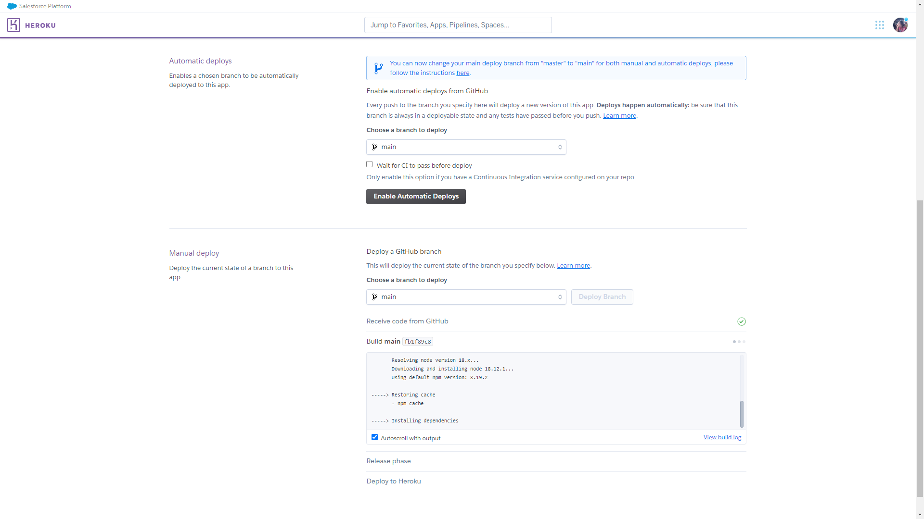

* + - 1. Deployed successfully, click on "View" button to get API URL

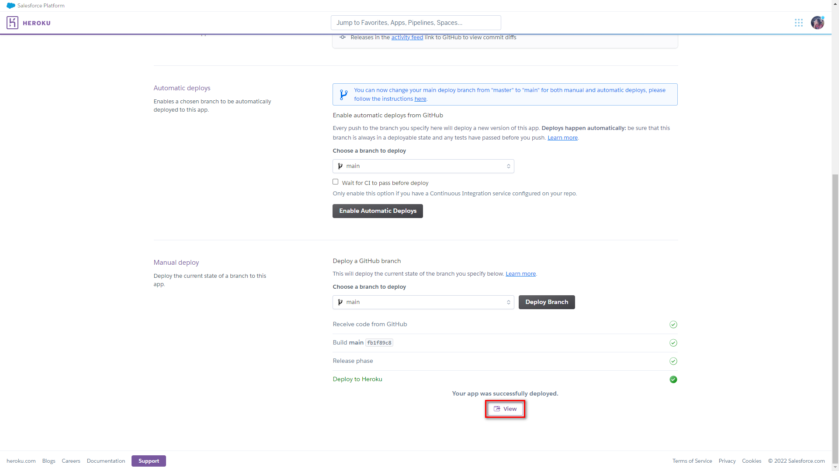

1. **Mobile installation guides**
2. Go into Internal storage

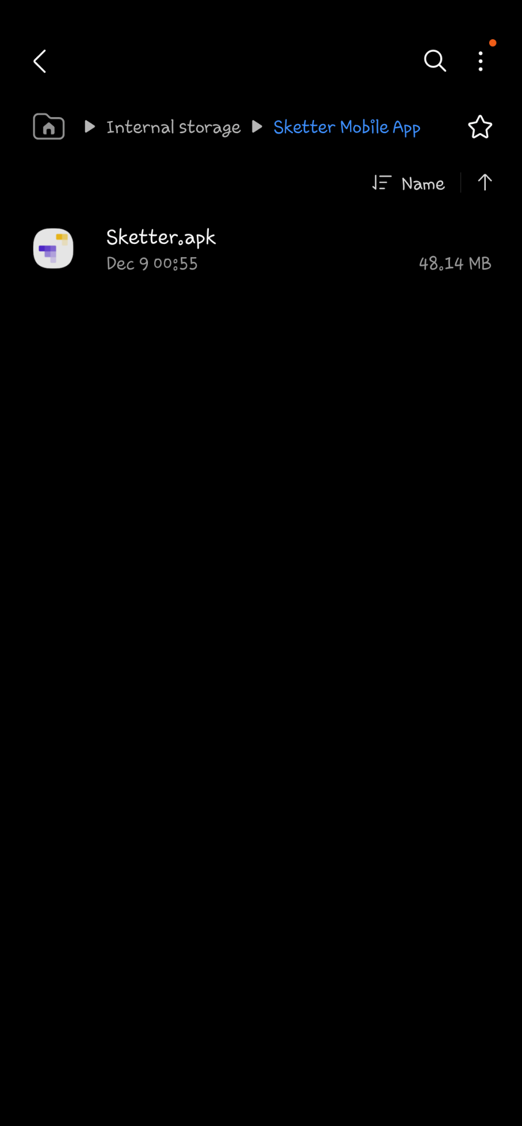

1. Install file Sketter mobile application with Sketter.apk by pressing “Install” button

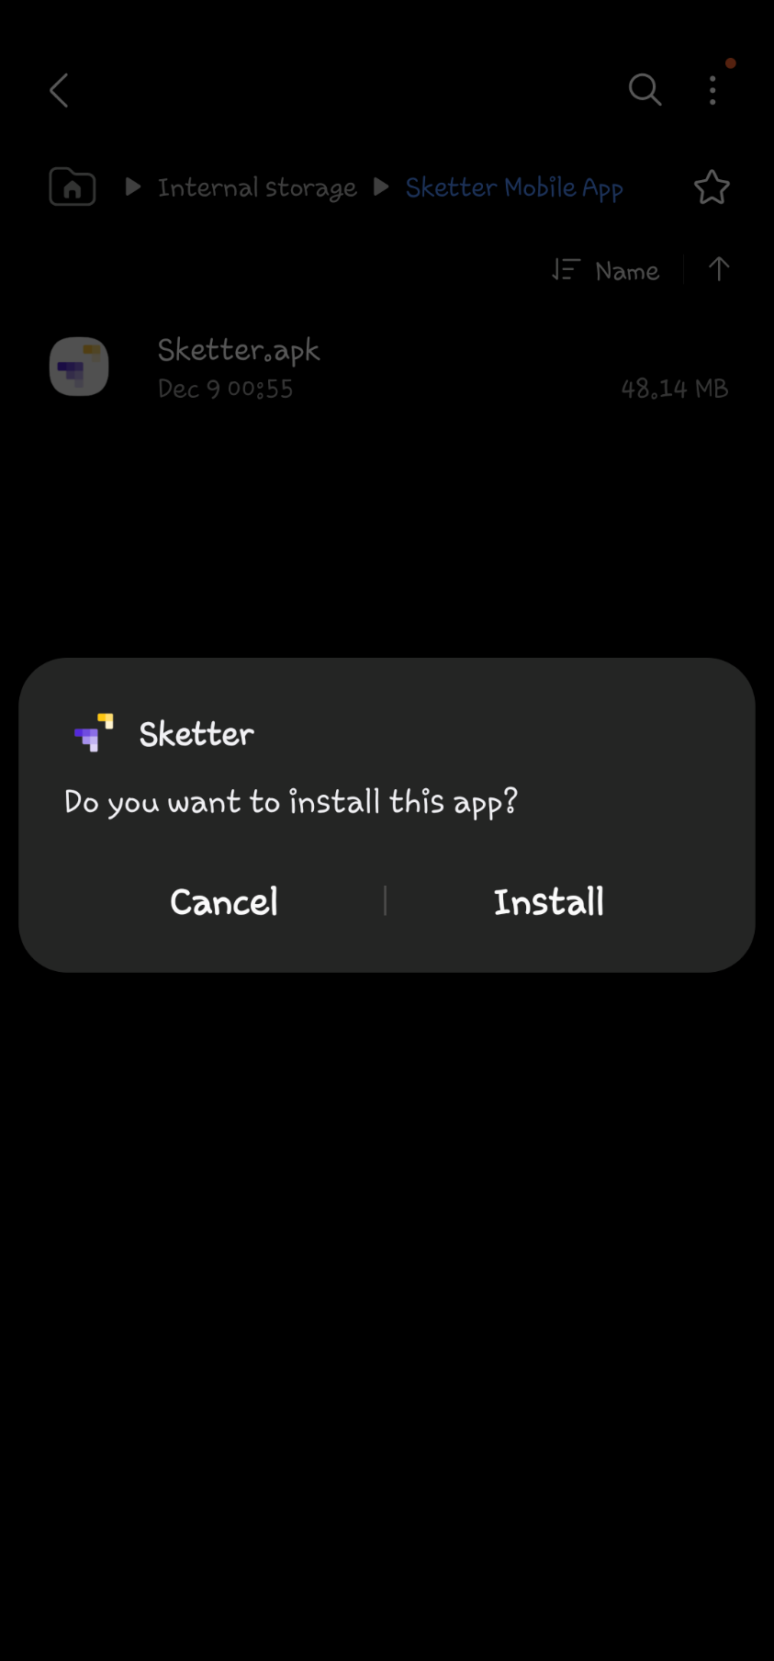

1. Waiting for the install

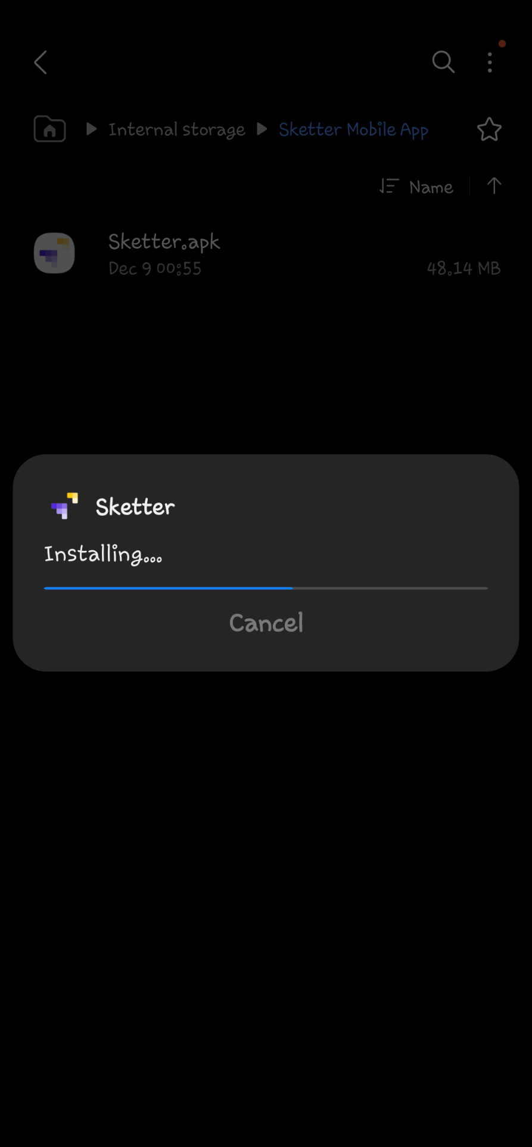

1. Press “Open” button to open Sketter

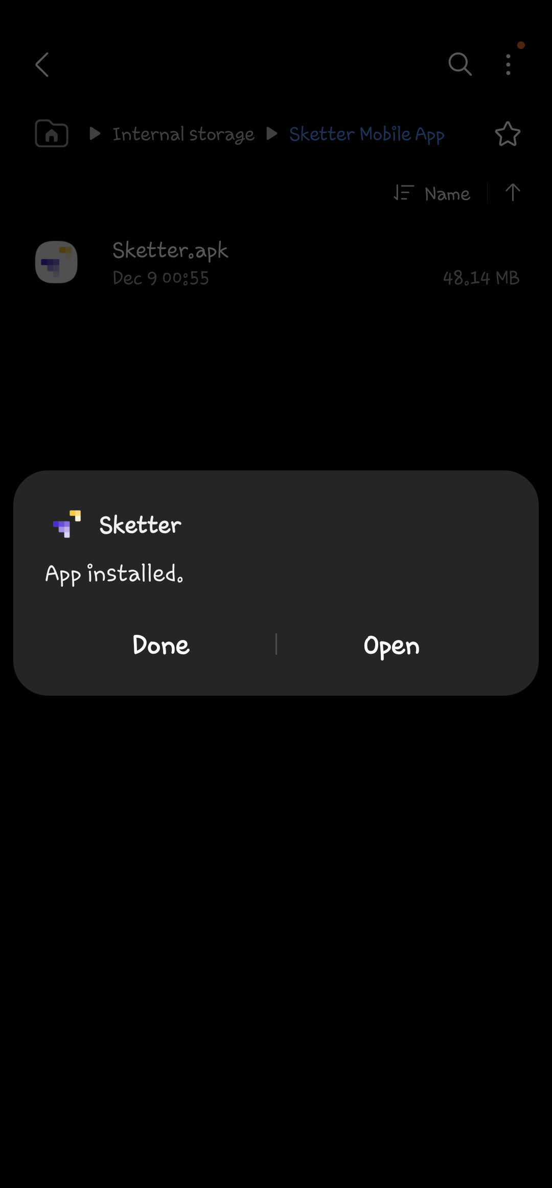

1. **Web installation guides**
2. Open file "package.json" in Web Service folder (C:\Users\Admin\Documents\Capstone\sketter-fe), then copy API URL to proxy in "package.json" and push it to GitHub

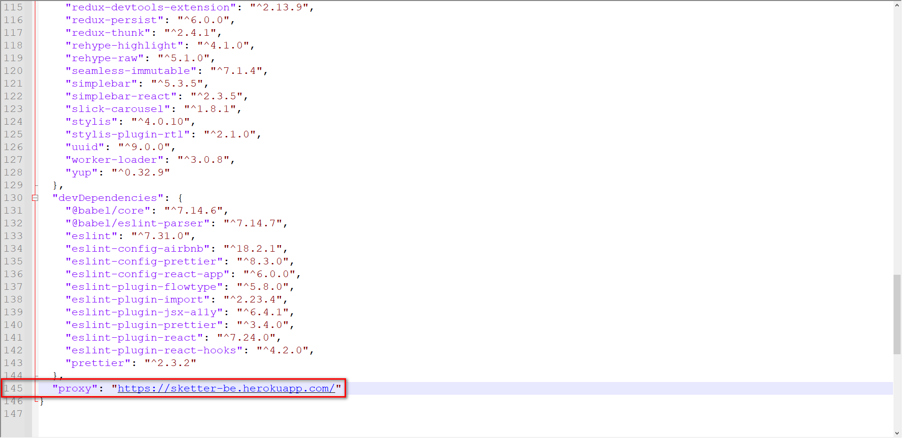

1. Access link https://www.cloudflare.com, then click on "Log In" button

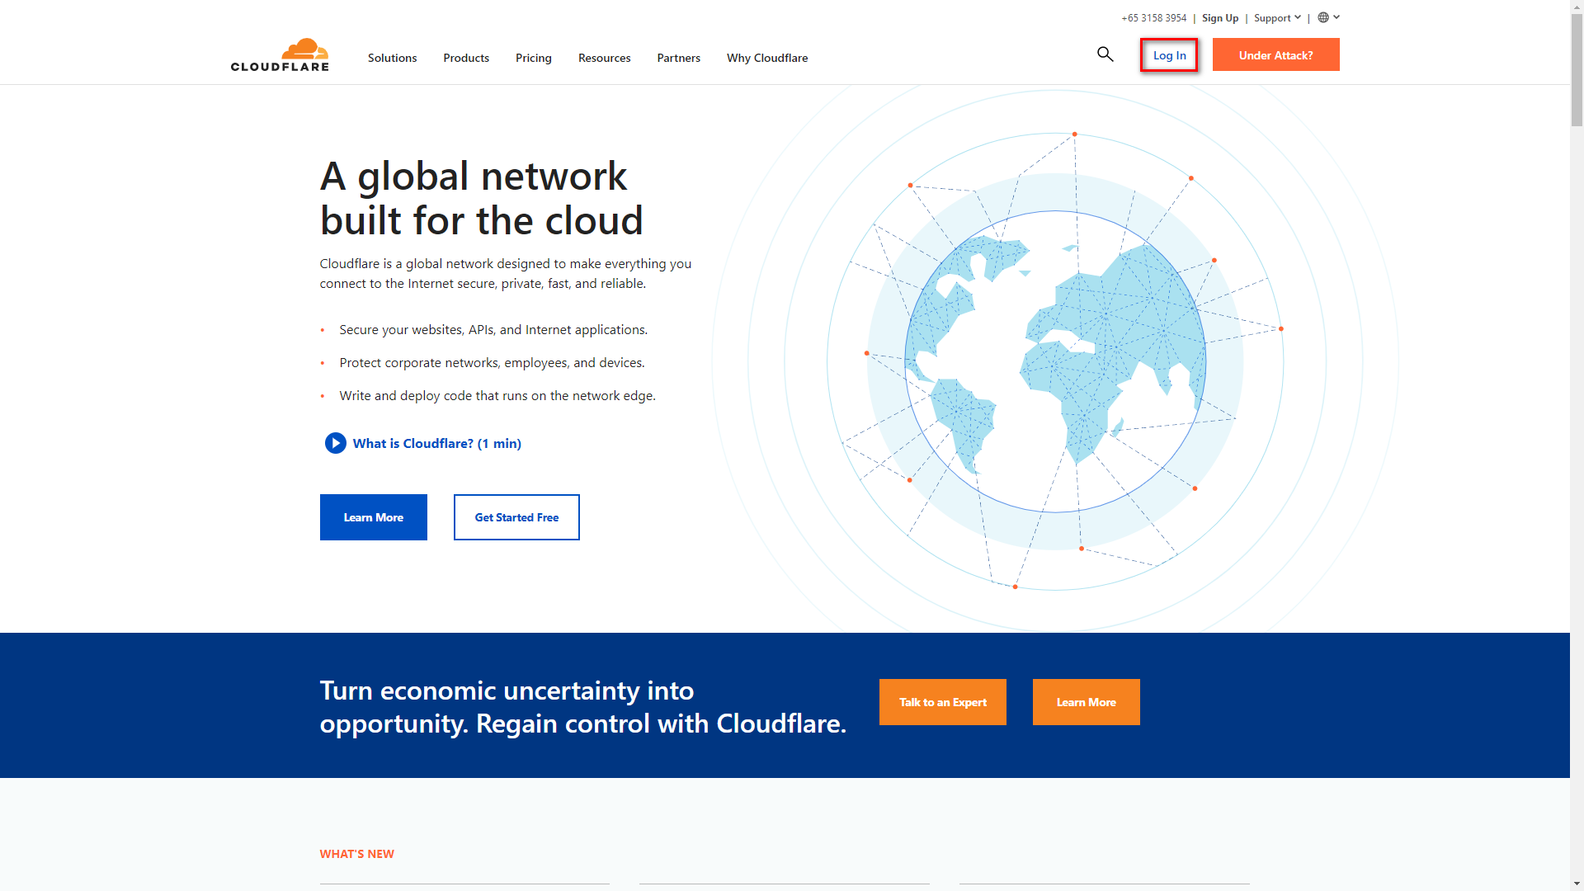

1. Login with your Cloudflare account

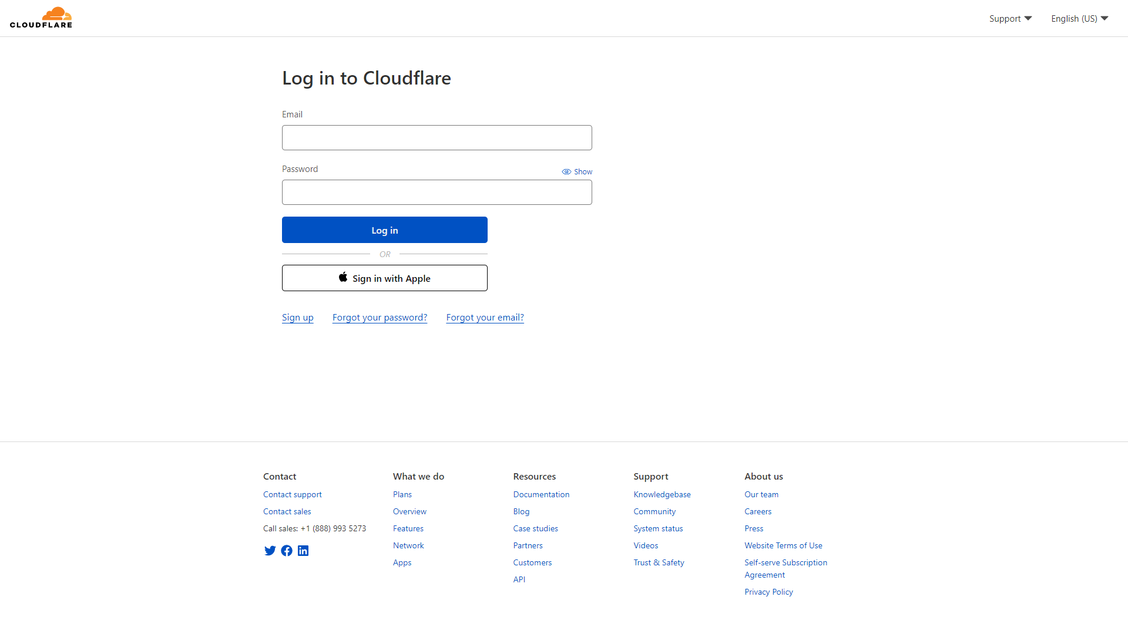

1. On home page, Click on "Pages" button

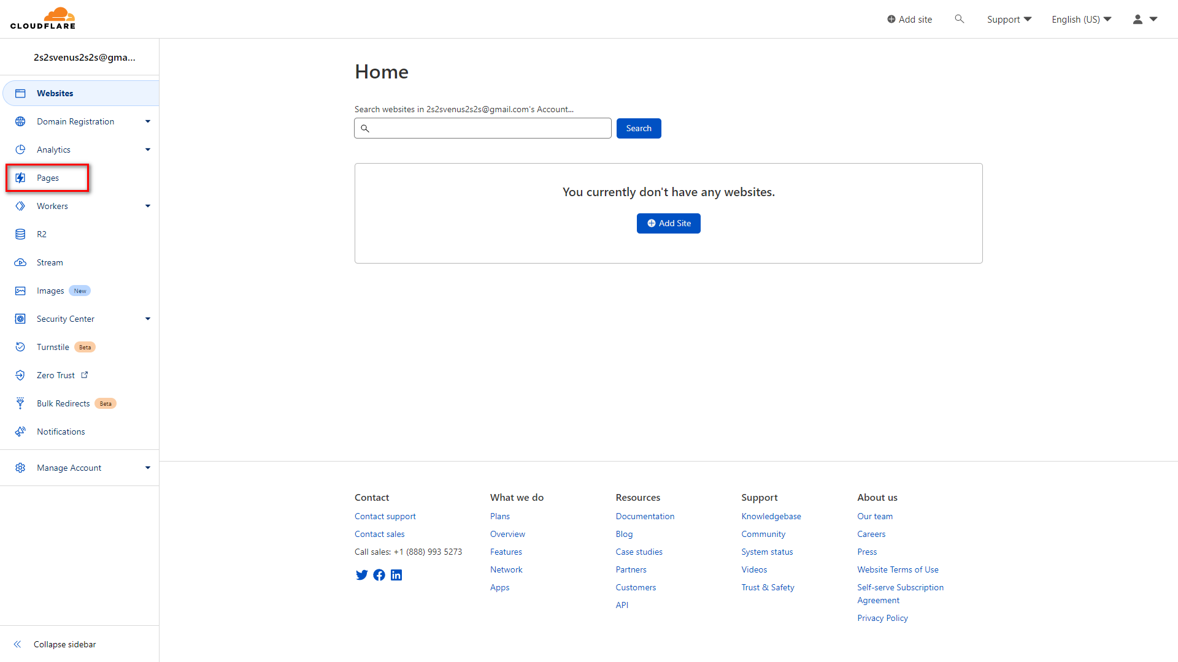

1. Click on "Create a project" button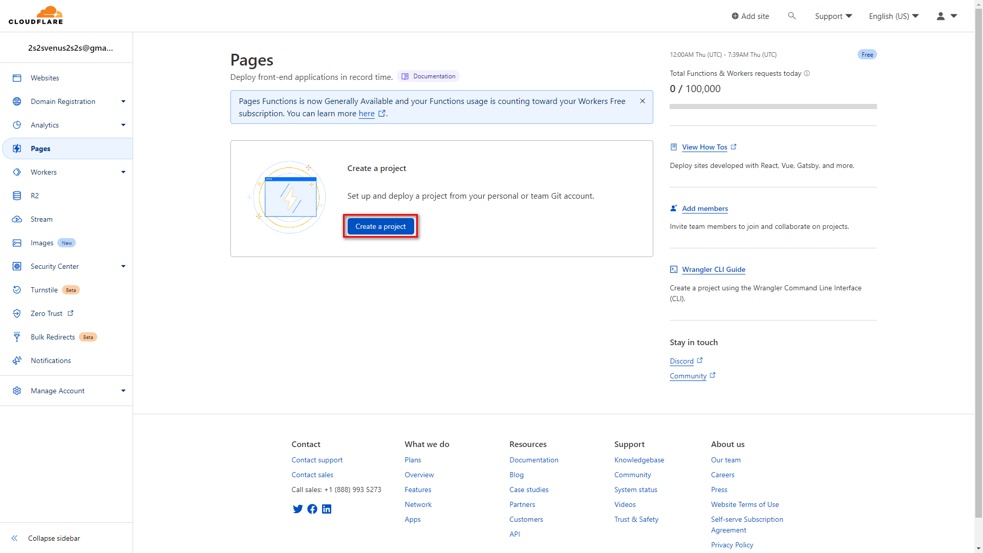
2. Click on "Connect to Git" button

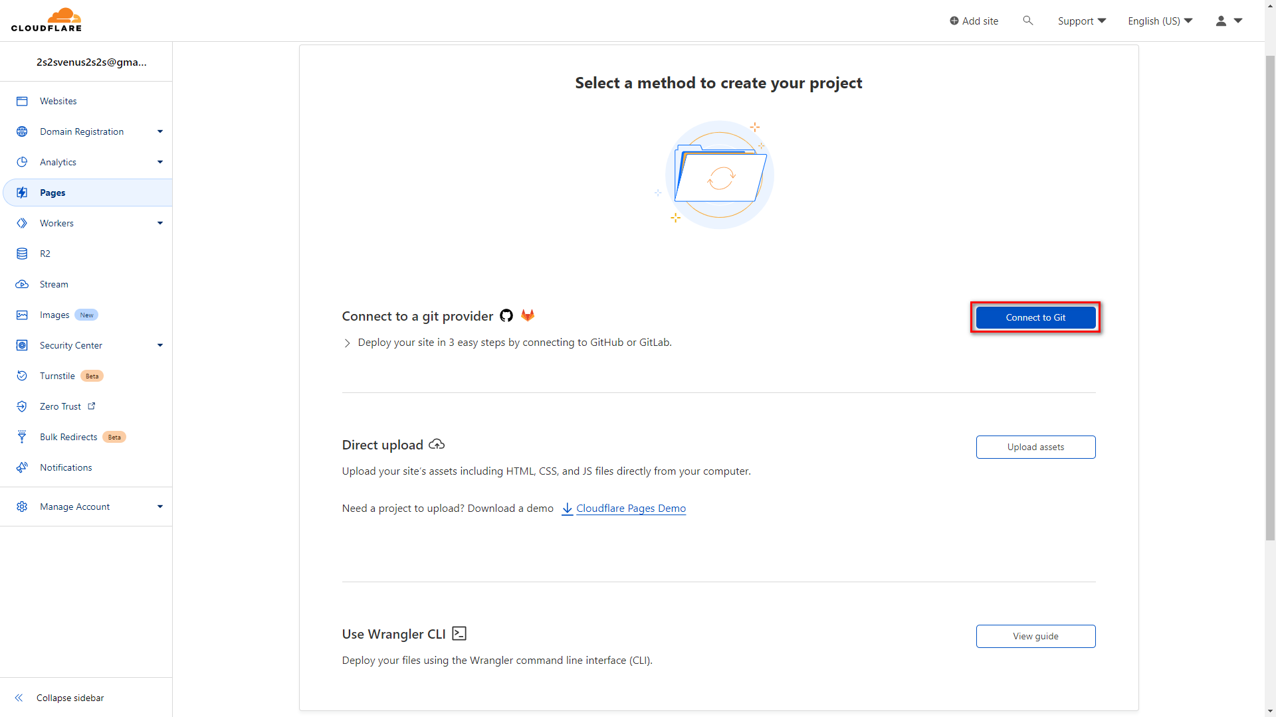

1. In GitHub tab, choose GitHub account and repository, then click "Begin setup" button

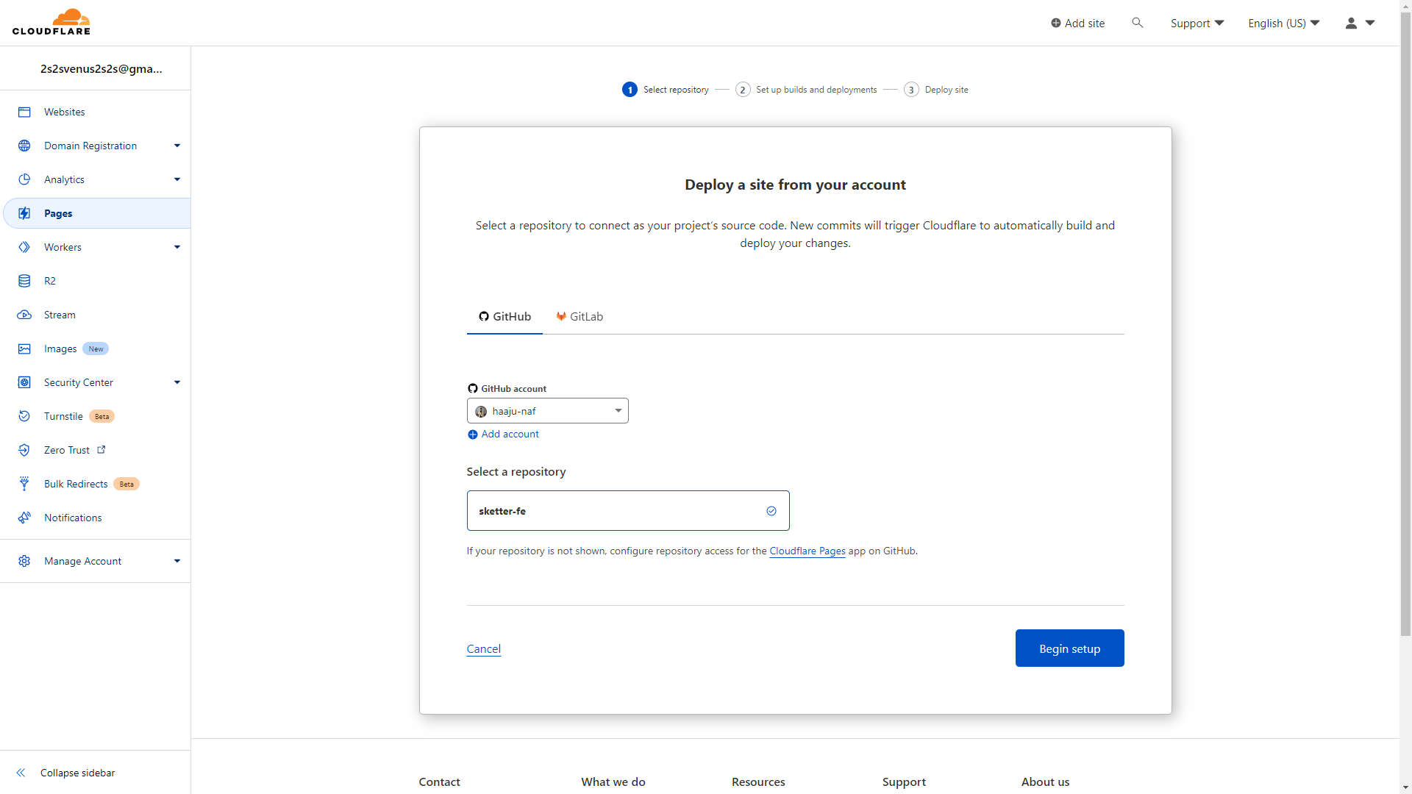

1. Input project name, choose production branch, select framework preset, and configure environment variables, then click on "Save and Deploy" button

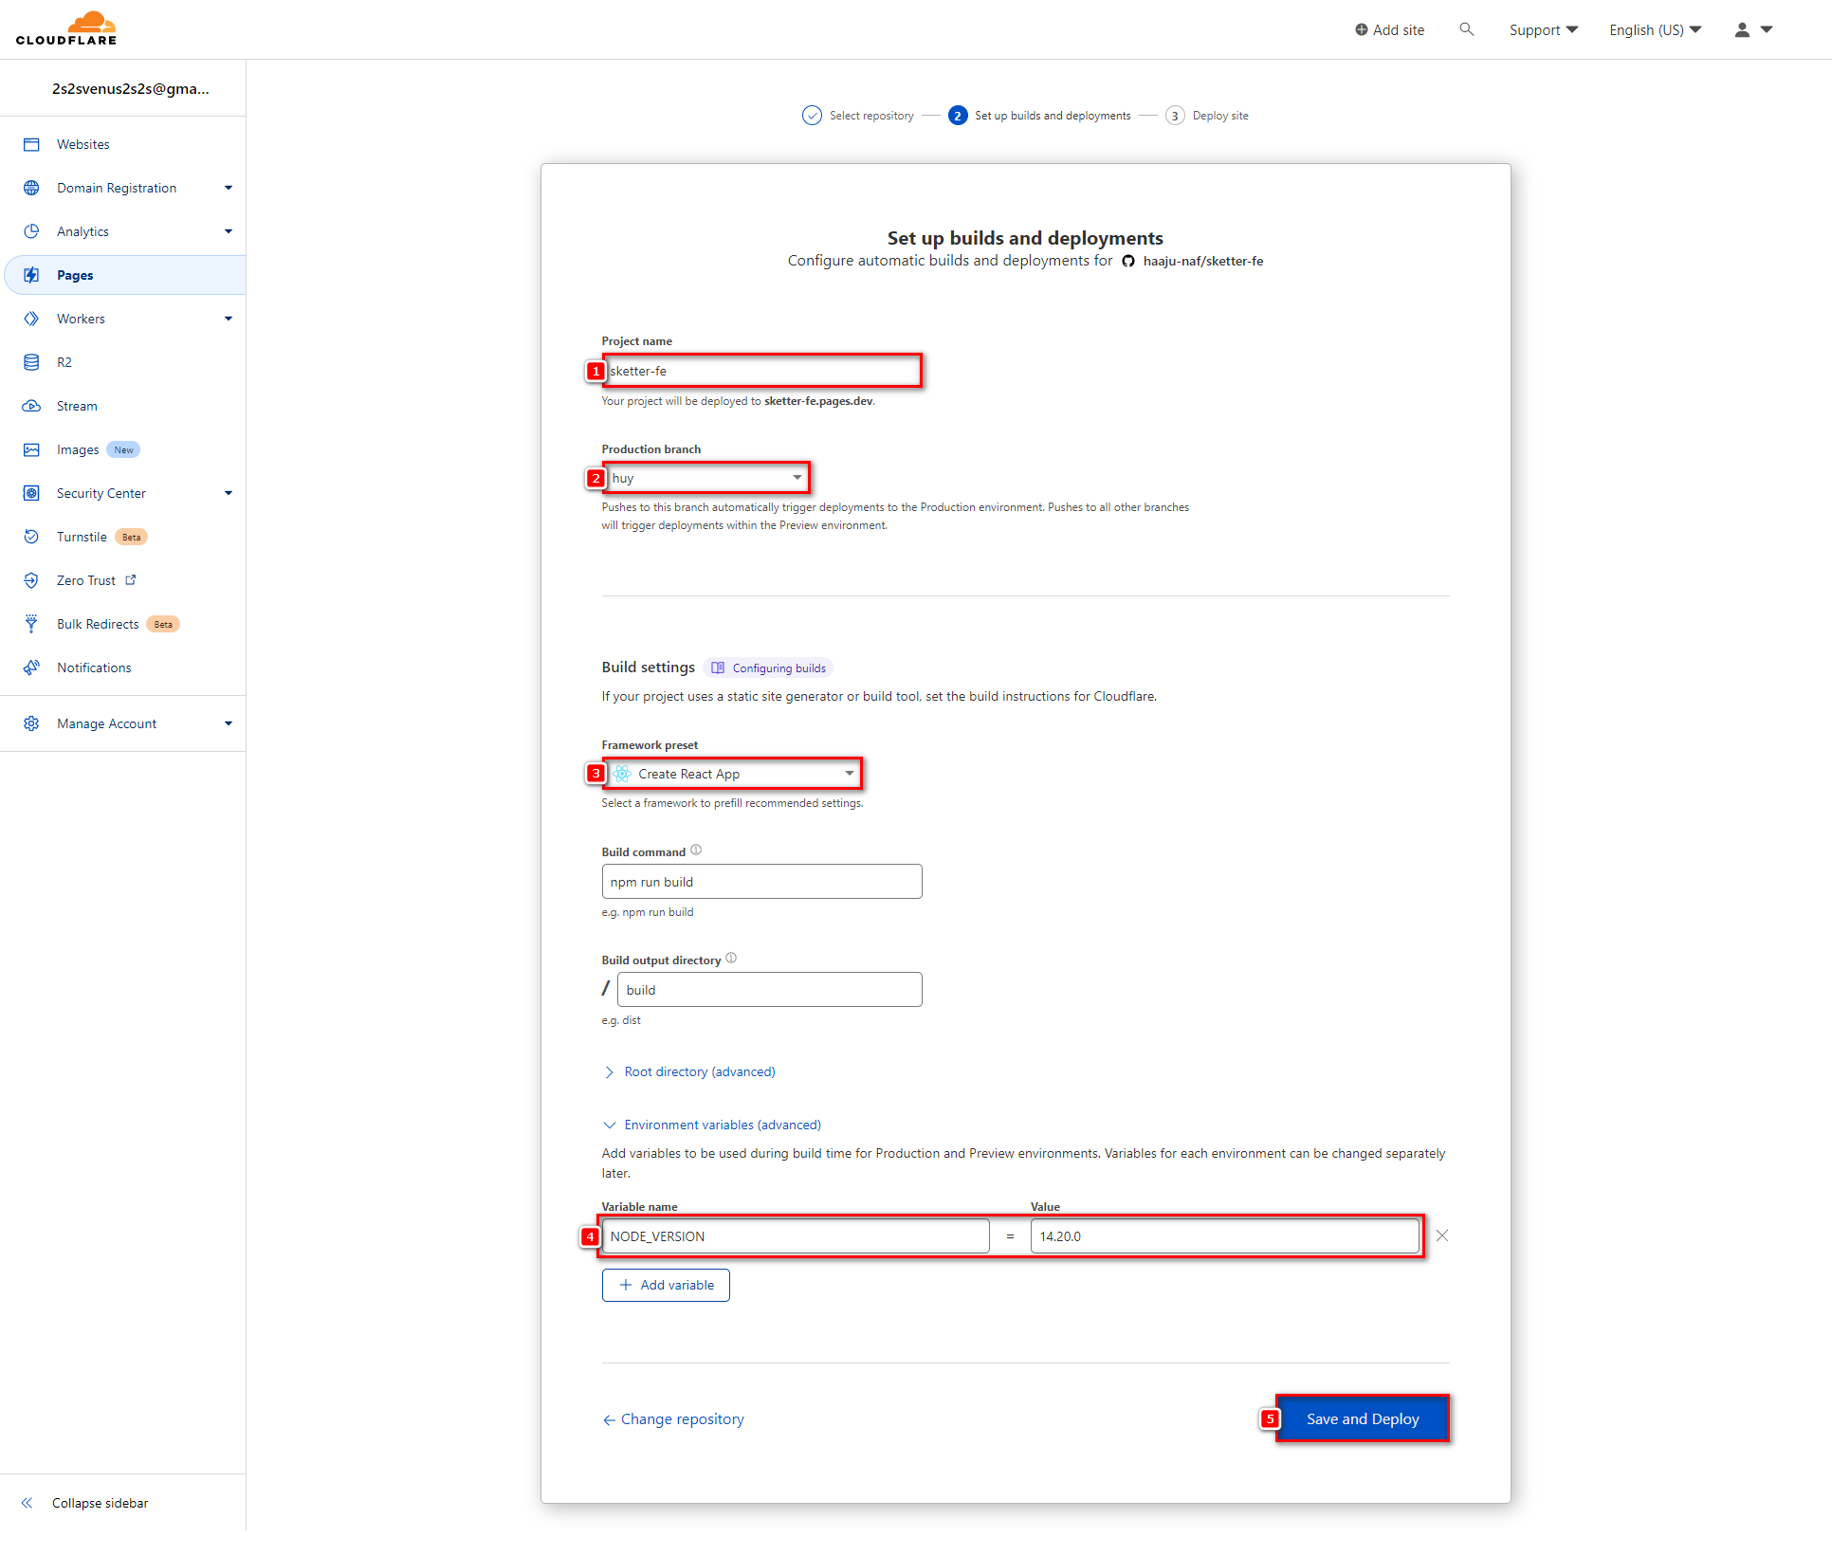

1. Wait for Cloudflare deploy

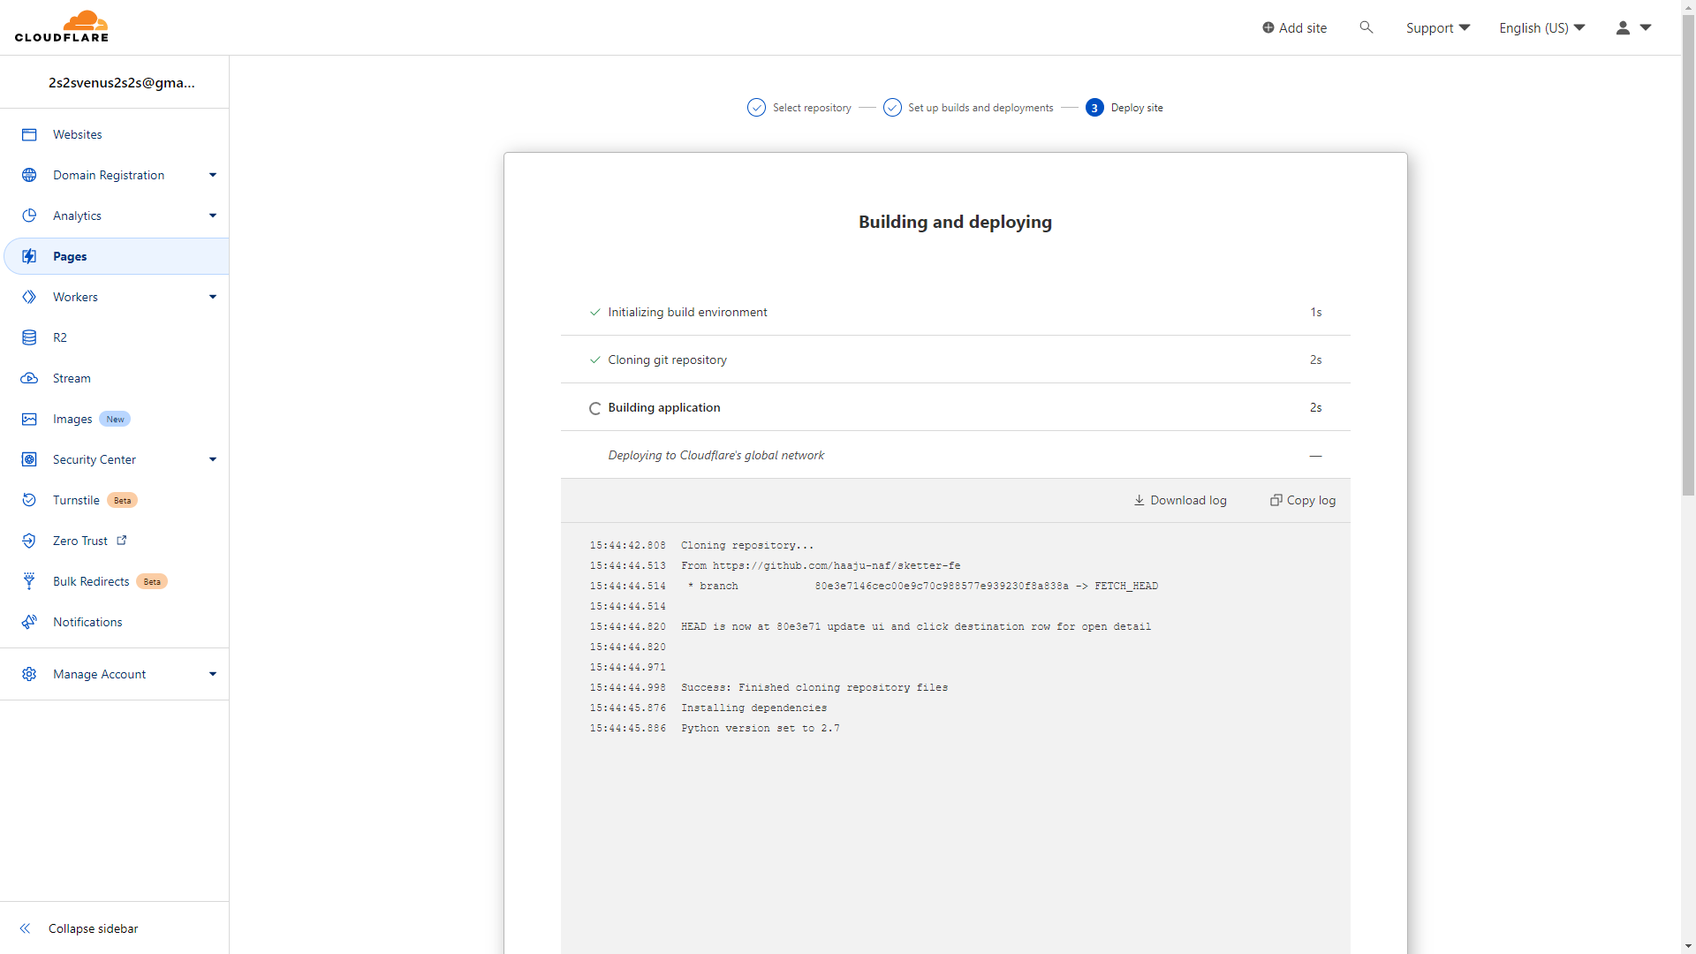

1. Deployed successfully, click on URL to open web in a new tab

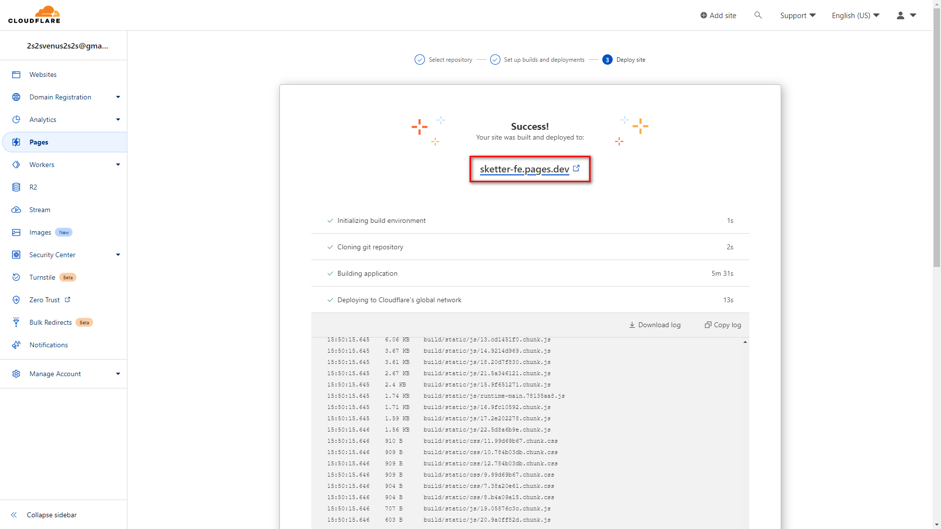

1. **User Manual**
2. **Overview**

The application is divided to support user categories including: Administrator, supplier, supplier manager, user. Features for managing users, destinations, promotions, and features that support for scheduling while travelling

* Admins use the web app to manage accounts, manage different types of locations
* Manage partners using the web app to be able to manage all the locations included in the app
* Partners use the web app to be able to manage the locations they own, in addition to managing release and testing voucher
* Travellers use mobile apps to be able to schedule manual or manual schedules to assist in travelling, purchasing vouchers from locations for a savings experience